Important Paper – 2008
Class – X
Subject – Hindi

1º inamnailaiKt gad\yaaMSa kao pZ, kr ]%tr ilaiKe. ³10´
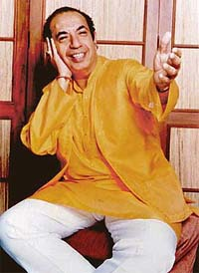
doSaBai@t ko gaItaoM kI prMpra maoM mahond` kpUr ka naama mah%vapUNa- hO.jaba BaI hma mahond mahond` kpUr ka ijak` krto hOM tao hmaaro mana maoM ]nakI Civa doSaraga ko ilae ek A Ahma\ gaayak ko $p maoM kaOMQatI hO.yah saca hO ik doSaBai@t AaOr prmpragat maUlyaaoM ko ko ijatnao laaokip`ya gaIt mahond` kpUr nao gaae hOM ]tnaI saM#yaa maoM ]tnao EaoYz gaanao dUsar dUsaro gaayak nao nahIM gaae.

mahond` kpUr kao maQya p`doSa sarkar nao saugama saMgaIt ko xao~ maoM gaayana
AaOr saMgaIt inado-Sana ko ilae lata maMgaoSakr purskar idyaa gayaa.mahond` ko naama ka
smarNa krto hI hmaaro jaohna maoM ek eosao gaayak kI Civa kaOMQa jaatI hO jaao mad\iQama
svaraoM maoM BaI ]tnaI KubasaUrtI sao gaata hO ijatnaa ik }Ðcao svaraoM maoM.ek eosaa gaayak
ijasaka naama laoto hI hmaaro mana maoM ek saaqa tmaama vah gaIt Aanao ¹ jaanao lagato hOM ijanaka doSa sao vaasta haota hO¸ ijanaka maana mayaa-da sao vaasta haota hO ¸ ijanaka saMskaraoM sao vaasta haota hO.mahond` kpUr na isaf- ek gaayak hOM bailk ek eosaI Sai#sayat hOM ijanakI Civa baohd sahja evaM ek SaalaIna vyai@t kI hO.vao baohd AnauSaasana ko saaqa Apnao sauraoM kao saaQato hOM.sacamauca vah idlaaoM kao jaIt laoto hOM ¸ jaba vao gava- sao khto hOM ¹ jaIto hOM tumanao doSa tao @yaa hmanao tao idlaaoM kao jaIta hO.

pMjaaba sao Aa[- ApnaI pIiZ,yaaoM ko haonahar AaOr gauNaI saupu~ mahond` kpUr ka janma maumba[- maoM 9 jaUna 1934 kao huAa qaa.vyaavasaaiyak Garanao maoM janma laonao ko baavajaUd ]naka saMgaIt ko p`it $Jaana bacapna sao hI qaa.[sako ilae ]nhoM Apnao pirvaar sao p`ao%saahna BaI imalaa.]nhaoMnao saoMT jaoivayasa- ka^laoja ¸ maumba[- sao Aqa-Saas~ maoM snaatk kI ]paiQa ga`hNa kI.vao baarh vaYa- kI ]ma` maoM svagaI-ya maaohmmad rfI ko maurId hao gae.vao ]nako Gar BaI jaayaa krto qao.rfI saahba nao ]nakao p`ao%saaiht ikyaa.EaI mahond` kpUr nao pMiDt tulasaIdasa Samaa- ¸ ]stad inayaaja, Ahmad ¸ manaaohr maaotdar ¸ fOyaaja, Ahmad ¸ saMgaIt inado-Sak husnalaala sao Saas~Iya saMgaIt kI iSaxaa laI.yauvaa haoto hI ]nhaoMnao p`itiYzt Aako-sT/a maoM gaanaa Sau$ ikyaa.]nhoM iflmaaoM maoM gaanao ka Avasar imalaa.

yah BaI yaaoga hI kha jaaegaa ik ]nhaoMnao tBaI dIvaalaI kI rat naamak ek eosaI iflma maoM paSva- gaayana ijasako hIrao tlat mahmaUd qao.]nakI lagana kao p`ao%saaiht krnao vaalaaoM maoM #aOyyaama BaI qao ijanhaoMnao ]nhoM Ainala ivaSvaasa ko pasa Baojaa .Ainala da nao ]nhoM pMjaabaI iflma hIrao maoM gaanao ka Avasar p`dana ikyaa.[sa trh ]nakao rah imalanaa AarMBa hao ga[-.[sa baIca ]nakao ek Avasar saI º ramacand` nao idyaa navarMga maoM ¸ ijasamaoM ]nhaoMnao "AaQaa hO cand`maa gaIt gaayaa".naaOSaad nao jaba ]nasao ApnaI iflma saaohnaI maihvaala ko ilae " caaÐd iCpa AaOr taro DUbao" gavaaya tao ]nakao Kuba sauiK-yaaÐ imaila.yah ek eosaa Avasar qaa jaba svayaM mahond` kpUr ek Aa%maivaSvaasa ka AnauBava kr rho qao.

baI º Aar º caaopD,a nao ]nhoM ApnaI iflma QaUla ka fUla maoM gaanao ka Avasar idyaa.]nhIM idnaaoM ]naka jauD,naa manaaoja kumaar sao huAa.manaaoja kumaar ek AiBanaota ko $p maoM tIna dSak tk Cae rho jaao ek p`kar sao ihndustana ko saMskarI ¸ sauSaIla ¸ AaOr SaalaIna yauvaa ka p`itinaiQa%va ApnaI iflmaaoM maoM naayak ko $p maoM krto rho.manaaoja kumaar kI banaa[- hu[- iflmaoM SahId ¸ pUrba AaOr piScama ¸ ]pkar ¸ raoTI kpD,a AaOr makana iflmaoM hOM ijanamao mahond` kpUr ko gaae gaIt " maora rMga do basaMtI caaolaa " jaOsao yaadgaar gaIt gaae.

mahond` kpUr kI gaayana p`itBaa bahurMgaI hO.vah doSaBai@t p`Qaana iflmaaoM ko psandIda gaayak rho hOM.$maanaI gaItaoM maoM BaI samaa baaÐQanao maoM BAI vah safla rho hOM."iksaI p%qar kI maUrt sao maaohbbata ka [rada hO" iktnao hI eosao gaIt rho haoMgao¸ijanamaoM mahond` kpUr kI Aavaaja, AiBavyai@t ka ek Alaga hI $maana rcait hO.mahond` kpUr svayaM ApnaI phcaana hOM.]nakI saRjana yaa~a A%yaMt saMGaYa- AaOr pirEama ko saaqa saaqa lagana AaOr yaaogyata sao imalao saaqa-k yaSa kI khanaI khtI hO.

- " doSaraga" ka @yaa AaSya hO.
- "ija,k`" ka ihndI pyaa-yacaavaI ilaiKe.
- PaSva-gaayak iksao khto hOM.
- mahond` kpUr iksa p`kar ko gaanaaoM ko ilae AiQak jaanao jaato hOMÆ
- "ja,ohna " ko ilae ihndI Sabd ilaiKe.
- mahond` kpUr ka pirvaar maUlat: iksa p`aMt sao hOÆ
- mahond` kpUr iksa trh ko [nsaana ko $p maoM jaanao jaato hOMÆ
- $maanaI gaanai iksao khto hOMÆ
- "Ahma\ gaayak" sao Aap @yaa samaJato hOMÆ.
- ek ]pyau@t SaIYa-k ilaiKe.

2º Baava saaOndya- spYT kIijae. ³5´
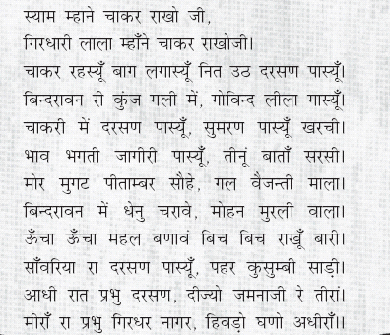

3º inamnailaiKt p`SnaaoM ko ]%tr 60 SabdaoM maoM ilaiKe. ³20´

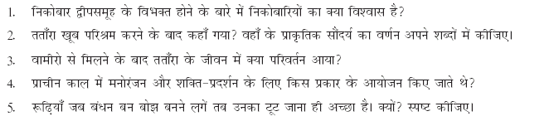

4º ttaÐra Aqavaa vaamaIrao ka cair~ ica~Na Apnao SabdaoM maoM kIijae. ³5´

5º inamnailaiKt gad\yaaMSa kao pZ, kr ]%tr ilaiKe. ³5´
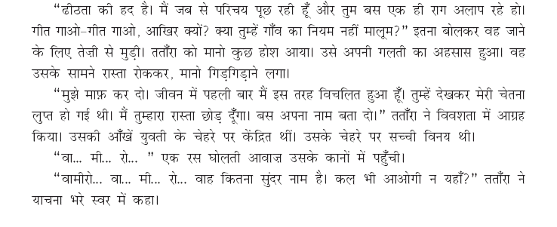

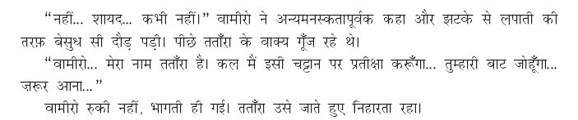

- paz AaOr laoKk ka naama ilaiKe.
- ttaMra kI mana:isqait pr p`kaSa Dailae.
- vaamaIrao ka "kBaI nahIM" ka ]%tr iksa baat ka saUcak hOÆ
- [sa gad\ya ka p`saMga spYT kIijae.
- vaamaIrao nao ttaÐra inamaM~Na @yaaoM AsvaIkar ikyaaÆ

6º maIra ko pd ka p`itpad\ya ilaiKe. ³5´

