Sample Paper- 2013
Sub : Multimedia And Web Technology
Class-XI

Time allowed : 3 Hours Maximum Marks : 70
Note :
- Please check that this question paper contains 7 questions..
- Answer the questions after carefully reading the text.
- Please write down the serial number of the question before attempting it .
1. Question given below are based on HTML:
- Give example of Physical and Logical Tags. 1
- What do you understand by “Hyper Text” in HTML? 2
- How is the <P> is different from <PRE> tag? 2
- Correct the errors in the following HTML code: 1
<HTML> <BODY> alas! I could pass exam.
<TITLE>
<P align=red> this is my first exam</p> </HEAD>
</HTML>
- Write a note on the <DL> list available in HTML. 2
- Name the type of linking given in following diagram. 2

2. Question given below are based on HTML:
- Differentiate between <TEXTAREA> and <SELECT> tag. 2
- Your best friend has created a web page with the url:www.naveen.com/personal/howtocracktest.html. you now want to link to this web page, when you click on the photograph of your friend which you have placed on your web page. Assume that the name of file containing your friend’s photograph is “c:\myschool\myfriend.jpg” 2
- Fill in the blanks” 2
  - The values that Valign attribute of <TH> tag can take are _________,_____ and _____.
  - The values,which the scrolling attribute of <FRAME> tag takes, are ____,____ and ____.
- Name the tag and attribute to do the following: 2
  - To specify how data in the form is to be sent to the destination.
  - To specify the email address to which the form is to be mailed.
- Give the output of the following HTML code: 2
<html> <frameset rows=20%,*>
<frame src=a.html”>
<frameset cols=50%,*>
<frame src=b.html”>
<frame src=c.html”>
</frameset> </frameset> </html>
3 . Question given below are based on HTML: 10
Write the HTML code to generate a Web Page in the format given below :
Consider the following while writing the HTML code
1. Background color of the page should be “Magenta”, text color should be “Maroon” .
2. Title of the page is “CBSE new attempt”.
3. Text color of main heading on the page should be “Blue”.
4. Font face of text in the page should be “Arial”.
5. Picture used in the page is the file “class12.jpg”.
6. Use the concept of list .
7. Pages linked to :
Multimedia--m.html , Internet--int.asp , Vedioconferencing--ve.avi , Animated courses--ac.jsp
8. multimediaandwebtech@aol.com mail id should be linked properly.

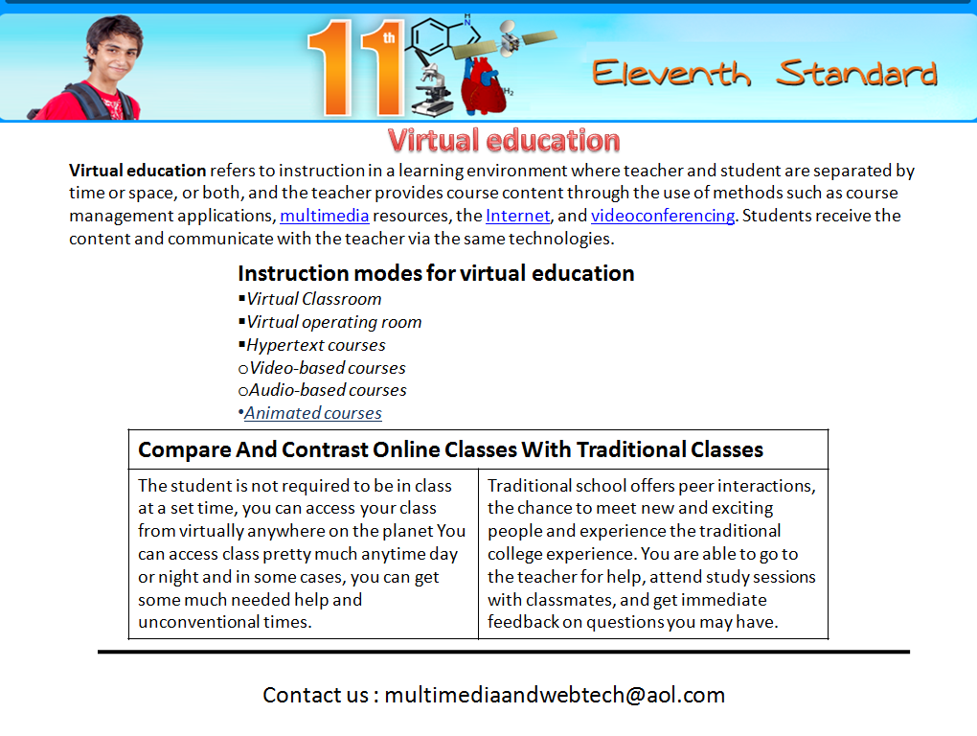

4. Question given below are based on VBScript:
- What do you understand by “Client – server” technology. 1
- What are variable? Which statement is used for declaring variables in VBscript. 2
- What are VBScript constants? 1
- Differentiate between the MsgBox and InputBox functions. 2
- What is the purpose of the if statement? Describe the different forms of if statement. 2
- What are operators? Name all the types of operator. 2
5. Question given below are based on VBScript:
a) Change the following script using For ……..next without affecting the output: 2
<script language="VBScript">
sub result()
dim i,r,rev,k
k=4320100
do while k>12000000
r=k mod 10
k=k+50000
loop
end sub
</script>
b)Rewrite the following code after correcting the errors: 2
<”script language” =vbscript>
sub result()
dim s
s=1
do while s<10 jump 1
a mod 2 equals 0 then
Ans=ans*a
Endif
next
document.right(ans)
</script>
c) Give the output for the following script code: 2
<script language=”vbscript”>
b=12
for a=43 to 52 step 5
c=a+b
document.write(c)
document.write(“<br>”)
next
</script>

d) Write a procedure for Submit button in a form to display the message “You are selected” if the stream is “science” and percentage is greater than or equal to 75, otherwise it should display “Sorry, not selected.” Use textboxes to enter stream and percentage. 4

6. Question given below are based on Photoshop:
- What do you understand by the term multimedia? Write three images and three sound formats.2
- How the bitmap graphics is different from vector graphics. 2
- What is a Layer? What is the advantage of using a Layer? 2
- Write the steps to design a collage. 2
- Write any five uses of Photoshop. 2
7. Question given below are based on CSS and VBScript.
- Differentiate between inline and external Style Sheets. 2
- Name the cascading order of the styles used in a HTML document. 1
- Correct the error in the following code 2
<HTML> <head> <title>Inline Style Sheet</title></head>
<BODY>
H1<style : “color=red; font_size=25px”>
</H1>
</HTML>
- Find the output of the following code segments: 5
  - Document .write(LEFT(RTRIM( “### IPL India”),5)
  - Document .write(MID(“Other places to search”,4,2))
  - Document .write(LEN(“multimedia & web Technology”))
  - Document .write(INSTR(“Alumni 2013”,”20”))
  - Document .write(ABS(1^3200-10*4/2)

