Guess Paper – 2013
Class – XII
Subject – Informatics Practices

IP RECORD
1.greatest of three numbers .

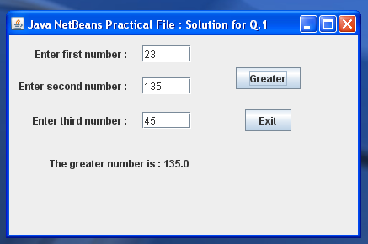

Sol. private void grButtonActionPerformed(java.awt.event.ActionEvent evt) {
float N1, N2, N3; // Variables to hold three input values.
float max; // Variable to hold maximum value.
N1 = Integer.parseInt(txtN1.getText());
N2 = Integer.parseInt(txtN2.getText());
N3 = Integer.parseInt(txtN3.getText());
// only checks the nonzero value
if ((N1 >= 0) && (N2 >= 0) && (N3 >= 0)) {
max = N1;
if (N2>max)
max = N2;
if (N3>max)
max = N3;
jLabel4.setText("The greater number is : " +max);
}
}

private void exButtonActionPerformed(java.awt.event.ActionEvent evt) {
System.exit(0);
}

2.moving data from text fields to text area

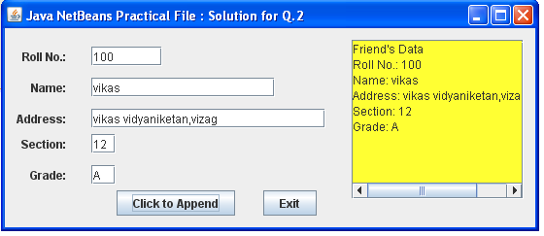

Sol. private void jButton1ActionPerformed(java.awt.event.ActionEvent evt) {
jTextArea1.append("Friend's Data" + "\n"); // Roll No.
jTextArea1.append("Roll No.: " + jTextField1.getText() + "\n"); // Roll No.
jTextArea1.append("Name: " + jTextField2.getText() + "\n"); // Name
jTextArea1.append("Address: " + jTextField3.getText() + "\n"); // Address
jTextArea1.append("Section: " + jTextField4.getText() + "\n"); // Section
jTextArea1.append("Grade: " + jTextField5.getText() + "\n"); // Grade
}

3. display salary according to designation .
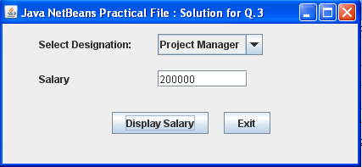

Sol. private void btnSalActionPerformed(java.awt.event.ActionEvent evt) {
String Desig = jComboBox1.getSelectedItem().toString();
if (Desig.equals("Project Manager")) {
jTextField1.setText("200000");
} else if (Desig.equals("Manager")) {
jTextField1.setText("150000");
} else if (Desig.equals("Architect")) {
jTextField1.setText("100000");
} else if (Desig.equals("Team Leader")) {
jTextField1.setText("100000");
} else if (Desig.equals("Sr. Programmer")) {
jTextField1.setText("75000");
} else if (Desig.equals("Programmer")) {
jTextField1.setText("50000");
} else if (Desig.equals("Operator")) {
jTextField1.setText("25000");
}
}

private void btnExitActionPerformed(java.awt.event.ActionEvent evt) {
System.exit(0);
}

4. arthimetic operations

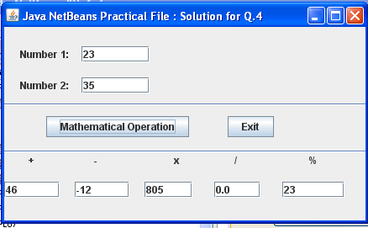
Sol. private void btnAOActionPerformed(java.awt.event.ActionEvent evt) {
int n1, n2, aoPlus, aoMult, aoRem, Diff;
float aoDiv;
n1 = Integer.parseInt(txtNum1.getText());
n2 = Integer.parseInt(txtNum2.getText());
aoPlus = n1 + n2 ;
Diff = n1 - n2;
aoMult = n1 * n2;
aoDiv = n1 / n2;
aoRem = n1 % n2;
txtPlus.setText(String.valueOf(aoPlus));
txtMinus.setText(String.valueOf(Diff));
txtMult.setText(String.valueOf(aoMult));
txtDiv.setText(String.valueOf(aoDiv));
txtMod.setText(String.valueOf(aoRem));
}

private void btnExitActionPerformed(java.awt.event.ActionEvent evt) {
System.exit(0);
}

5. find the reverse of a given no.

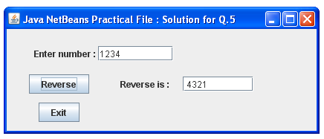
Sol. private void jButton1ActionPerformed(java.awt.event.ActionEvent evt) {
System.exit(0);
}
private void btnRevActionPerformed(java.awt.event.ActionEvent evt) {
String str;
int value, r_digit;
value = 0;
while (value <= 0) {
value = Integer.parseInt(txtNum.getText());
if (value <= 0) {
JOptionPane.showMessageDialog(this, "The number must be positive");
break;
}
}
str = " ";
while (value != 0) {
r_digit = value % 10;
str = str + Integer.toString(r_digit);
value = value / 10;
}
txtRev.setText(str);
}
6. calculate percentage and grade
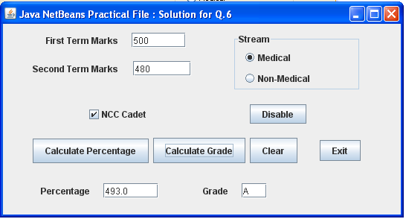

Sol. private void cmdCalcGradeActionPerformed(java.awt.event.ActionEvent evt) {
float per = Float.valueOf(txtPer.getText());
String gr="";
// Medical section
if (optMed.isSelected()) {
if (per >= 80)
gr = "A";
else
if (per >= 60 && per <= 78)
gr = "B";
else
if (per < 60)
gr = "C";
}
// Non-Medical section
else
if (optNMed.isSelected()) {
if (per >= 75)
gr = "A";
else
if (per >= 50 && per <= 74)
gr = "B";
else
if (per < 50)
gr = "C";
}
txtGr.setText(gr);
}

private void cmdClearActionPerformed(java.awt.event.ActionEvent evt) {
txtFirst.setText("");
txtSecond.setText("");
txtPer.setText("");
txtGr.setText("");
chkNCC.setSelected(false);
optMed.setSelected(true); // Default button selected
optNMed.setSelected(false);
}
private void cmdExitActionPerformed(java.awt.event.ActionEvent evt) {
System.exit(0);
}
private void btnDisActionPerformed(java.awt.event.ActionEvent evt) {
txtPer.enable(false);
txtGr.enable(false);
optMed.setSelected(true); // Default button selected
optNMed.setSelected(false);
}
private void cmdCalcPerActionPerformed(java.awt.event.ActionEvent evt) {
int fTerm, sTerm;
int Total=0;
float per=0;
fTerm = Integer.parseInt(txtFirst.getText());
sTerm = Integer.parseInt(txtSecond.getText());
Total = fTerm + sTerm; // Total marks
per = Total/2; // Percentage of marks
if (chkNCC.isSelected())
per = per + 3; // Extra 3% is given as NCC Cadet
// Displaying percentage
txtPer.setText(Float.toString(per));
}

7.class report
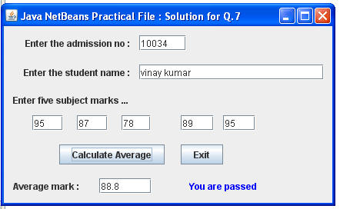

Sol. class Report
{
int adno;
String Name;
float M1, M2, M3, M4, M5;
float average;
float getavg( )
{
return ((M1 + M2 + M3 + M4 + M5)/5);
}
void read_info( )
{
adno = Integer.parseInt(txtAdm.getText());
Name = txtSname.getText();
M1 = Integer.parseInt(txtM1.getText());
M2 = Integer.parseInt(txtM2.getText());
M3 = Integer.parseInt(txtM3.getText());
M4 = Integer.parseInt(txtM4.getText());
M5 = Integer.parseInt(txtM5.getText());
average = getavg();
}
void displayinfo()
{
txtAvg.setText(Float.toString(average));
if (average > 40) {
jLabel5.setText("You are passed");
jLabel5.setForeground(Color.blue);
}
else {
jLabel5.setText("You are failed");
jLabel5.setForeground(Color.red);
}
}
}
private void btnExitActionPerformed(java.awt.event.ActionEvent evt) {
System.exit(0);
}
private void btnAvgActionPerformed(java.awt.event.ActionEvent evt) {
// Report class object
Report RP = new Report();
// Member method accessed through class object
RP.read_info();
RP.displayinfo();
}

8.create an application using list and combo boxes
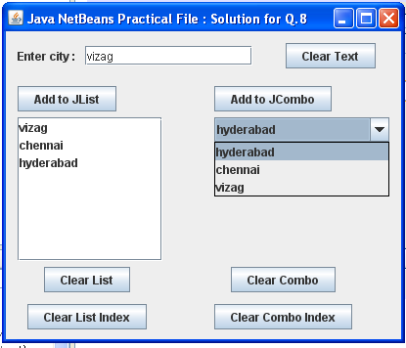

Sol. private void cmdListActionPerformed(java.awt.event.ActionEvent evt) {
String City = txtCity.getText();
DefaultListModel dModel = (DefaultListModel) jList1.getModel();
dModel.addElement(City);
jList1.setModel(dModel);
}

private void cmdLCActionPerformed(java.awt.event.ActionEvent evt) {
DefaultListModel dModel = (DefaultListModel) jList1.getModel();
dModel.clear();
}

private void cmdComboActionPerformed(java.awt.event.ActionEvent evt) {
String City = txtCity.getText();

DefaultComboBoxModel cModel = (DefaultComboBoxModel) jComboBox1.getModel();
cModel.addElement(City);
jComboBox1.setModel(cModel);
}

private void cmdCCActionPerformed(java.awt.event.ActionEvent evt) {
DefaultComboBoxModel cModel = (DefaultComboBoxModel) jComboBox1.getModel();
cModel.removeAllElements();
}

private void cmdLCIndActionPerformed(java.awt.event.ActionEvent evt) {
String City = (String) jList1.getSelectedValue();
int ind = jList1.getSelectedIndex();
if (jList1.isSelectedIndex(ind)) {
DefaultListModel dModel = (DefaultListModel) jList1.getModel();
dModel.remove(ind);
JOptionPane.showMessageDialog(this, "Deleted name " + City);
jList1.setModel(dModel);
} else
JOptionPane.showMessageDialog(this, "Note name is selected from list");
}

private void cmdClearActionPerformed(java.awt.event.ActionEvent evt) {
txtCity.setText("");
}

private void cmdCBIndActionPerformed(java.awt.event.ActionEvent evt) {
String City = (String) jComboBox1.getSelectedItem();
int ind = jComboBox1.getSelectedIndex();
DefaultComboBoxModel cModel = (DefaultComboBoxModel) jComboBox1.getModel();
cModel.removeElementAt(ind);
JOptionPane.showMessageDialog(this, "Deleted name " + City);
jComboBox1.setModel(cModel);

9. String manipulation
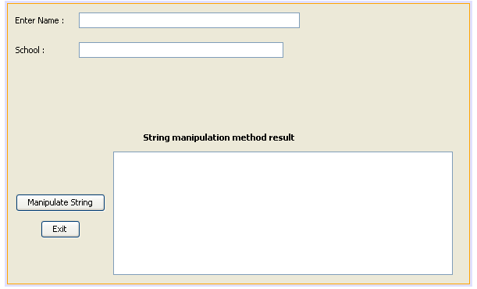

Sol. private void jButton1ActionPerformed(java.awt.event.ActionEvent evt) {
System.exit(0);
}

private void btnStringActionPerformed(java.awt.event.ActionEvent evt) {
String Name = txtName.getText();
String School = txtSch.getText();
String nName = Name.concat(School); // Concatenate Name with School
int nlength = Name.length();
String nStr = Name.substring(9); // Index stats from 9th position
String nStr1 = School.substring(9, 13); // Index start from 9th position till 13th
String uCase = Name.toUpperCase(); // Converts into uppercase letters
String LCase = School.toLowerCase(); // Converts into lowercase letters
String mess1 = " My Personal Bio-Data ";
String Year = "2010";
String nTrim = mess1.trim() + " " + Year;
txtStringArea.append("Concatenated string: " + nName + "\n");
txtStringArea.append("Length of '" + Name + "' is: " + nlength + "\n");
txtStringArea.append("Name.substring(9) is: " + nStr + "\n");
txtStringArea.append("School.substring(9, 13) is: " + nStr1 + "\n");
txtStringArea.append("Name.toUpperCase() is: " + uCase + "\n");
txtStringArea.append("School.toLowerCase() is: " + LCase + "\n");
txtStringArea.append("mess1 trim is: " + nTrim + "\n");
}

10. create a desktop application
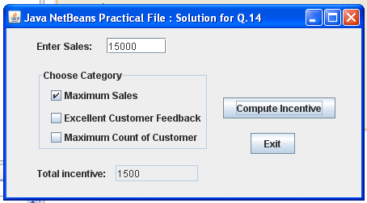

Sol. private void btnIncActionPerformed(java.awt.event.ActionEvent evt) {
int sales = 0;
if (!txtSales.getText().trim().equals("")) {
sales = Integer.parseInt(txtSales.getText().trim());
}
double incentive = 0.0;
if (jCheckBox1.isSelected()) {
incentive = incentive + 0.1; // 10%
}
if (jCheckBox2.isSelected()) {
incentive = incentive + 0.08; // 8%
}
if (jCheckBox3.isSelected()) {
incentive = incentive + 0.05; // 5%
}
txtInc.setText("" + Math.round(sales * incentive));
}

