CLASS IX
SAMPLE PAPER-01
SCIENCE
Time : 3 hrs Marks : 80
GENERAL INSTRUCTIONS:
- Question numbers 1-2 carry 1 mark.
- Question numbers 3-11 carry 2 marks.
- Question numbers 12-21 carry 3 marks.
- Question numbers 22-27 carry 5 marks.
1. Rohan said that his weight is 45kg. Rosin said it is his mass and not weight. Who is correct and what exactly is the weight of Rohan as per definition of weight?
2.A) Name the component of xylem that helps in side way conduction of water.
B) Name the outermost covering of all the plant body parts.
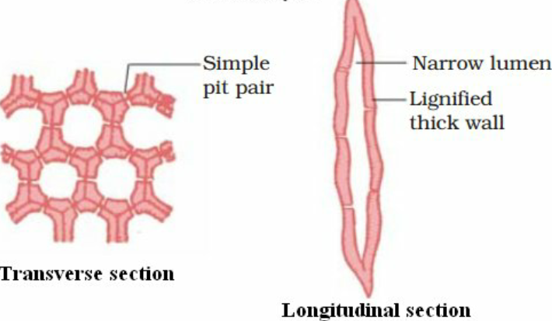
3. Identify the below picture and find it’s location and function in the plant body.

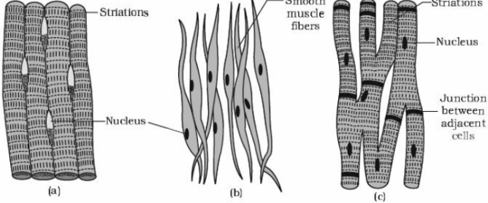
4. Identify the below given animal tissues A,B,C and write any four differences between them.
5. Which component of the cell is also known as “power houses of the cell” and why?
6.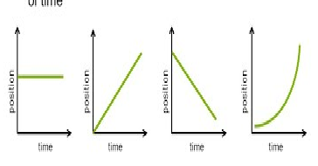
6. What do each position graph indicate?
7. Prove that force is the product of mass and acceleration
8. If acceleration due to gravity is independent of mass of the object, why does coin reach the ground first, when coin and feather are dropped from the same height?
9. Why is a heap of sand put in a long jump pit? Give reason connecting it with rate of change of momentum
10. Why is evaporation considered as the best method for separating sugar from sugar solution?
11. Compare the properties of liquids and gases and state some similarities
12. When raga wanted to open the lid of the pressure cooker her hand was exposed to steam and she got severe burns, explain the reason?
13. A stone is thrown vertically upwards with a velocity of 4.9m/s. Find the velocity with which it returns to the ground and the time taken to reach the ground?
14. Give reasons for the following:
i) Use of seat belt while driving automobiles
II) Recoil of gun
iii) Fielder dragging the ball down after catching it( in cricket)

15. Calculate the force of gravity between the two objects each of mass 50kg and separated by a distance of 5 mts.
16. Identify solute and solvent from the following solutions:
a)Vinegar b)Tincture Iodine c)soda Water

17. Explain the working of desert cooer and earthen pot. State the property involved in giving cooling effect.
18. a) A solution contains 50 grams of common salt in 450 grams of water. Calculate the concentration of the solution.
b) Name the two methods by which a saturated can be converted into an unsaturated solution.

19. Write about composite fish culture and it’s advantages.
20. Mention the tissue present in the following:
A) Plant tissue that gives flexibility
B) Plant tissue that gives mechanical support
C) Plant tissue that increases the length of internode
D) Tissue present in our skin
E) Tissue that connects two bones
F) Living component of the xylem tissue.

21. What are the desirable agronomic characters of fodder crops and cereals?
22. Sai Krishna suggested his village farmers to grow soybean in five rows and maize in five rows and follow the same pattern throughout his one acre of land. The farmers agreed to do so, in hope of better yield. Answer the following questions based on above information.
A) What is the given suggestion called?
B) On what basis crops are to be selected in such practice?
C) What are the values noticed in Sai Krishna?
D) What are the advantages with the above mentioned cropping pattern?

23. A) Differentiate between plant cell and animal cell.
B) Pick up any three cell organelles from the plant cell and write their functions.

24. Define force. What is its unit? State the effects of an unbalanced force on an object
25. State the universal law of gravity. Derive an equation from it. When every object attracts every other object, why does apple falls down and earth do not raise towards apple? Justify
26. Classify the following as physical and chemical changes:
i) Drying the clothes in the Sun
ii) Burning kerosene in a lantern
iii) Sublimation of camphor
iv) Formation of coal and petroleum
v) Burning LPG while cooking
27. What is dry ice? How is it formed? Write the property shown by Dry ice. Name one more which shows properties similar to that of dry ice.
**************

