Sample Paper – 2012-13
Class – XII- Comm
Subject – INFORMATICS PRACTICES
Time Allowed: 3 hours Maximum Marks: 70
Note:
- Answer the questions after carefully reading the text.
- Give Design wherever required.

Q1
- Rewrite the code using While Loop? 2
int j,i=5;
for (j=1;j<=i;j++)
{
System.out.println( “ “+j);
}
- What will be the contents of jTextarea1 after executing the following code: 1

jTextarea1.setText(“Kendriya\n Vidyalaya\t Guna”);
- Rewrite the code using switch statement: 2

If(k==1)
Day=”Monday”;
elseif(k==2)
Day=” Tuesday”;
elseif(k==3)
Day=” Wednesday”;
else
Day=”-”;
- Rewrite the following program code using a for loop: 2
Int i=1,sum=0;
While(i<10)
{
sum+=i;
i+=2;
}
- The following has some error(s).Rewrite the correct code underlining all the corrections made: 2

Int i, j=5;
i==j+5;
if(i=j)
{
jtextfield1.setText(“I and j are unequal”);
jtextfield1.setText(“I and j are not equal”);breaks;
}
else
jtextfield1.setText(“I and j are equal”)

Q2 a) Define inheritance with reference to object oriented programming. 1
b) While working in net beans, Ranjeeta included a list box in the form. Now she wants
the list of her friend’s names to be displayed in it .Which property of list box control should she use to do this? 1
c)What is the purpose of default clause in a switch statements ? 1

e) Write the two properties of jtextfield? 1
h)What is a list ? How is it different from combo box? 1

Q3 a. What is significance of Group By Clause in used in SELECT query ? 2
b. What do you understand by Transaction COMMIT & ROLLBACK? 2
c. What is constraint? Explain the difference between default and check constraints. 2
d. You need to remove all the rows from the Sales_LIST table. You want to release the 1 storage spaces but do not want to remove the table structure. What is the solution to the problem?
e. Predict the output: 3
- Select round(29.21,1), round(32.76,1);
- Select power(2,5);
- SELECT DAYOFMONTH(‘2009-08-24’);
- Select concat(‘catch a ’ ,concat( ‘falling’, ‘star’));
- SELECT MID(‘STUDENTS’,2,3);
Q 4 a) Create table Depart including constraints: 2
b) Add one more column Email of datatype Varchar and size 30 to the table Depart 1
- Insert values in the table as S101, ‘Sales’, “delhi’, 120. 1

Column Name | Dept ID | DeptName | DepartLOC | Distance
Key Type | Primary
Constraint |  | NOTNULL
Datatype | Number | Varchar | Varchar | Number
Length | 2 | 20 | 20 | 4

Q5. (a)If database “Emplyoee” exists, which Mysql command helps you to starts working in that database? 1
(b) Mohit created a table in Mysql .later on he found that there should have been another column in the table. Which commands should he use to add another column to the table? 1 (c) Remove the errors from query and rewriting it. 1
Select* from book where Price=NULL;
(d) Which command is used in MySql to make the changes in database permanents? 1
(e)The itemno and cost column of a table “ITEM” are given below. 2
itemno | Cost
101 | 5000
102 | NULL
103 | 4000
104 | 6000
105 | NULL

Find the output of the following queries:
i)SELECT AVG(cost) FROM ITEMS;
ii) SELECT cost+100 FROM ITEM WHERE itemno>102;
(g) A table “Animals“ in a database has 3 columns and 10 records. What is the degree and cardinality of this table? What will happen if we add 2 more rows 2
(h) Differentiate DDL and DML commands with examples of each. 2
(i) What are multirow functions? 1

Q 6 The Pincode column of table ‘Post’ is given below- 2

Pincode
110001
120012
300048
281001

i. SELECT Pincode from Post where Pincode like = “ %1” ;
ii. SELECT Pincode from Post where Pincode Like = “ 0 %” ;

Q 7 Write SQL commands for the queries given from a to d and from e to h write the output of the SQL commands based on a table LIBRARY shown below:
- To display the title of all books with Price between 100 and 300. 1
- To display Title and Author of all the books having type Prog and published by BPB. 1
- To display the list of all the books with price more than 130 in ascending order of Qty. 1
- To display the list of all books whose quantity is less than 4. 1
- Select MIN(Price) from Library; 0.5
- f) Select Sum(Price * Qty) from Library where Qty > 3; 0.5
- g) Select Avg(Price) from Library where Qty < 4; 0.5
- h) Select Count(Distinct Publisher) from Library; 0.5
No. | Title | Author | Subject | Publisher | Quantity | Price
1 | Data Structure | Lipschute | DS | McGraw | 4 | 217.00
2 | DOS Guide | NORTRON | OS | PHI | 3 | 175.00
3 | Turbo C++ | Robort Lafore | Prog | Galgotia | 5 | 270.00
4 | Dbase Dummies | Palmer | DBMS | PustakM | 7 | 130.00
5 | Mastering Windows | Cowart | OS | BPB | 1 | 225.00
6 | Computer Studies | French | FND | Galgotia | 2 | 75.00
7 | COBOL | Stern | Prog | John W | 4 | 1000.00
8 | Guide Network | Freed | NET | Zpress | 3 | 200.00
9 | Basic for Beginners | Norton | Prog | BPB | 3 | 40.00
10 | Advanced Pascal | Schildt | Prog | McGraw | 4 | 350.00
Table: LIBRARY

Q8 Virus software Hut has developed the following Interface as shown below.

Virus S/w Hut
Name of customer

Bill amount

O Cash O Credit Card O Cheque

Discount

Net Amount
Calculate Discount

Stop

- Write the code to make the TextFields for Discount & Net Amount in editable. 1
- Write code to “Calculate Discount“ button as per given criteria and discount and net amount should be displayed in TextField. 3
- Write code for “Stop“ button to close the interface. 1
Payment Mode | Discount
Cost | 15 %
Credit Card | N/L
Cheque | 10 %

Q9(a) What do you understand by primary key and candidate key. 2 (b) What is front-end? 1
(c) Give societal impacts of e-business. 2
(d) What are the benefits of E-Learning? 1
(e) Anu works for a Hotel. Sky warts to create controls on a form for the following function. Choose appropriate controls from TextField, Label , RadioButton , CheckBox , List , ComboBox ,Button and write in the third column. 2
S.No. | Controls use to | Control
1 | Select room type
2 | Enter customers name
3 | Enter arrival date
4 | To book rook

Q10 a) Develop an Application in java netbeans for calculating Amount (3)

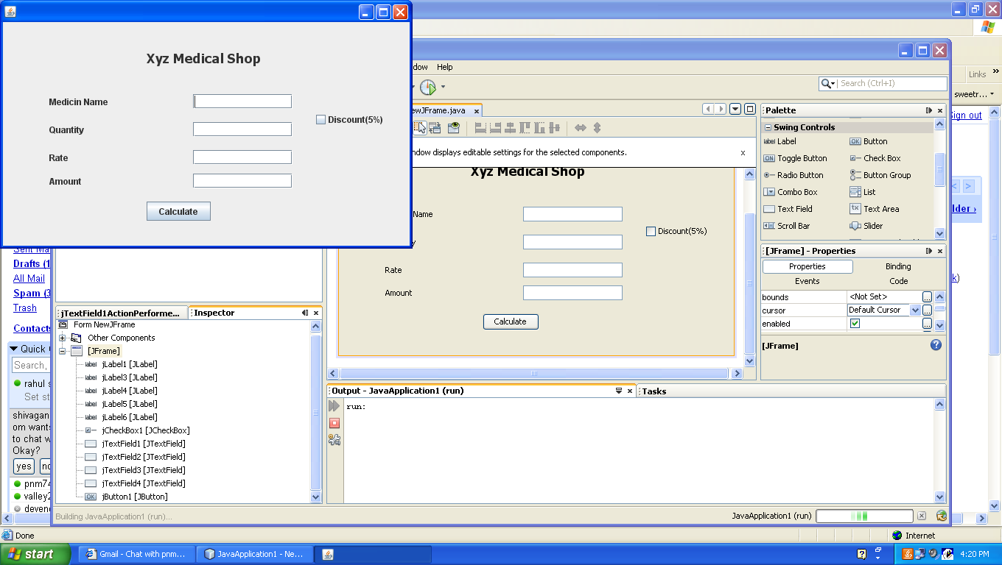

b) Develop an Application in javanetbeans (3)

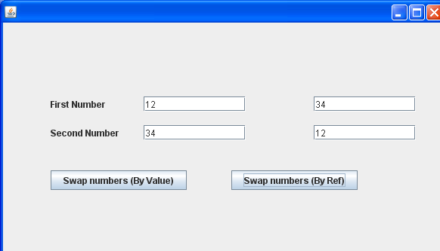

(c) Consider the following tables ACTIVITY and COACH. Write SQL commands for the statements (i) to (iv) and give outputs for SQL queries (v) to (viii) 6
ACode | ActivityName | ParticipantsNum | PrizeMoney | ScheduleDate
1001 | Relay 100x4 | 16 | 10000 | 23-Jan-2004
1002 | High jump | 10 | 12000 | 12-Dec-2003
1003 | Shot Put | 12 | 8000 | 14-Feb-2004
1005 | Long Jump | 12 | 9000 | 01-Jan-2004
1008 | Discuss Throw | 10 | 15000 | 19-Mar-2004

Table: ACTIVITY

Table: COACH
PCode | Name | ACode
1 | Ahmad Hussain | 1001
2 | Ravinder | 1008
3 | Janila | 1001
4 | Naaz | 1003

(i) To display the name of all activities with their Acodes in descending order.

(ii) To display sum of PrizeMoney for each of the Number of participants groupings (as shown in column ParticipantsNum 10,12,16)

(iii) To display the coach’s name and ACodes in ascending order of ACode from the table COACH

(iv) To display the content of the GAMES table whose ScheduleDate earliar than 01/01/2004 in ascending order of ParticipantNum.

(V) SELECT COUNT(DISTINCT ParticipantsNum) FROM ACTIVITY;

(vi) SELECT MAX(ScheduleDate),MIN(ScheduleDate) FROM ACTIVITY;

(vii) SELECT SUM(PrizeMoney) FROM ACTIVITY;

(viii) SELECT DISTINCT ParticipantNum FROM COACH;

