SAMPLE PAPER-2013
CLASS-XII
SUBJECT:- PHYSICS
Marks :70 Time 3 hr

General Instructions:
- All questions are compulsory.
- There are 29 questions in total. Questions 1 to 8 are very short answer type and carry one mark each.
- Questions 9 to 16 are carry two marks each. Questions 17 to 25 are carry three marks each. Question 26 is value based question of four marks. Questions 27to 29 are carry five marks each.
- There is no overall choice. However, an internal choice has been provided in one question of two marks, one question of three marks and all three questions of five marks each. You have to attempt only one of the given choices in such question.
- Use of calculator is not permitted. However, you may use log tables if necessary.
- You may use the following values of physical constants wherever necessary:

- For long distance radio broadcasting, we use short wave band only, why?
- Draw the wave front coming out of the convex lens when a plane wave front of light incident on it.
- Two identical loops, one of copper and another of aluminum are rotated with the same speed in same magnetic field. In which case, the induced (a) emf (b) current will be more, why?
- What should be the length of the dipole antenna for a carrier wave of frequency 3 x 10⁸Hz?
- Two wires A and B are of same metal and of same length have their areas of cross section in the ratio 2:1. If the same potential difference is applied across each wire in turn, what will be the ratio of current flowing in A and B?
- An electric dipole is kept with its dipole moment vector along X- axis. What will be the direction of the field strength at a point on its (a) axial line (b) equatorial line?
- A steady current flows in a metallic conductor of non-uniform cross section. Which of these quantities is constant along the conductor current, current density, drift velocity, electric field?
- Why does metallic piece become very hot when it is surrounded by a coil carrying high frequency alternating current?
- The current ‘i’ flows in a wire of circular cross section with the free electrons travelling with a drift velocity ‘v’. What is the drift velocity of the electron when a current of ‘2i’ flows in another wire of twice the radius and of the same material?
- How much current is drawn by primary coil of a transformer which steps down 220V to 22Vto operate device with an impedance of 220 ohm?
- Draw a plot showing the variation of power of a lens with the wavelength of incident light.
- The threshold frequency of a metal if ‘F₀’, when the light of frequency ‘2 F₀’ is incident on the metal plate, the maximum velocity of the electron emitted is V₁, when the frequency of incident radiation is increased to ‘5 F₀’, the maximum velocity of electron emitted is V₂. Find the ratio of V₁ and V₂.
- The output of a two input NOR gate is fed as input to a NOT gate. Write down the truth table for final output of the combination. OR Identified the logic gate marked P and Q in the given logic circuit given below. Write down the output at X for the input (i) A=0, B=0 (ii) A=1 and B=1.
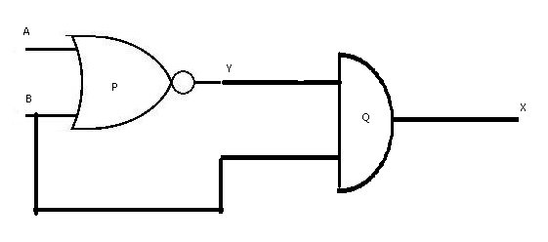

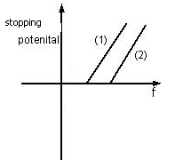
- Figure shows variation of stopping potential with the frequency for two photo sensitive material 1 and 2. 1. Why is the slope same for both line. 2. For which material will the emitted electron have greater kinetic energy for incident radiation of same frequency? Justify your answer?
- Apply Gauss’ law to obtain an expression for electric field intensity at a point due to an infinitely long, thin, uniformly charged straight wire.
- Define electric flux. Write its S.I unit. A charge q is enclosed by a spherical surface of radius R. if the radius is enclosed is reduced to half, how electric flux through the surface would change.
- The diagram given below, represent the block diagram of a generalized communication system. Identified the element, labeled as X, Y, and Z, in this diagram. Explain the function of each of these elements.

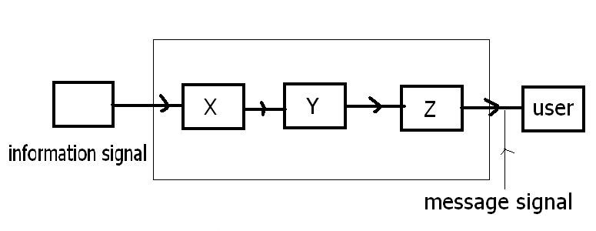

- (a) Define the term 1. Mass defect 2. Binding energy for a nucleus and state the variation between the two. (b) For a given nuclear reaction the B.E/ nucleon of product nucleus/nuclei is more than that for original nucleus/nuclei. Is this nuclear reaction exothermic or endothermic in nature? Justify your choice. OR
- The number of nuclei of a given radioactive nucleus, at time t=0 and t=T are N_{o} and N_{o}/n respectively. Obtain the expression for half life of this nucleus in term of ‘n’ and T. (b.) Identify the nature of the radioactive radiations emitted in each step of the decay chain given below _{Z}X ^{A} _{Z-2}X ^{A-4} _{Z-2}X ^{A-4} _{Z-1}X ^{A-4}
- Define the term’ electric dipole moment’. Is it scalar or vector? Deduce an expression for electric field at the point on the equatorial plane of an electric dipole of length 2a.
- Draw a graph showing variation of potential energy of a pair of nucleon as a function of their separation indicate the region in which the nuclear force is (a) attractive (b) repulsive. Also write two characteristics features which distinguish it from Coulomb force.
- The magnetic field in a plane electromagnetic wave is given by B_{y} = 2 x 10⁻⁷sin (0.5 x 10³X + 1.5 x 10¹¹) J (a) what is the wavelength and frequency of the wave. (b.) Write an expression for the electric field.
- Draw course of rays through a compound microscope. Also write the equation for magnifying power?
- Two cell of emf 1.5V and 2 V and internal resistance 1 ohm and 2 ohm respectively are connected in parallel to pass a current in the same direction through an external resistance 5ohm. (a) Draw the circuit diagram. (b) Using Kirchhoff’s law, calculate current through each branch of the circuit and potential difference across the 5 ohm resistor.
- (1.) State the law that gives the polarity in the induced emf. (2.) A 15µF capacitor is connected to 220V,50 Hz source, find the capacitive reactance and the rms current.
- A convex lens made of a material of refractive index n₁ is kept in a medium of refractive index n₂. Parallel rays of light are incident in the lens. Complete the path of the rays of light emerging from the convex lens if : (1) n_{1>} n₂ (2) n₁₌ n₂ (3) n_{1<} n_{2.}
- Thushar was using a galvanometer in the practical class; unfortunately it fell from his hand and broke. He was upset, some of his friend advised him not to tell the teacher but Thushar decided to tell his teacher. Teacher listened to him patiently and on knowing that the act was not intentional, but just an accident, did not scold him andused the opportunity to show the internal structure of galvanometer to the whole class. (a) What are the values displayed by Thushar. (b) Explain the principle, construction and working of moving coil galvanometer.
- (a) Explain the term ‘capacitive reactance’. Show graphically the variation of capacitive reactance with frequency of applied alternating voltage. (b.) An AC voltage E= E_{o} sinωt is applied across a pure capacitor of capacitance . Show mathematically that the current flowing through it leads the applied voltage by a phase angle of $\frac{π}{2}$ .
OR (a.) What does the term ‘Phasors’ in ac circuit analysis mean? (b.) An ac source of voltage E= E_{o} sinωt, is applied across a pure inductor of inductance ‘L’. Obtain an expression for the current I, flowing in the circuit. Also draws the (a) phasor diagram (b) graph of V and I versus ωt for the circuit.
- Show by a diagram the image formation of a point object by a double convex lens having radii of curvature R₁ and R₂.hence derive the formula
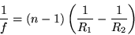

Where, f is the focal length and n is refractive index of material of the lens. OR
Define the term wave front. Draw the wave front and corresponding rays in the case of a (1) plane wave (2) diverging spherical wave. Using Hygen’s construction of wave front, explain the refraction of a plane wave front at a plane surface and hence verify the Snell’s law.
- Define the term ‘depletion layer and barrier potential for a P-N junction diode. How does an increase in the doping concentration affect the width of depletion region? Draw the circuit of a full wave rectifier. Explain its working. OR
Why the base region of transistor is kept thin and lightly doped. Draw the circuit diagram of the set-up used to study characteristics of a npn transistor in its common emitter configuration. Sketch the typical (i.)Input characteristics (ii) output for characteristics this transistor.
---------------------

