GUESS PAPER(2012-13)
CLASS-XII
INFORMATICS PRACTICES
Time – 3 Hrs. MM 70
General Instructions
There are 6 pages and 7 questions.
All the questions are compulsory
Write down the serial number of the question before attempting it.
Corporate (C)unit
Mumbai

1 a) Q1 The Birla Telcom has set up its offices in DELHI .

DELHI
Research(R)
Development unit(D)
Back office(B)

R TO B 110M Number of computers
RTO D 16KM WING R 158
R TO C 1800M WING B 79
B TO D 13KM WING D 90
WING C 51
Suggest the kind of network required for connecting office units 1
1) Research to back office
2)Research to development unit
b)Suggest the most suitable device for connecting all the computers within each of their office units? 1
c)Suggest a communication media to be procured by the company for connecting office units in Pondicherry for very effective high speed communication. 1
d) Suggest a cable layout for connecting office units in Pondicherry . 1
e) Suggest an effective method/technology for connecting office unit in Mumbai 1
f) Meena is reading the content of Reema’s file . What is she doing ? How can it be prevented ? 2
g) What are the various privileges that can be given to different users of computer 1
h)What are the freedoms given to users using free software. 2
Q2a) Which method is used to convert a number to string? 1
b) What is the use of control structures in a program 1
c) Analyze the program segment and determine how many times the body of loop will be executed
x=5 ; y=50; 2
while (x<=y)
{ y=y/x;
jTextField1.setText (“” +y) ; }
d) Write a JAVA code that takes a character from JTextField1 and find whether it is a vowel or not and display it in JtextField2. 2
e) Write HTML command to insert an image located in C DRIVE of your computer
and give it a border. 1
f) Create a form that contains a button and a text field. 2
g) Is it a valid xml tag .Justify your answer 1
<student > reena </student>
Q3a)Differentiate between procedural and object oriented programming 2
b)Explain polymorphism with examples. 2
c)What happens after the execution of following statement: 1
jTextField1.setEditable(false);
d)What is MYSQL? 1

e) What does % and _ mean with like statement. Explain with help of example 2

f) A student id (5 digits) is stored in a string variable . You want to store it as decimal type in XCD variable . Write JAVA statement to do this. 1

g)”Primary Key of a table can be defined at the time of table creation only and cannot be changed” .Justify your answer. 1
Q4 a) State the output of the given code: 2
int tick=10;
int k;
for(k=1; k<=10; k=k+2)
{ if (tick% k ==0 )
jTextField1.setText( “ “+k + “ is a factor of “ + tick);
else
jTextField1.setText(Integer.toString(k));}
b) Rewrite the code Using Switch case - 2
char c = ‘g’;
if(c = = ‘g’)
string x = “Greetings” ;
if(c = = ‘b’)
string x = “Bye” ;
if(c = = ‘d’)
string x = “ok”;
else string x = “Sorry! No Message Available”;
c) Name the method used to retrieve the selected item from jComboBox. 1
d) What’s wrong with the while statement? 1
while((ctr<5) &&(ctr>30))
{ int i=i++;}
e) double number;
string sn;
number= Double.parseDouble(jTextField1.getText( ));
JTextField2.setText(Integer.toString(sn.length( )));
- How many variables and objects have been declared in the above code? 2
- Name any one native class along with its methods . 2
f) . Prachaar Store is a Magazine distributor for Bharat Today. It is offering heavy discounts on the subscription of Bharat Today. The distributor plans to computerize its billing system. A programmer is required to make the following GUI interface to calculate the Discount Amount & Bill Amount to be paid by the subscriber as shown below:
The annual subscription of Bharat Today for one year is Rs.1400/- without any discount. Under the current scheme discounts are being offered as follows:
Control | Name | Description
jTextField1 | txtName | To store Subscribers Name
jTextField2 | txtAddress | To display the address
jTextField3 | txtTot | To display Total Amount
jTextField4 | txtDisc | To display Discount Amount
jTextField5 | txtNet | To display Net Amount
jComboBox1 | cmbPeriod | To choose “one”/ ”Two” / “Four”
jCheckBox1 | chkMember | To become a member
jButton1 | btnCalTotDisc | To Calculate Total & Discount
jButton2 | btnCalNet | To display Net Amount
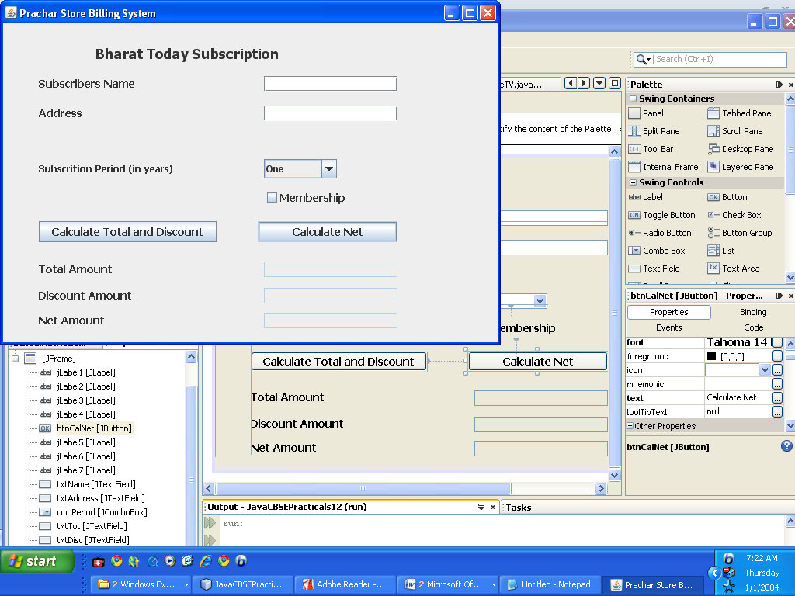
Subscription Period in years | Discount
One | 10%
Two | 15%
Four | 25%

An additional discount of Rs. 200/- is given to the subscriber who wants to become a member of the Prachaar store.
Create the above interface in Java(using NetBeans) and set/write code for the questions that follow:
- Ensure at design time that the textfields for Total Amount (txtTot) Discount Amount(txtDisc) and Net Amount(txtNet) are uneditable and btnCalNet is not active 2

- When “Calculate Total & Discount” button(btnCalTotDisc) is clicked, calculate and display the Total amount and discount in their corresponding textfields(txtTot & txtDisc) 2+2
- When “Calculate Net” button (btnCalNet) is clicked display the Net amount in the textField txtNet . 1

Q5 a) Table Employee has 4 records and table Dept has 3 records in it. Mr jain wants to display all the information stored in both of these related tables. 1
SELECT * FROM EMPLOYEE ,DEPT ;
He forgot to specify equijoin. How many rows will get displayed on execution of this query?

b) There is a column c1 in table t1 . The following two statements are giving different outputs. What may be the possible reason ? 1
SELECT COUNT(*)FROM T1;
SELECT COUNT(C1) FROM T1;
c) What are constraints ?Are they useful or not. Justify your answer. 2
d) Name two statements that can be used to end a transaction. 2

e) Write SQL statements for the queries (i) ,(ii) and output for (iii) and (iv): 4
Table: STORE
ItemNo | Item | Scode | Qty | Rate | LastBuy
2005 | Sharpener Classic | 23 | 60 | 8 | 2009-06-31
2003 | Ball Pen 0.25 | 22 | 50 | 25 | 2010-02-01
2002 | Gel Pen Premium | 21 | 150 | 12 | 2010-02-24
2006 | Gel Pen Classic | 21 | 250 | 20 | 2011-03-09
2001 | Eraser Small | 22 | 220 | 6 | 2009-01-19
2004 | Eraser Big | 22 | 110 | 8 | 2009-12-02
2009 | Ball Pen 0.5 | 21 | 180 | 18 | 2009-11-03
Note:
- ItemNo is the Primary Key.

I Delete those records whose last buy is before 2003
ii Add another column Category of type character in the table
iii Select round ( qty*110/100, 1)from store where rate>10;
iv Select MID(“informatics”,3,4), substr(“practices”,3);
Q6 Table: Employee Table: Department
a)Identify Primary Key, Alternate Key, Candidate Keys in each table & Foreign Key from the following two tables: 2
Eno | Name | Designation | Salary | Deptno
45 | Ramanuj Singh | Director | 90000 | 10
32 | Gareema Seth | Manager | 78000 | 20
12 | John Brooke | Accountant | 25000 | 20
9 | Ahmed Abdul | Manager | 78000 | 30
Deptno | Dname | City
10 | Research | Delhi
20 | HRD | Delhi
20 | HRD | Kolkata

b) Display employee name and department number who reside in DELHI. 2

c) Display the sum of salary for each department with minimum salary as 20000 2

d) Explain the states of auto commit. 1
Q7 a)The web address of national portal of INDIA. 1
b)Name two container controls in Java. 2
c)To reach the customers in an effective manner many shops provide their services on net. It falls under which IT application category? 1
d)Explain two major parts of IT applications with example. 2

