Sample Paper 2013
Class – X

Subject – Math’s
Time: 3 hours Maximum marks: 90
- All questions are compulsory.
- The question paper consists of 34 questions divided into 4 sections, A, B, C, D Section-A comprises of 8 questions of 1 mark each. Section-B comprises of 6 questions of 2 marks each. Section-C comprises of 10 questions of 3 marks each and Section D; comprises of 10 questions of 4 marks each.
- Question numbers 1 to 8 in Section-A are multiple choice questions where you select one correct option out of the given four.
- There is no overall choice. However, internal choice has been provided in 1 question two marks, 3 questions of three marks each and 2 questions of four marks each have to attempt only one of the alternatives in all such questions.
- Use of calculators is not permitted.
SECTION –A
- If the altitude of the sun is at 60⁰, then the height of the vertical tower that will cast a shadow of length 40m is (a) 40/√3 m (b) 20√ 3m (c) 40√3m (d) 40m.
- One card is drawn from a well shuffled deck of 52 cards. What is the probability of getting a red face card? (a) 1/13 (b) 3/26 (c) 1/26 (d) 3/13.
- An unbiased die is thrown .The probability of getting a multiple of 3 is: (a) 0 (b) ½ (c) 1/3 (d) 1/6.
- The roots of the equation x²+x-p(p+1)=0, where p is a constant, are (a) p,p+1 (b) –p,p+1 (c) p,-(p+1) (d) –p, -(p+1)
- If the roots of the equation 12x²+mx+5=0 are real and equal then m is equal to (a) 8√15 (b) 2√15 (c)4√15 (d) 10√5.
- The 4th term from the end of the A.P: -11,-8,-5…..49 is (a) 37 (b) 40 (c) 43 (d) 58.
- To draw a pair of tangents to a circle which are inclined to each other at an angle of 60⁰, it is required to draw tangents at end points of those two radii of the circle, the angle between which should be (a) 120⁰ (b) 135⁰ (c) 90⁰ (d) 60⁰.
- 12 solid spheres of the same size are made by melting a solid metallic cylinder of base radius 1cm and height 1/3 of 48cm. The radius of each sphere is (a) 4cm (b) 3cm (c) 2cm (d) 1cm.

SECTION—B
- Which term of the AP: 3,15,27,39,… will be 120 more than its 21st term? OR The sum of 5th and 7th term of an AP is 52 and the 10th term is 46. Find the common difference.
- What is the perimeter of a triangle with vertices A(0,4), O (0,0) and B (3,0).
- For what value of k will the points (k,-1), (2,1) and (4,5) lie on a line?
- In fig. APB and COD are semicircles of diameter 7cm each, while ARC and BSD are semi circles of diameter 14cm each. Find the perimeter of the shaded region. (use π = 22/7).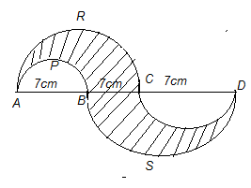
- A solid metallic sphere of radius 3cm, is melted and recast into small solid spherical balls of radius 0.3cm. Find the number of balls formed.
- In two concentric circles , prove that all chords of the outer circle which touches the inner circle are of equal lengths.
SECTION - C
- From the top of a light house, the angles of depression of two ships on the opposite sides of it are observed to be 30⁰ and 60⁰. If the height of the light house is h metres and the line joining the ships passes through the foot of the light house, show that the distance between the ships is 4/√3 h metres.
- Two dice are thrown simultaneously, What is the probability hat (a) 5 will not come upon either of them? (b) 5 will come upon atleast once? (c) 5 will come up at both dice?
- In a locality ,28 children out of 35 worked for making their area clean and green. What is the probability that a child selected at random, worked for the society? (a) Which social values are being reflected here? (b) What does the value of the ratio tell us about the children of this locality?
- Solve the quadratic equation $\frac{1}{x-2}+ \frac{2}{x-1}= \frac{6}{x}$ by factorization method. $OR$ Find the roots of the following equation: 6a² x² – 7abx - 3b² = 0 , (a≠0)
- The first term of AP is 5, the last term is 45 and the sum is 400. Find the number of terms and the common difference.
- In fig. ABC, is circumscribing a circle . Then find the length of BC. OR PQ is a chord of length 8cm of a circle of radius 5cm. The tangents at P and Q intersect at a point T. Find the length TP. 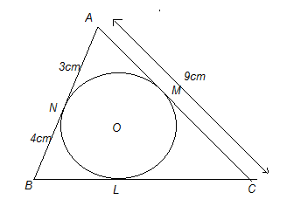
- Draw a circle of radius 6cm. From a point 10cm away from its centre, construct the pair of tangents to the circle and measure their lengths.
- The line segment joining the points A (2,1) and B(5,-8) is trisected at the point P and Q such that P is nearer to A. If P also lies on the line given by 2x-y+k=0, find the value of k.
- A square field and an equilateral triangular park having equal perimeters. If the cost of ploughing the field @ Rs.5/m² is Rs. 720, find the coast of maintaining the park @ Rs.10/m² OR Find the perimeter of an equilateral triangle if the area of the circle inscribed in it is 154cm². (take √3=1.73) (use π =22/7)
- A vessel is in the form of a hollow hemisphere mounted by a hollow cylinder. The diameter of the hemisphere is 14cm and the total height of the vessel is 13cm. Find the inner surface area of the vessel.

SECTION --D
- A straight highway leads to the foot of a tower. A man standing at the top of the tower observes a car at an angle of depression of 30⁰, which is approaching the foot of the tower with a uniform speed . six seconds later the angle of depression of the car is found to be 60⁰. Find the time taken by the car to reach the foot of the tower from this point OR
From an aeroplane vertically above a straight horizontal road, the angles of depression of two consecutive mile stones on opposite sides of the aeroplane are observed to be α and β. Show that the height in miles of aeroplane above the road is $\frac{tanα tanβ}{tanα+tanβ}$.
- Solve the following equation for x : 9x² -9(a+b)x+(2a²+5ab+2b²)=0
- Two water taps together can fill a tank in 9$\frac{3}{8}$ hours. The tap of larger diameter takes 10 hours less than the smaller one to fill the tank separately. Find the time in which each tap can separately fill the tank.
- A spiral is mae up of successive semicircles, with centres alternately at A and B starting with centre at A, of radii 0.5cm, 1.0cm, 1.5cm, 2.0cm…in Fig. What is the total length of such a spiral made up of thirteen consecutive semi-circles ? (take π=22/7)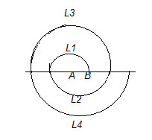
- Two tangents PA and PB Re drawn to a circle with centre O from an external point P Prove that APB=2 ∠OAB 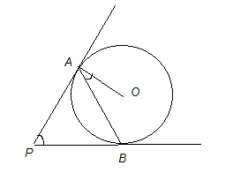
- Four points A (6,3), B(-3,5), C(4,-2) and D(x,3x) are given in such way that $\frac{area of ∆DBC}{area of ∆ABC}= \frac{1}{2}$ . Find x.
- PQRS is a diameter of a circle of radius 6cm. The lengths PQ, QR and RS are equal. Semicircles are drawn on PQ and QS as diameters as shown in fig. Find the area of shaded region.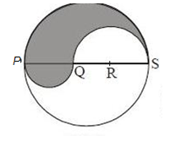
- A bucket made of aluminum is of height 20cm and has its upper and lower ends of radii 36cm and 21cm respectively. Find the cost of making the bucket if the cost of aluminum sheet is Rs.50 per 100cm². OR An oil funnel of tin sheet consists of a cylindrical portion 10cm long attached to a frustum of a cone. If the total height be 22cm, diameter of the cylindrical portion be 8cm and the diameter of the top of the funnel be 18cm, find the area of the tin required to make the funnel.
- Five containers shaped like a right circular cylinder having diameter 12cm and height 15cm are full of ice cream.This ice-cream is to be filled into cones of height 12cm and diameter 6cm, having a hemispherical shape on the top and is to be distributed to the children in an orphanage. Find the number of such cones which can be filled with ice cream. What values does a person doing such an act possess?
- Prove that the tangent at any point of a circle is perpendicular to the radius through the point of contact. Using the above do the following : In fig, O is the centre of two concentric circles. AB is a chord of the larger circle touching the smaller circle at C. Prove that AC=BC.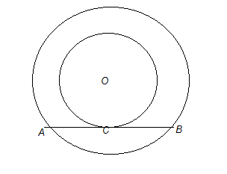
www.coolGuru.net
myguru@coolGuru.net

