Guess Paper 2013
Class – XII
Subject – Mathematics
Time : 3 Hours Max. Marks : 100
General Instructions
1. All questions are compulsory.
2. The question paper consists of 29 questions divided into three sections A,B and C.
Section A comprises of 10 questions of one mark each, section B comprises of 12
questions of four marks each and section C comprises of 07 questions of six marks each.
3. All questions in Section A are to be answered in one word, one sentence or as per the exact
requirement of the question.
4. There is no overall choice. However, internal choice has been provided in 4 questions of four
marks each and 2 questions of six marks each. You have to attempt only one of the alternatives
in all such questions.
5. Use of calculators is not permitted. You may ask for logarithmic tables, if required
Section-A

1.If *: R R ,a,b,c,d є R such that (a,b) *(c,d) = (ac, b + ad) Find the identity element of the function.
2. . Find Ia x b I, if
3. Find gof and fog if f:R-R and g:R-R are given by f(x) = cos x and g(x)= 3 x 2 .Show that gof = fog
4.Show that the points A (1, 2, 7) B(2, 6, 3) and C (3, 10 ,-1) are collinear.
5.If A and B are two matices such that AB =A and BA = B then what is value of B².
_{6.Show that the points A(2i}ˆ _{-j} ˆ_{+k} ˆ_{),B ( i}ˆ_{--3j}ˆ_{-5k}ˆ _{), C ( 3i}ˆ_{-4j}ˆ _{-4k} ˆ)are the vertices of a ght angled triangle.
7.Examine whether the function f given by f(x) = x² _{is continuous at x = 0 .}
8.Find the rate of change of the area of a circle with respect to its radius r at r = 6 .
9.If a line y = x + 1 is a tangent to the curve y ²= 4x . find the point the of contact ?
10.Use differential to approximate √ 36.6.
SECTION_- B
11.Solve for x:
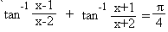
Or
Simplify: 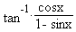
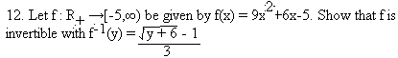
13. Using properties of determinants, prove that

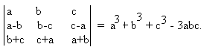

OR
Using elementary transformations find the inverse of

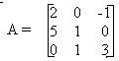
14. Find the values of a and b such that the function defined

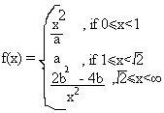
.
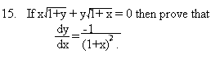
OR
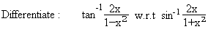
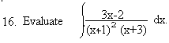
17. Using differentials, find the approximate value of (255)^{1/4} upto four places of decimals.

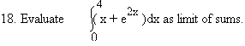
19. Find the shortest distance between the lines
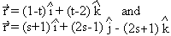
20. Using properties of definite integrals, evaluate
21. Using vectors find the area of the triangle whose vertices are A(1,1,2), B(2,3,5) and C(1,5,5).
22. The probability that a bomb dropped from a plane will strike the target is 1/5. If six bombs are
dropped, find probability that (i) exactly two will strike the target.
(ii) atleast two will strike the target.
OR
In a test, an examinee either guesses or copies or knows the answer to a multiple choice question
with four choices. The probability that he makes a guess is 1/3 and the probability that he copies
the answer is 1/6. The probability that his answer is correct given that he copied it is 1/8. Find
the probability that he knows the answer to the question, given that he correctly answered it.

SECTION C
23.Solve the following system of equation by matrix method.
3x - 2y + 3z = 8
2x + y – z = 1
4x – 3y +2z = 4
24.Prove that the volume of the largest cone that can be inscribed in a sphere of radius
R is 8/27 of the volume of the sphere.
OR
Show that semi-vertical angle of right circular cone of given surface area and maximum volume is
Sin⁻¹ (1/3).
25. Using integration ,find the area of the region bounded by the triangle whose vertices are (1,0), (2,2) and (3,1). OR
Find the area of the region enclosed between the two circle x² + y² = 4 and (x –2)² + y² = 4 .
26.Find the shortest distance between the lines l₁ and l₂ whose vector equations are
r = î + ĵ + λ(2 î – ĵ + ĸˆ) r = 2 î + ĵ –k + μ ( 3 î – 5 ĵ + 2 ĸˆ)
27.A house wife wishes to mix up two kind of foods X and Y in such a way that mixture contains at least 10 units of vitamin A, 12 units of vitamin B and 8 units of vitamin C. The vitamin contents of 1 kg of food X and 1 kg of food Y are as given in the following table:
Food | Vitamin A | Vitamin B | Vitamin C
X | 1 | 2 | 3
Y | 2 | 2 | 1

28. Bag –I contains 3 red and 4 black balls while another bag –II contains 5 red and 6 black balls. One ball is drawn at random from one of the bags and it is found to be red. Find the probability that it was drawn from bag –II.
29 Evaluate: ₀ ∫^{л/2} Log Sin x dx.

M.A.CHAUHAN(MUSA SIR)
Mob.7500943454

