Class – IX
Session -2021-22
TERM 1 ( Set-2)
Subject- Mathematics (Standard) 041
Time Allowed: 90 minutes Maximum Marks: 40
General Instructions:
1. The question paper contains three parts A, B and C
2. Section A consists of 20 questions of 1 mark each. Any 16 questions are to be attempted
3. Section B consists of 20 questions of 1 mark each. Any 16 questions are to be attempted
4 Section C consists of 10 questions based on two Case Studies. Attempt any 4 questions from each Case Studies.
5. There is no negative marking.
SECTION A
( Section A consists of 20 questions of 1 mark each. Any 16 questions are to be attempted)
 | The name of horizontal and the vertical lines drawn to determine the position of any point in the Cartesian plane?  - ordinate and abscissa  - abscissa and ordinate  - X axis and Abscissa  - Y-axis and ordinate | [1]
 | A linear equation in two variables has  - infinitely many solutions.  - Only two solution  - It depends upon the coefficients of the variables  - None of these | [1]
 | OQ is a line. Ray OR is perpendicular to line PQ. OS is another ray lying between rays OP and OR. If ∠ QOS = 125⁰ and ∠ POS = 63⁰ then the value of ∠ ROS is  - 62⁰  - 26⁰  - 31⁰  - 13⁰ | [1]
 | The area of a regular hexagon is 600cm². Determine its perimeter.  - 100 cm  - 110 cm  - 120 cm  - 125 cm | [1]
 | AB is a line segment and line l is its perpendicular bisector. If a point P lies on l, then  - AP=BP  - AB=AP=BP  - Can’t say  - Insufficient of data | [1]
 | If 2^{x}=3^{y}=6^{z} then $\frac{1}{x}+\frac{1}{y}=$  - 2  - 3  - 6  - $\frac{1}{z}$ | [1]
 | In the figure, BC = CE and 1 = 2. then  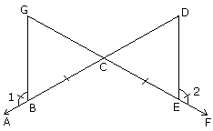  CD is equal to  - GC  - DE  - GB  - BC | [1]
 | The number representing A on the number line is  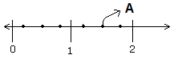  - 1.6  - 1$\frac{2}{3}$  - 1$\frac{1}{3}$  - None of the above | [1]
 | The value of k, if x = 5, y = -2 is a solution of the equation 2x + 3y = k.  - -4  - 4  - 0  - None of above | [1]
 | Find the value of 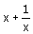 given x=  - 2-$\sqrt{3}$  - 2$\sqrt{3}$  - 4  - None of the above | [1]
 | E and F are respectively the mid-points of equal sides AB and AC of ∆ ABC then AEC angle is equal to  - $∠$ABF  - $∠$ACE  - $∠$AFB  - None of the above | [1]
 | Find the sides of an isosceles right triangle whose area is 50 cm².  - 5 cm  - 10 cm  - 15 cm  - 20 cm | [1]
 | 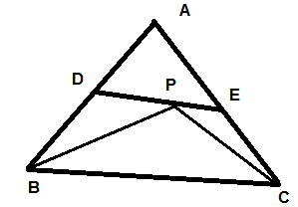  If DE is parallel to BC , BP and CP are the angle bisectors of B and C respectively and BD=a cm and CE= b cm, then DE=  - a-b  - ab  - a+b  - none of these | [1]
 | Express $4.2\overline{34}$ in the form of $\frac{p}{q}$ .  - $\frac{2097}{495}$  - $\frac{4192}{999}$  - $\frac{4294}{990}$  - $\frac{2096}{495}$ | [1]
 | A plane is divided by a horizontal and a vertical line segment into four parts then these are  - equal to one an other  - unequal to one an other  - both (a) and (b)  - None of the above | [1]
 | The decimal form of $\frac{327}{500}$ is  - 0.654  - 0.645  - 0.665  - 0.655 | [1]
 | If PQ || ST, ∠ PQR = 120° and ∠ RST = 110°, the magnitude of ∠ QRS is  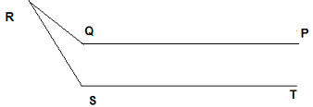  - 20⁰  - 10⁰  - 5⁰  - None of these | [1]
 | ∆ABC is an isosceles triangle in which AB = AC. Side BA is produced to D such that AD = AB . The measure of ∠ BCD is  - 60⁰  - 90⁰  - 120⁰  - Can’t say | [1]
 | 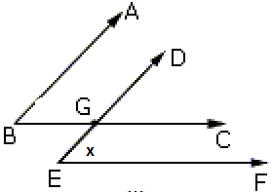  In the above figure, if AB is parallel to ED and BC is parallel EF, and $∠$BGD=135⁰. Find the value of $∠$DEF.  - 135⁰  - 65⁰  - 45⁰  - None of the above | [1]
 | 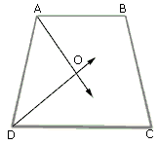  ABCD is a trapezium, AB // CD, if AO and DO are the angle bisectors of A and D respectively, then $∠$AOD is  - 45⁰  - 90⁰  - 135⁰  - None of the above | [1]
 | SECTION-B  Section B consists of 20 questions of 1 mark each. Any 16 questions are to be attempted | [1]
 | The scale that is taken to plot (70, 90)on the graph paper is  - 1 cm = 7 units  - 1 cm = 9 units  - 1cm = 10 units  - None of the above | [1]
 | There is a triangular rose garden of dimensions 65 m, 70 m and 75 m. Find the cost of planting rose in it at the rate of Rs 75 per m².  - Rs.157500  - Rs.150500  - Rs.157000  - Rs.175500 | [1]
 | In the given figure, both BM and DN are equal perpendiculars on the segment AC. Then  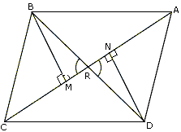  - AC trisect BD  - AC bisects BD  - AC is equal to BD  - None of these | [1]
 | 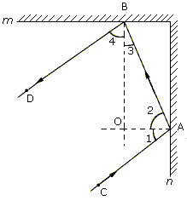  In the above fig. m and n are two mirrors placed perpendicular to each other. If the $∠$CAO is 55⁰, then the measure of $∠$ 4 is  - 55⁰  - 45⁰  - 35⁰  - None of these | [1]
 | An ant travels 5 cm in west direction and then 3 cm in north direction. Taking its starting point as the origin and east direction as positive x-axis, write its position as a co-ordinate on the graph.  - (5,3)  - (-5,3)  - (-5,-3)  - (5,-3) | [1]
 | 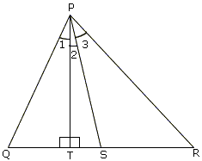  In the figure, PS is the bisector of P and PT QR, the value of TPS is Q= 86⁰ and R=63⁰ then TPS is  - 23⁰  - 46⁰  - 11.5⁰  - None of the above | [1]
 | Find two integers between 3 and 4  - 3.1 and 4.1  - 3.2 and 3.9  - 2.9 and 4.1  - None of the above | [1]
 | If both a and b are rational number, then a and b have  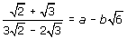  - exactly one pair of values  - infinitely many pair of values  - can’t say  - None of the above | [1]
 | E is the mid point on the side BC of a ABC, such that the perpendiculars from E on the sides AB and AC are equal. Then LAE is equal to  - LEB  - MEC  - MAE  - All of these  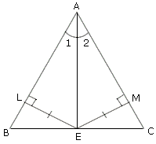 | [1]
 | On dividing the quotient is  - 5+$\sqrt{6}$  - 5-$\sqrt{6}$  - 5$\sqrt{6}$  - $\frac{5}{\sqrt{6}}$ | [1]
 | Drawing room of Mr. Kapur has a triangular floor of dimensions 7 m, 8 m, 9 m respectively. He wants to cover it with marble tiles of size 20 cm 25 cm. How many tiles does he need to purchase?  - 587  - 557  - 337  - 537 | [1]
 | In the given figure, AB > AC and AD is the angle bisector of A. then xº 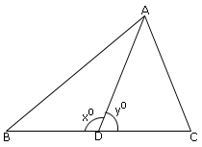  - greater than y⁰  - less than y⁰  - equal to y⁰  - None of these | [1]
 | The true class limits of 16-20, if 21-25, 26-30, 31-35 are the class intervals in the distribution is  - 16.5-20.5  - 15.5 – 20.5  - 16.5 – 21.5  - None of the above | [1]
 | Out of the followings, which one is the example of an inclusive class interval  - 0 -10, 10-20 and so on  - 1 -10, 11-20 and so on  - 0.5 – 10.5, 10.5 – 20.5 so on  - None of the above | [1]
 | If four isosceles right angled triangles of side 5 m are removed from the corners of a rectangular plot 20 m 10 m, then find the area of the remaining portion.  - 160 m²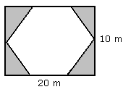  - 1750 m²  - 140 m²  - 150 m² | [1]
 | The class-marks of a continuous and uniform frequency distribution are  6, 10, 14, 18, 22, 26, 30.  the class size of each class interval is  - 4  - 8  - 5  - None of the above | [1]
 | 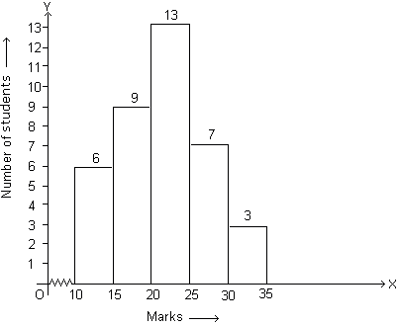  In the above figure the class marks of 20-25 is  - 13  - 12.5  - 9  - 7 | [1]
 | On simplifying 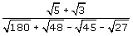, the simplest form is  - $\frac{6+\sqrt{15}}{21}$  - $\frac{15+\sqrt{6}}{21}$  - $\frac{6-\sqrt{15}}{21}$  - None of the above | [1]
 | The coordinates of two points which lie on the opposite sides of the y-axis and equidistant from the Y- axis are  - (-3,4) and (-4,3)  - (-3,4) and (3,4)  - (-3,4) and (4,3)  - (-3,4) and (4,-3) | [1]
 | if one acute angle is double the other, then the length of the hypotenuse is  - twice the length of the smallest side  - thrice the length of the smallest side  - greater than the other two sides  - All of these | [1]
 | SECTION- C  Section C consists of 10 questions based on two Case Studies. Attempt any 4 questions from each Case Studies.  CASE STUDY - I | [1]
 | 100 plants each were planted in 100 schools during Van Mahotsava. After one month, the number of plants that survived were recorded as :  95, 67,28, 32, 65, 65, 69, 33, 98, 96, 76, 42, 32, 38, 42, 40 ,40 ,69 ,95 ,92 ,75 ,83 ,76 ,83, 85, 62, 37 65, 63, 42, 89, 65, 73, 81, 49, 52, 64, 76, 83, 92, 93, 68, 52, 79, 81, 83, 59, 82, 75, 82, 86, 90, 44, 62, 31, 36, 38, 42, 39, 83, 87, 56, 58, 23, 35, 76, 83, 85, 30, 68, 69, 83, 86, 43, 45, 39, 83, 75, 66, 83, 92, 75, 89, 66, 91, 27, 88, 89, 93, 42, 53, 69, 90, 55, 66, 49, 52, 83, 34, 36.  To present such a large amount of data so that a reader can make sense of it easily, we condense it into groups like 20-29, 30-39, . . . , 90-99. | [1]
  Class Interval | Tally marks | Frequency
  20 -29 |  | 3
  30-39 |  | 11
  40-49 |  | 12
  50-59 |  | 8
  60-69 |  | 18
  70-79 |  | 10
  80-89 |  | 23
  90-99 |  | 12
 | The number of school in which maximum number of plants survive is  - 99  - 23  - 80  - None of the above | [1]
 | The number of school in which minimum number of plants survive is  - 29  - 20  - 3  d) None of the above | [1]
 | Group of trees that are survived in equal number of schools are  - 90-99 and 40-49  - 50-59 and 60-69  - 90-99 and 80-89  - None of the above | [1]
 | Number of schools in which 75 trees survived is  - 18  - 10  - 23  - None of the above | [1]
 | Number of schools in which no trees survived is  - 3  - 0  - 12  - None of the above  CASE STUDY - II | [1]
 | 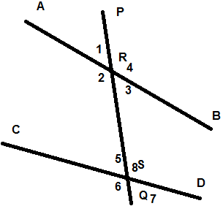
 | In the above figure which two pair of angles are equal  - $<1=<8$  - $<1=<5$  - $<1=<3$  - $<1=<6$ | [1]
 | Sum of which pair of angles is 180⁰  - <2 and <6  - <2 and <3  - <2 and <8  - <2 and <4 | [1]
 | Which of following pair of angles form a pair of corresponding angles  - <1 and <5  - <1 and <6  - <3 and <5  - <3 and <4 | [1]
 | Which of following pair of angles form a pair of alternate exterior angles  - <4 and <5  - <4 and <6  - <4 and <8  - None of the above | [1]
 | Under which of the following condition(s) the two lines AB and CD are parallel is  - <2 =<6  - <1 = <7  - Both (a) and (b)  - None of the above | [1]

