Sample Paper –2013
Sub: Foundation of IT
Class X
Time: 3 Hours Max Marks: 90
Section A
A. Fill in the blanks. 10
1. In Xml the _____________________ element is required to close after all tags.
2. __________________is a program that is downloaded on your computer to harm your data.
3. XML attribute value should always be enclosed in _____________________
4. A ____________________is person who attempts to maliciously hack computer or computer networks.
5. href attribute is used with <A> tag to specify the ____________________of the link.
6. ____________is the extension of an XML file.
7. ______________and _________________are the two types of viruses.
8. An __________________ is required to protect your computer from virus.
9. In HTML to insert a column in a table we use ______________________tag.
10. ___________________is the software that is downloaded on your computer to track your activities
without your knowledge.
B. State True or False. 10
- W3C stands for World Wide Web Consortium.
- <? XML Version=’1.0’?> is correct statement to give the version to the XML program.
- ROWSPAN attribute with <TABLE> tag is used to merge more than one cell row wise.
- Junk mail is that mail which violets the rules made for emails.
- Align and Valign are the attributes used with <TD> tag to set the alignment of data in a table.
- Title is an attribute of the <A> tag.
- XML is not a case sensitive language.
- Xml tags cannot be customized because these are predefined tags.
- An anti-virus can delete or corrupt your data on your computer.
- SRC attribute of the <IMG> tag is used to provide the URL of the Image.
C. Carefully study the webpage given below. Identify 10 tags that have been utilized in creating this webpage and write the usage of each of them. 15

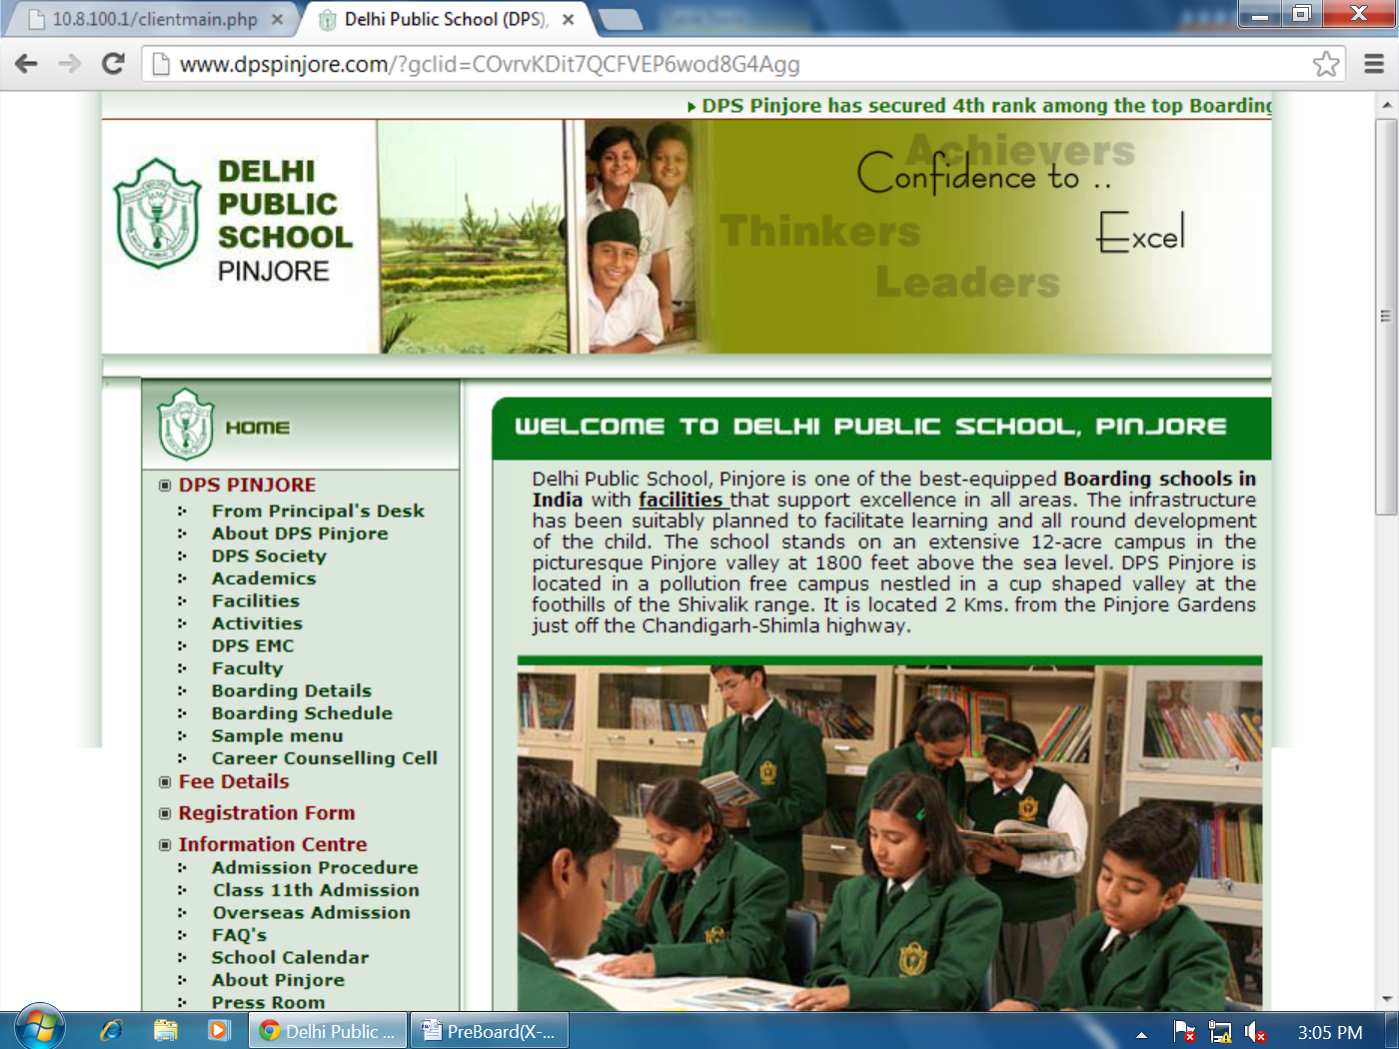

D. Answer the following questions.
D.1 Mr. Vikas is working for an IT firm where he needs to backup his data of around 500 MB at the end of each day. Each day backup needs to be achieved separately for future reference. Suggest any two economic data backup devices, which he can use for this purpose. 2
D.2 Differentiate between worm and virus. 2
D.3 Name one specific software/tool for each of the following category: 5
D.3.1 On-line backup tool
D.3.2 A software that checks syntax of a program written in XML.
D.3.3 Junk e-mails are also called as…………
D.3.4 The HTML tags which have both starting and closing tags are called ……………
D.3.5 A persons who finds the security gap in operating systems
E. Do as Directed.
E.1 Draw the XML tree for code given below. 5
<BOOKS>
<NOVELS>
<THRILLERS>
<AUTHOR>ABC</AUTHOR>
<PRICE>105</PRICE>
</THRILLERS>
<FICTION>
<AUTHOR>XYZ</AUTHOR>
<PRICE>205</PRICE>
</FICTION>
</NOVELS>
</BOOKS>
E.2 Write the HTML code to generate the following output of a table with the content exactly in the same format as shown within the table: 5
My Office Stock
Items | Year 2009 | Current year | Demand | Extras
Computers | 900 | 1000 | 1100 | 20
Stationary | 10000 | 11000 | 18000 | 800
Telephones | 50 | 30 | 35 | 20

F. Write the HTML code to generate the following output. 10.
Professional Careers
(An ISO 9002 Organization)

1. Computer Courses
a. BCA
b. MCA

2. Management Courses
a. BBA

b. MBA

____________________________________________________________________

For Further details contact us : profession_course@gmail.com

Note the following points while generating the webpage.
- Link colour is blue, Active link color is red and visited link color is cyan.
- Title of the page is “Professional Career”.
- Heading of the page is Yellow.
- Image used is “image1.jpg”.
- Caption of the table is Red colored.
- Table border is green and with size 1.
- The links are BCA.html, MCA.html, BBA.html, MBA.html, A.html respectively.
- Background color is “Pink”.

Section B
G. Multiple Choice Questions. 16
1) An XML document has a logical structure and a _________ structure.
a) Physical b) Virtual
c) Imagnary d) Physical or Virtual
2) What should be the first and last pair of tags in your Web document?
a) <html></html> and <body></body> b) <start><end> and <body></body>
c) <head><body> and <title></title> d) <title></title> and <body<>/body>
3) Which property tells how many rows a cell should span?
a) colspan=n b) Both rowspan=n and colspan=n
c) <Merge cell> d) rowspan=n
4) A programmer that break into secure systems for enjoyment is known as
a) Hackers b) Cracker
c) Breaker d) Burglers

5) The full form of the CSS is_____________________
a) Coloured System Software b) Coloured Software System
c) Coloured Style sheet d) Cascading Style Sheet
6) Digital code attached to a message that uniquely identifies the message is called
a) Digital Signature b) Digital certificate
c) Digital Id d) Electronic Id
7) What is the correct syntax in HTML for inserting an image on webpage?
a) <LINK src=”abc.jpg”> b) <IMG SRC= “abc.jpg”>
c) <Picture src=”abc.jpg”> d) <IMG Href=”abc.jpg”>
8) Which of following tag can be used to display the following Formula H₂SO₄?
a) <SUP> b) <SUPSCRIPT>
c) <BASE FORMULA> d) <SUB>
9) Which of the following is an attribute of the <A> Link?
a) SRC b) Name
c) Cell padding d) Bold
10) Which of following devices can store the maximum data?
a) Magnetic Tape b) Hard Disk
c) DVD d) Pen Drive
11) Choose the correct HTML tag for the largest heading:
a) <h6> b) <heading>
c) <head> d) <h1>
12) __________ is a general term used to refer to viruses,worms ,spyware etc.
a) Adware b) Malware
c) Bug d) Anti Virus

13) Which of the following is the correct syntax to include the stylesheet in XML?
a) <?xml style-sheet type= “text/css” href= “abc.css”?>
b) <?xml-stylesheet type= “text/css” href= “abc.css”?>
c) <?xml style-sheet “text/css” href= “abc.css”?>
d) <xml style-sheet type= “text/css” href= “abc.css”>
14) How can you create an e-mail link?
a) <mail href="a@b"> b) <mail>a@b</mail>
c) <a href="a@b"> d) <a href="mailto:a@b.com">

15) What is correct way of describing XML data?
a) XML uses a DTD to describe data b) XML uses a description node to describe data
c) XML uses a XSL to describe data d) XML uses a validator to describe data
16) Which of the following is the correct name for an XML element?
a) <4R_no> b) <R_n>
c) <Roll no> d) <”Rn”>

