Guess Paper – 2013
Class – IX
Subject – Science

Total marks : 90 | Total time: 3:00 Hrs
Test instructions: General Instructions:
i) The question paper comprises of two sections, A (Question No. 1 to 24)and B (Question No. 25 to 42), you are to attempt both the sections.
ii) All questions are compulsory.
iii) There is no overall choice. However, internal choice has been provided in all the five questions of five marks category. Only one option in such questions is to be attempted.
iv) All questions of section A and all questions of section B are to be attempted separately.
v) Question numbers1 to 3 in section A are one mark question. These are to be answered in one word or one sentence.
vi) Questions numbers 4 to 7 are two marks questions, to be answered in about 30 words.
vii) Question numbers 8 to 19 are three marks questions, to be answered in about 50 words.
viii) Question numbers 20 to 24 are five marks questions, to be answered in about 70 marks.
ix) Question numbers 25 to 42 in section B are multiple choice questions are based on practical skills. Each question is a one mark question. You are to choose one most appropriate response out of the four provided to you.

Questions:

1] | Give one example where kinetic energy is transferred from one object to other.
2] | What are polyatomic ions?
3] | What are the different states in which water is found during the water cycle?
4] | Flash and thunder are produced simultaneously. But thunder is heard a few seconds after the flash is seen, why? How does the speed of sound in air vary with rise in density of the medium?
5] | (a) Name any two green house gases.  (b) What causes global warming?
6] | Give two examples where oxygen is not playing any role in supporting life.
7] | Write two points of difference between gymnosperms and angiosperms.
8] | (a) Draw a diagram depicting low pitched sound and high pitched sound.  (b) When a person uses deodorant spray, the other person standing at a distance would hear the sound of spraying first and the fragrance of spray would reach him later. Why so?
9] | (a) How do you define mechanical work?  (b) Name and define SI unit of work?  What do you mean by positive and negative work? Give example.
10] | Explain the working and application of a SONAR.
11] | Define work. What are the conditions on a force for doing work on an object?
12] | State three conditions necessary for hearing sound.
13] | State any three postulates of Dalton's atomic theory.
14] | Calculate the number of molecules of sulphur present in 16 g of solid sulphur.
15] | (a) If an element M has mass number 27 and atomic number 13, how many protons and neutrons does its atom contain?  (b) Write the electronic configuration of an atom with atomic number 6.
16] | Give two examples of each of the following:  (a) Diseases which spread through air.  (b) Diseases which spread through water.  (c) Diseases which spread through insect.
17] | What precautions can you take in your school to reduce the incidence of infectious diseases? Mention any three points.
18] | (a) List any two benefits of classification.  (b) Why bryophytes and pteridophytes grow in moist and shady places?
19] | Explain, how HIV-AIDS virus affects and damages our body? What is an antibiotic?
20] | 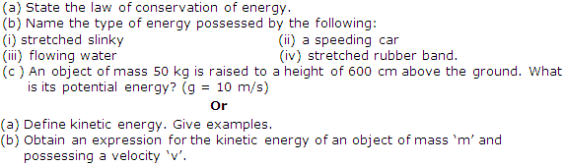
21] | 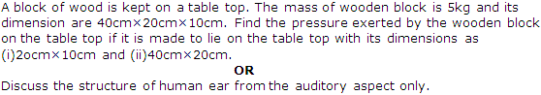
22] | (a) Chlorine occurs in nature in two isotopic forms with masses 35 u and 37 u in the ratio of 3:1. Calculate the average atomic mass of chlorine atom on the basis of this data.  (b) Give any three uses of three isotopes.  OR  (a) Write three points of difference between isotopes and isobars.  (b) Describe Bohr's model of the atom?
23] | (a) Describe with diagram the oxygen cycle operating in nature.  (b) How depletion of ozone layer takes place?  Or  (a) Define the following terms:  (i) Ammonification  (ii) Nitrification  (iii) Denitrification  (b) State any two applications of green house effect.
24] | (a) Define the following terms:  (i) Lichens  (ii) Cryptogamae  (iii) Phanerogams  (b) Why whales are not grouped in the fishes?  (c) What is bilateral symmetry?  Or  (a) Give reasons for the following:  (i) Bryophytes are called amphibians of plant kingdom.  (ii) From Phylum Platyhelminthes onwards, animals are categorized as 'triploblastic'.  (iii) The presence of 'coelom' in an animal's body is considered as advantageous.  (b) What are oviparous animals?  (c) Name the phylum in which pharyngeal gill slits are present.
25] | Reverberation produced in large auditoriums is due to:
A. | Reflection of sound by windows.
B. | Absorption of sound by walls.
C. | Absorption of sound by floor.
D. | Reflection of sound by walls and ceiling.

26] | The least count of a spring balance is 1 g wt. When it is suspended freely without any weight attached to the hook, the pointer is just in front of second small division on the scale. The zero error is
A. | -2 g wt
B. | Zero
C. | +1 g wt
D. | +2 g wt

27] | A student noted down the following observations in his note book:  (i) Weight of the stone in air = 272 g wt  (ii) Weight of the stone in water = 192 g wt  (iii) Weight of the stone in salty water = 176 g wt  The relative density of the salty water must be
A. | 11/12
B. | 11/17
C. | 13/17
D. | 6/5

28] | A student lowers a body in a liquid filled in a container. He finds that there is a maximum apparent loss in weight of the body when
A. | It just touches the surface of the liquid.
B. | It is partially immersed in the liquid.
C. | It is partially immersed and also touches the sides of the container.
D. | It is completely immersed in the liquid.

29] | An object exerts a force F on a surface of surface area A. The pressure P acting on the surface is given by
A. | P = A/F
B. | P = FA
C. | P = F/A₂
D. | P = F/A

30] | In the experiment of verification of reflection of sound, the incident sound is directed along
A. | Normal to the axis of the tube.
B. | At an angle of 30 from the axis of the tube.
C. | At an angle of 45 from the axis of the tube.
D. | Axis of tube.

31] | A student while verifying laws of reflection of sound measured the angle between the incident sound wave and reflected sound wave as 110º. The angle of reflection is
A. | 27
B. | 110
C. | 55

32] | On which of the following factors does the speed of propagation of a pulse in a slinky not depend upon?
A. | Dimensions of slinky
B. | Material of slinky
C. | Room temperature
D. | Length of the slinky

33] | Who stated the Law of conservation of mass?
A. | Dalton
B. | Cavendish
C. | Thomson
D. | Lavoisier

34] | According to Law of conservation of mass of reactants wil be equal to the mass of:
A. | Catalysts
B. | Heat released
C. | Heat absorbed
D. | Products

35] | Skin is kept moist in earthworms. It helps in
A. | Locomotion
B. | Protection
C. | Both (a) and (b)
D. | Respiration

36] | 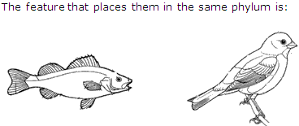
A. | Pointed head
B. | Bulky thorax
C. | Presence of scales
D. | post anal tail

37] | 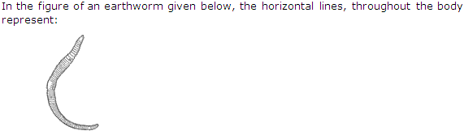
A. | Cells of the body.
B. | Cell walls separating the cells of the body.
C. | Vertically arranged muscles of the body.
D. | Septa separating segments of the body.

38] | 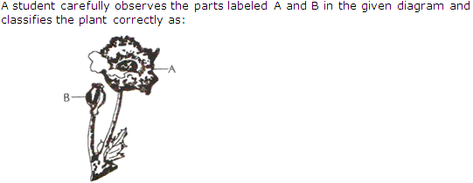
A. | A bryophyte
B. | A pteridophyte
C. | A gymnosperm
D. | An angiosperm

39] | Rajiv found out the role of spiracle in a cockroach as:
A. | Excretion
B. | Circulation
C. | Movement
D. | Respiration

40] | 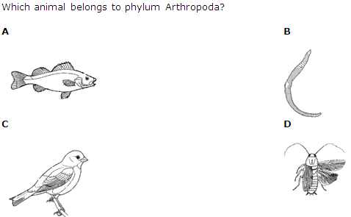
A. | A
B. | B
C. | C
D. | D

41] | A specimen of a fish was given to students to identify the externally visible chordate feature in it. The student would look for:
A. | Operculum
B. | notochord
C. | Dorsal tubular nerve cord
D. | post anal tail

42] | The sub division of Spirogyra is:
A. | Fungi
B. | Bryophyta
C. | Pteridophyta
D. | Algae


APEX INSTITUTE FOR IIT-JEE /AIEEE / DCE, 0120-4901457, +919990495952, +919910817866 www.apexiit.co.in/

