Computer Science
CLASSXII

Time: 3 Hrs. M.M. 70

General instructions:
- All questions are compulsory
- Read all questions carefully
- Programming Language: C++.

Q.1 (a) What is the difference between Object Oriented Programming and Procedural programming? [2]
(b) Write the names of the headers files to which the following belong: [1]
(i) frexp ( ) (ii) isalnum ( )
(c) Rewrite the following program after removing the syntactical errors(if any). Underline each correction. [2]
struct Pixels
{
int Color, Style; }
void ShowPoint (Pixels P)
{
cout <<P.Color , P.Style<< endl;
}
void main ( )
{
Pixels Point1 = (5, 3);
ShowPoint (Point1);
Pixels Point2 = point1;
Color.Point1+ = 2;
ShowPoint(Point2);
}
(d) Find the output of the following program: [3]
#include <iostream.h>
void ChangetheContent(int Arr[ ], int Count)
{
for (int C =0; C < Count ; C++)
Arr [C – 1]+ = Arr [C];
}
void main( )
{
int A[ ] = {3,4,5} , B[ ] = {10 , 20, 30, 40 } , C [ ] = {900, 1200};
ChangetheContent(A,3);
ChangetheContent(B,4);
ChangetheContent(C,2);
for(int L = 0; L < 3; L ++) cout <<A[L]<< ‘#’;
cout <<endl;
for( L =0 ; L <3; L++) cout <<B[L] <<’#’;
cout<<endl;
for(L=0;L<3; L++) cout <<C[L] <<’#’;
}
(e) Find the output of the following program: [2]
#include <iostream.h>
struct Game
{
char Magic [20], int Score;
};
void main ( )
{
Game M = {“Tiger”, 500};
char *Choice;
Choice = M.Magic;
Choice[4] = ‘P’;
Choice[2] = ‘L’;
M.Score+ = 50;
cout <<M.Magic <<M.Score <<endl;
Game N = M;
N.Magic[0] = ‘A’; N.Magic[3] =’J’;
N.Score - = 120;
Cout <<N.Magic <<N.Score <<endl;

getch ( );
}
(f) In the following program, if the value of N given by the user is 20, what maximum and minimum values the program could possibly display? [2]
#include <iostream.h>
#include <stdlib.h>
void main( )
{
int N, Guessnum;
randomize ();
cin >>N;
Guessnum = random (N-10 ) + 10;
cout << Guessnum <<endl;
}
Q.2(a) What do you understand by inheritance? Give a suitable example of the same.[2]
(b) Answer the questions(i) anmd (ii) after going through the following program:[2]
class Match
{
int Time;
public:
Match( ) //Function 1
{
Time = 0;
cout << “Match commences” <<endl;
}
void Details( ) //Function 2
{
cout << “Inter Section Baketball Match”<< endl;
}
Match (int Duration ) //Function 3
{
Time = Duration;
cout <<”Another Match begins now”<< endl;
}
Match (Match &M) //Function 4
{
Time = M.Duration;
cout <<”Like Previous Match” <<endl;
}
};
- Which category of constructor – Function 4 belongs to what is the purpose of using it?
- Write statements that would call the member Function1 and 3?
(c) Declare a class COMPANY with the following members: [4]
Data members:
(i) Name of the owner. (ii) Telephone number.
(iii) Address of the company (iv) Residence address (v) Number of Employee.
Member functions:
- input_data ( )
- output_data( )
Declare an array of COMPANY to store the information for 50 company. Use the array in main ( ) to read and display information.
(d) Consider the following declarations and answer the questions given below: [4]
class Animal
{
int leg:
protected:
int tail;
public:
void INPUT (int );
void OUT ( );
};
class wild : private Animal
{
int Non_veg;
protected:
int teeth;
Public:
void INDATA (int, int )
void OUTDATA( );
};
class pet : public Animal
{
int veg;
public:
void DISP (void);
};
- Name the base class and derived class of the class wild.
- Name the data member(s) that can be accessed from function DISP ( ).
- Name the member function(s), which can be accessed from the objects of class pet.
- Is the member function OUT( ) accessible by the objects of the class wild?
Q.3(a) Assume an array A[20][15], if the base address of the array is 1000, calculate the address of the location where the 4th element of the array is stored. Find out the problem for column-major order and row major order of storage. Assume that each element needs 4 bytes of storage. [4]
(b) Write a function in C++ to INSERT operation in a dynamically allocated stack considering the following description: [4]
struct Node
{
float U,V;
Node *Link;
};
class QUEUE
{
Node *Rear, *Front;
public:
QUEUE ( ) {Rear=NULL ; Front = NULL ; }
void INSERT ( );
void DELETE ( );
~QUEUE ( );
};
(c) Use a stack to evaluate the following postfix expression and show the content of the stack after execution of each operation. Don’t write any code. Assume as if you are using push and pop member functions of the stack. [2]
AB – CD + E*+ (Where A = 5, B = 3, C = 5, D = 4 and E = 2)
(d) Write a function in C++ to find and display the sum of each row and each column of a 2 dimensional array of type float. Use the array and its size as parameters with float as its return type. [3]
(e) Write a function selection_sort to sort the passed array of 10 integers in descending order using selection sort. [3]

Q.4(a) Observe the program segment given below carefully and fill the blanks marked as Statement1 and Statement2 using seekp( ) and seekg( ) functions for performing the required task. [1]
#include <fstream.h>
class Item
{
int Imno; char Item[20];
public:
//Function to search and display the content from a particular record number
void Search (int) ;
//Function to modify the content of a particular record number
void Modify(int);
};
void Item :: Search (int RecNo)
{
fstream File;
File.Open(“STOCK.DAT” , ios :: binary | ios :: in);
__________________________ //Statement 1
File.read((char*)this , sizeof(Item));
Cout <<Ino <<” = = >” << Item << endl;
File.close ( );
}
void Item :: Modify (int RecNo)
{
fstream File;
File.open (“STOCK.DAT”, ios ::binary | ios :: in | ios :: out);
cin>> Ino;
cin.getline(Itm,20 );
_________________________ //Statement 2
File.write ((char*) this sizeof(Item ));
File.close ( );
}
(b) Write a function in C++ to count the number of lines present in a text file [2]
“STORY.TXT”.
(c) Write a function in C++ to search for BookNo from a binary file “BOOK.DAT”, assuming the binary file is contained the objects of the following class: [3]
class BOOK
{
int Bno; char Title [20];
public :
int Rbno ( ) { return Bno; }
void Enter ( ) { cin >> Bno; gets (Title); }
void Display ( ) { cout << Bno <<Title <<endl; }
};

Q.5(a) What do you understand by the term Primary Key and Degree of a relation in relational database? [2]
(b) Consider the following tables EMPSALARY. Write SQL commands for the statements (i) to (iv) and give outputs for SQL queries (v) to (viii). [6]

EMPLOYEES
EMPID | FIRSTNAME | LASTNAME | ADDRESS | CITY
010 | George | Smith | 83 First Street | Howard
105 | Mary | Jones | 842 Vine Ave. | Losantville
152 | Sam | Tones | 33 Elm St. | Paris
215 | Sarah | Ackerman | 440 U.S. 110 | Upton
244 | Manila | Sengupta | 24 Friends Street | New Delhi
300 | Rabert | Samuel | 9 Fifth Cross | Washington
335 | Henry | Williams | 12 Moore Street | Boston
400 | Rachel | Lee | 12 Harrson St. | New York
441 | Peter | Thompson | 11 Red Road | Paris

EMPSALARY
EMPID | SALARY | BENEFITS | DESIGNATION
010 | 75000 | 15000 | Manager
105 | 65000 | 15000 | Manager
152 | 80000 | 25000 | Director
215 | 75000 | 12500 | Manager
244 | 50000 | 12000 | Clerk
300 | 45000 | 10000 | Clerk
335 | 40000 | 10000 | Clerk
400 | 32000 | 7500 | Salesman
441 | 28000 | 7500 | Salesman

(i) To display Firstname, Lastname, Address and City of all employees living in Paris from the table EMPLOYEES.
(ii) To display the contents of EMPLOYEES table in descending order of FIRSTNAME.
(iii) To display the Firstname, Lastname, and Total Salary of all Managers from the tables EMPLOYEES and EMPSALARY, where Total Salary is calculated as Salary + Benefits.
(iv) To display the Maximum salary among Managers and Clerks from the table EMPSALARY.
(v) SELECT FIRSTNAME, SALARY FROM EMPLOYEES, EMPSALARY
WHERE DESIGNATION = ‘Salesman’ AND EMPLOYEES.EMPID = EMPSALARY.EMPID;
(vi) SELECT COUNT (DISTINCT DESIGNATION FROM EMPSALARY;
(vii) SELECT DESIGNATION, SUM (SALARY) FORM EMPSALARY
GROUP BY DESIGNATION HAVING COUNT (*) >2;
(viii) SELECT SUM (BENEFITS) FROM EMPLOYEES WHERE DESIGNATION = ‘Clerk’ ;

Q.6(a) State and verify Associative law in Boolean Algebra. [2]
(b) Write the equivalent expression for the following Logic Circuit: [2]
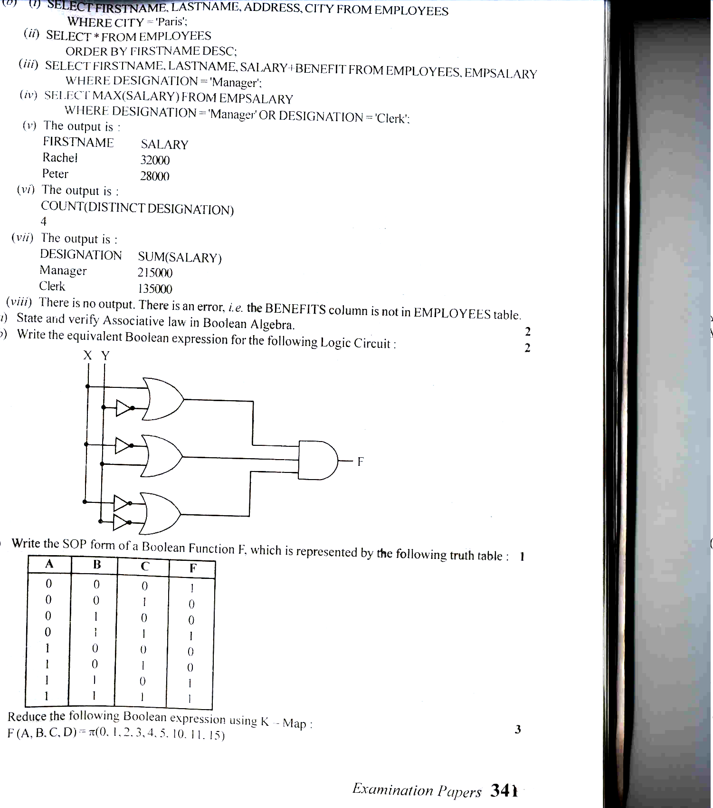
(c) Write the SOP form of a Boolean Function F, which is represented by the following truth truth table: [1]
A | B | C | F
0  0  0  0  1  1  1  1 | 0  0  1  1  0  0  1  1 | 0  1  0  1  0  1  0  1 | 1  0  0  1  0  0  1  1

(d) Reduce the following Boolean expression using K- Map:
F (A,B,C,D) = (0,1,2,3,4,5,10,11,15) [3]
Q.7(a) What is the significance of ARPANET in the network? [1]
(b) Expand the following terminologies: [1]
(i) CDMA (ii) GSM
(c) Give two major reasons to have network security. [1]
(d) Describe MOSAIC. [1]
(e) Ravya Industries has set if its new center at Kaka Nagar for its office and web based activities. The company compound has 4 buildings as shown in the diagram below:

Raj
Building
Fazz
Building

Jazz
Building
Harsh
Building

Center to center distances between various buildings is as follows:

Harsh Building to Raj Building | 50 m
Raj Building to Fazz Building | 60 m
Fazz Building to Jazz Building | 25 m
Jazz Building to Harsh Building | 170 m
Harsh Building to Fazz Building | 125 m
Raj Building to Jazz Building | 90 m

Number of Computers in each of the building is follows:

Harsh Building | 15
Raj Building | 150
Fazz Building | 15
Jazz Building | 25

(e1) Suggest a cable layout of connections between the buildings. [1]
(e2) Suggest the most suitable place (i.e., building) to house the server of this organization with a suitable reason. [1]
(e3) Suggest the placement of the following devices with justification: [1]
- Internet Connecting Device /Modem
- Switch
(e4) The organization is planning to link its sale counter suitable in various parts of the same city. Which type of network out of LAN, MAN or WAN will be formed? Justify your answer. [1]

*******************************

