Sample Paper – 2008
Class – XII
Subject - Mathematics
Time : 3 Hours Max. Marks : 100
General Instructions
1. All questions are compulsory.
2. The question paper consists of 29 questions divided into three sections A,B and C.
Section A comprises of 10 questions of one mark each, section B comprises of 12
questions of four marks each and section C comprises of 07 questions of six marks each.
3. All questions in Section A are to be answered in one word, one sentence or as per the exact
requirement of the question.
4. There is no overall choice. However, internal choice has been provided in 4 questions of four
marks each and 2 questions of six marks each. You have to attempt only one of the alternatives
in all such questions.
5. Use of calculators is not permitted. You may ask for logarithmic tables, if required.
SECTION - A
1. Find the domain of the function e^{3logx}.
2. Find a branch of the function cos⁻¹ other than the principal value branch.
3. If A is a 3x3 matrix such that |A|=5 then what is |adjA| ?
4. What is the minimum value of | sin4x + 3| ?
5. Write square matrices A and B of order 2 such that AB=0, A≠0 and B≠0.
6. If and are any two vectors such that |.| = |x| then what is the angle between
and ?
7. If the lines 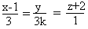 and 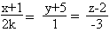 are perpendicular then find the value of k.
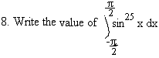
9. If and are unit vectors such that |+| =1 then what is |-|?
10. If A is a square matrix of order 3 such that |A| = 4 then find A(adjA).

SECTION_- B
11.Solve for x:
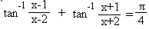
Or
Simplify:
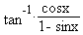
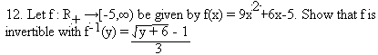
13. Using properties of determinants, prove that

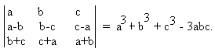

OR
Using elementary transformations find the inverse of

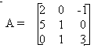
14. Find the values of a and b such that the function defined

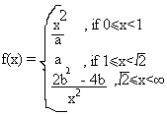
.
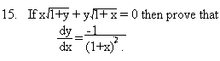
OR
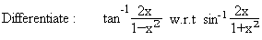
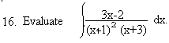
17. Using differentials, find the approximate value of (255)^{1/4} upto four places of decimals.

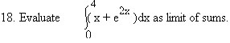
19. Find the shortest distance between the lines
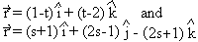
20. Using properties of definite integrals, evaluate
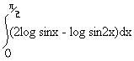
21. Using vectors find the area of the triangle whose vertices are A(1,1,2), B(2,3,5) and C(1,5,5).
22. The probability that a bomb dropped from a plane will strike the target is 1/5. If six bombs are
dropped, find probability that (i) exactly two will strike the target.
(ii) atleast two will strike the target.
OR
In a test, an examinee either guesses or copies or knows the answer to a multiple choice question
with four choices. The probability that he makes a guess is 1/3 and the probability that he copies
the answer is 1/6. The probability that his answer is correct given that he copied it is 1/8. Find
the probability that he knows the answer to the question, given that he correctly answered it.

SECTION-C
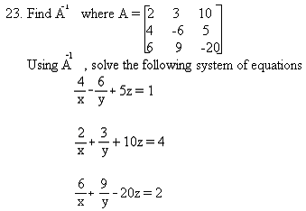
24. Find the local maxima and local minima of sin⁴x + cos⁴x, 0<x<л/2.
OR
Show that the semi vertical angle of right circular cone of given surface area and maximum
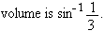
25. Solve the initial value problem :
(x + y)dy + (x – y)dx = 0 , y = 1 when x = 1.
26. Sketch the graph of the region
{(x,y) :0≤y≤x²+3 ;0≤y≤2x+3 ; 0≤x≤3}
Also find the area of the region using integration.
27. Let the number of times a candidate applies for a job be X and P(X=x)denotes the probability
that he will be selected x times. Given that

(k+1)x ,if x = 0
P(X=x) = 2kx ,if x=1 or 2
k(6-x),if x = 3 or 4 or 5

where k is a +ve real number.
- Find the value of k.
- What is the probability that he will be selected exactly three times.
- What is the probability that he will be selected atleast once.
- Find the mean and variance of the probability distribution of X.
OR
In a hostel 60% of the students read Hindi newspaper, 10% read English newspaper and 20%
read both. A student is selected at random..
- Find the probability that she reads neither Hindi nor English newspapers.
- If she reads Hindi newspaper, find the probability that she reads English newspaper.
- If she reads English newspaper, find the probability that she reads Hindi newspaper.
28. Find the vector equation of the line passing through the point (1,2,-4) and perpendicular
to the two lines
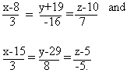
29. A diet for a sick person must contain atleast 4000 units of vitamins, 50 units of minerals
and 1400 units of calories. Two foods A and B are available at a cost of Rs4 and Rs3
per unit, respectively. If one unit of A contains 200 units of vitamin, 1 unit of mineral and
40 units of calories, one unit of B contains 100 units of vitamin, 2 units of minerals and
40 units of calories, find what combination of foods should be used to have the least cost?

