Class XII – Information Practices

- Answer the following question briefly (2*5)

    - Define SDLC?
    - What is data mining?
  - Provide four application area of Database?
  - What is UML? What are its various types?
  - What is Data Dictionary? What purpose does it solve?
  - What is testing? Can we consider software complete without testing? Why?

- Answer the following questions about Visual Basic in brief. (2*5)
  - What is a focus? What is the purpose of tab index property for a control?
  - What are dynamic arrays? How are they declared? What is the advantage of using dynamic arrays over static arrays?
  - Is it possible to display a picture in a command Button? How?
  - What is the difference between date and date$ functions?
  - What is the advantage of using data environment for data connectivity over ADODB and ADODC methods?]

- Answer the following questions about Oracle in brief
  - What are bind variables? What purpose do they solve? (2)
  - Why does oracle provide Varchar2 data type even when it has a char data type? (2)
  - Describe FOR Loop for oracle. What are its advantages? (2)
  - Create an Oracle function, which takes the unit price and qty and returns the total bill amount. (4)

- Answer the following question about Visual basic
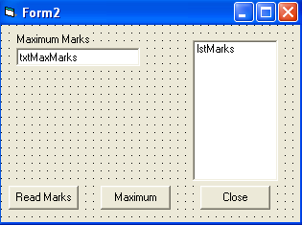
  - Create a dynamic array arrmarks. When the form loads total number of students is inputted through the input box. The arrmarks is re-declared with the size of array equal to the no of student. (2)
  - Create an event procedure, for the load event of cmdReadMarks. It read marks for the student and places them in the array and then transfers them into list box. (4)
  - Create a function maxMarks, which calculate the maximum marks obtained and is called on click event of cmdMaxMarks. The result is stored in txtMaxMarks. (4)

- Consider the form given below and write the code for:
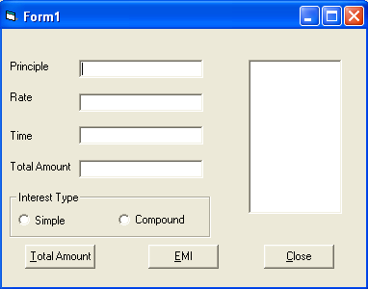
  - The default value of txtPrinciple, txtRate, txtTime should be set to 0, when the form is loaded. (1)
  - Create a function, which returns the Total amount based on the following formula:
If optSI is checked Total Amount= Principle+(Principal * Rate *Time)/100
If optic is checked Total Amount = Principle(1+Rate/100)^{Time} (4)
  - Call the function on click event of cmdCaluulate and stores the value in txtTotalAmount text box. (1)
  - Write a procedure, which fills lstEMI with EMI as many times as the number of months. Where EMI= Total Amount (4)
Time
- Consider the following Table:Score
Grade Char Primary key
MinMarks Number >0, <100
MaxMarks Number >0, <100
  - Create the above table with the given constraints. (2)
  - Create a function MinScore which takes a grade as parameter and returns the corresponding MinMarks. (2)
  - Create a function MaxScore which takes a grade as parameter and returns the corresponding MaxMarks. (2)
  - Create a procedure, which takes one parameter per column for the above table. It insert the parameter values in the table, if they satisfy the following conditions:
    - MinMarks> 0 and <100
    - MaxMarks> 0 and <100
    - MinMarks<MaxMarks (4)

- Consider the following table Rooms:
RoomNo Number 3 Primary Key
Category varchar2
Status varchar2
  - Create a PL/SQL statement, which takes a category as parameter and display the details of all similar rooms. (4)
  - Create a function, which takes RoomNo as parameter and return the status of that room. (4)
  - Create a trigger that stops the user form updating the roomno field. (2)

