Series RBG Set . A
CHEMISTRY
CLASS XII (Theory)

Time allotted: 3hours Maximum Marks: 70

General Instructions :-

- All questions are compulsory.
- Question number 1 to 5 are very short answer questions, carrying 1 mark each. Answer these in one word or about one sentence each.
- Question number 6 to 12 are short answer questions, carrying 2 mark each.
Answer these in about 30 words each.
- Question number 13 to 24 are short answer questions, carrying 3 mark each. Answer these in about 40 words each
- Question number 25 to 27 are long answer questions, carrying 5 mark each.
Answer these in about 70 words each.
- Use Log Table, if necessary. Use of calculator is not permitted.

1
- Write the unit of rate constant for n^{th} order reaction?
1
- How many effective sodium ions are located at the centre of edge of unit cell in NaCl crystal.
1
- Write the IUPAC name of CO-CH₃

CH₃
1
- If the pressure applied to the solution is larger than osmotic pressure the direction of osmosis can be reversed. Give an example where this process is used
- Complete the following reaction
1
3 CH₃-CHO ^{H+ 298K}
- Name the chief ore of tin. Write the steps involving the extraction of tin from its ore?
2
2
- In which forms amino acids show amphoteric behaviour. Define it?
2
- Define vulcanization of rubber? How vulcanization changes the character of natural rubber? OR What PHBV stands for. Give an example where PHBV is used as biodegradable polymer?
2
- Two particles A and B are in motion. If wavelength associated with particle A is 5x10-8 cm. Calculate the wavelength associated with particle B. If the momentum is half of A?
- Identify A,B,C & D in the following reaction OH
Conc. HNO₃ Br₂ in CS₂
A
B
2
273 K
(CH₃CO)₂

AlCl₃
D
C
2
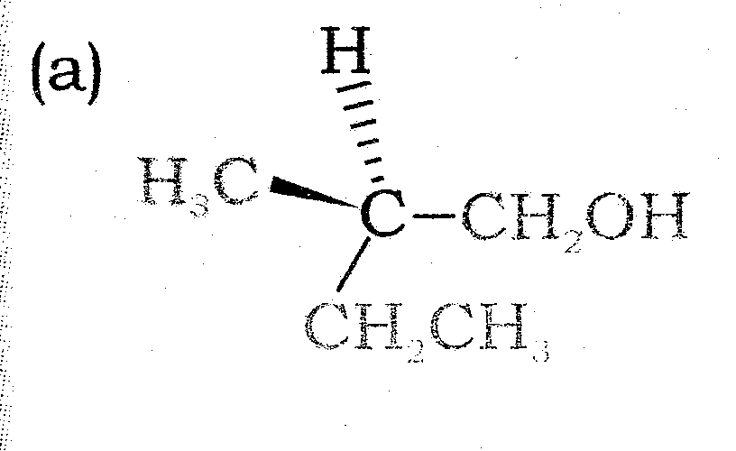
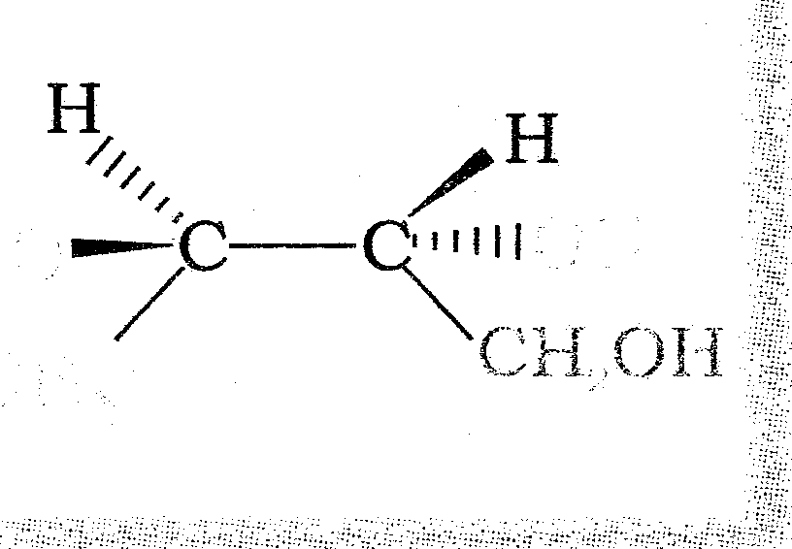
- Draw Fischer projection formulae for the following. A B
2
- Derive an expression ∆G _{system} = - T∆S _{total}
3
- State group displacement law. Calculate how many α & β particles are emitted in decay series of ²³⁸ U₉₂ to ²⁰⁶ Pb₈₂ .
3
- Distinguish between the following pairs of compounds. A. Benzaldehyde and acetaldehyde B. Acetophenon and benzophenon C. Benzaldehyde and Acetophenon
3
- Calculate the efficiency in packing in body centred cubic crystal structure by taking suitable example?
OR
Silver crystallize in fcc lattice. Its edge length of the cell is 4.077 x 10⁻⁸cm and density is 10.5 g cm⁻³ Calculate the atomic mass of silver?
- a) Give the IUPAC name of [PtCl (NH₂ CH₃)₅ (NH₃)₂]CL
3
- Write the name of linkage isomer of [Co (ONO) (NH3)5]²⁺
- Though CO is a weak Lewis base yet it forms a number of stable metal carbonyls. Explain
3
- The following results have been obtained during the kinetic studies of the reaction:
2A + B C + D
Experiment [A]/M [B]/M Initial rate of formation of D/M min⁻¹
I 0.1 0.1 6.0 x 10⁻³
II 0.3 0.2 7.2 x 10⁻²
III 0.3 0.4 2.88 x 10⁻¹
IV 0.4 0.1 2.40 x 10⁻²
Determine the rate of law and the rate constant for the reaction.
3
- Define the term
(a) Anti microbial
(b) Anti fertility drug
(c) Anti acid
3
- Find out whether it is possible to reduce MgO using carbon at 298 K. If not at what temperature it becomes spontaneous for the reaction
MgO_{(s)} + C_{(s)} Mg_{(s)} + CO_{(g)}
∆_{r}H⁰ = +491.18 kJ mol⁻¹ and ∆_{r}S⁰ = +197.67 JK⁻¹ mol⁻¹
3
- A organic compound A having molecular formula C₂H₂NO₂ on reduction with Fe/HCl gave another compound ‘B’ Compound ‘B’ on treatment with nitrous acid gave ethyl alcohol. However, when treated with CHCl3 / KOH it gave an offensive odour compound ‘C’ Identify ‘A’ ‘B’ & ‘C’
3
- The Henry law constant for oxygen dissolved in water is 4.34 x 10⁴ atm at 25⁰C. If the partial pressure of oxygen in air is 0.2 atm. Under ordinary atmospheric conditions. Calculate the concentration (in moles per liter) of dissolved oxygen in water in equilibrium with air at 25⁰C.
3
- Name different types at RNA found in the cell. State one function of each.
3
- Explain
  - Why bond order in H₂ is less than that of H₂
  - Why He₂ does not exist?
  - Mg is an excellent conductor. Why?
- Explain the term with suitable example.
3
  - Gel
  - Aerosol
  - Hydrosol
5
- Account for the following.
a) Sulphur in vapours state exhibit Para magnetism.
b) Fluorine is strongest oxidant among all halogen.
c) Among all the noble gases only xenon is known to form true chemical compound
d) PbO₂ is strongest oxidizing agent than SnO₂.
e) All the bonds in PCl₅ are not equivalent.
OR
(i) It is most important worldwide industrial chemical also known as King of chemical Identify it and explain its process of manufacture.
(ii) Draw the structure of
- Orthophosphoric acid
- Phosphonic acid
- Calculate the emf and ∆G of cell reaction for the following cell at 25⁰C.
5
Mg _{(s)} Mg²⁺(0.001M) Cu²⁺ (0.0001M) Cu _{(s)}
E⁰ value: Mg²⁺/ Mg = -2.37 V ; Cu²⁺/ Cu = + 0.34 V and F= 96500 Cmol⁻¹
How molar conductivity for CH3COOH and KCl vary with the dilution Explain?
OR
The conductivity of 0.001028 M acetic acid is 4.95 x 10⁻⁵ Scm⁻¹. Calculate its dissociation constant, if ٨^{о} for acetic acid is 390.5 Scm-1mol⁻¹. Define corrosion and explain mechanism of corrosion in iron?
5
- (i) Deduce proper reason.
- Transition elements exhibit higher enthalpy of atomization?
- Compounds of Sc³⁺ are colorless?
- Tungsten is used as filament?
(ii) Draw the structure of
- Dithiosulphatoargentate (I) ion.
- Dicromate ion
OR
Account for the following.
a) Name one volatile metal
- What is the copper matte?
- In nessler’s reagent which complex ion is present.
- Name the element which shows +7 oxidation state.
- Name a catylyst used in catalytic hydrogenation

