Subject Code: 067 No of Pages: 4
Sample Paper - 1
Term - I ₂₀₁₆₋₁₇
Class - XI
Multimedia and Web Technology

M.M. : 70 Time: 3 Hours

- Please check that this question paper contains 4 printed pages.
- Please check that this question paper contains 2 questions.
- Please write down the Serial Number of the question before attempting it.
- 15 minutes time has been allotted to read this question paper and will not write any answer on the answer script during this period.

- Answer the following questions based on Computer System:

  - Which of the following is not hardware : [1]
(a) Hard Disk (b) Printer (c) Keyboard (d) CPU (e) Assembler (f) Program to print table of 2
  - Write the full forms of the following terms : [9]
UPS, VDU, MICR, OMR, LCD, OCR, DVD, CPU, EPROM
  - Out of the following devices, write whether they are input devices, output devices or storage devices. Also write their function. [6]

- Light Pen
- Drum Printer
- Pen Drive
- Joystick
- Hard Disk
- Speaker

  - Write Short Notes on Following: [14]

      - System Software
      - UPS
      - CPU
      - Symbian
      - Compiler
      - Android
      - Control Unit

Answer the following questions based on Web Page Development:

  - Write Short Notes on following tags with a Suitable Example. [20]
[Specify all the attributes]

      - <HR>
      - <A>
      - <Frameset>
      - <Table>
      - <Textarea>
      - <IMG>
      - <Input>
      - <DL>
      - <P>
      - <Body>

  - Write the HTML code to generate a Web Page in the format given below : [8]
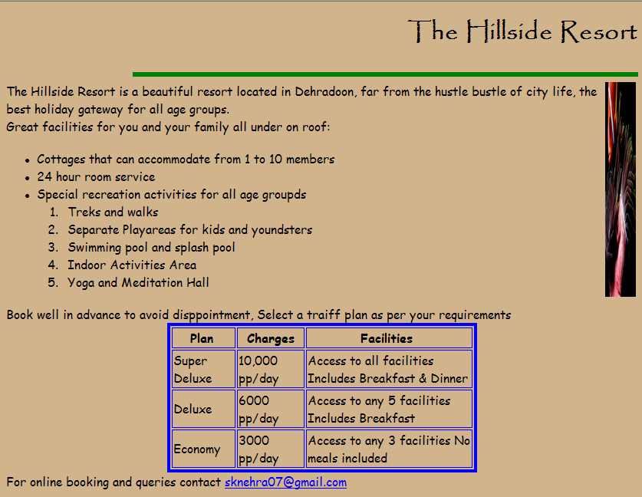
Consider the following points while writing the HTML code:
      - Title of the web page is Hillside Resort.
      - The Background colour of the web page is green.
      - Text style of main heading is Papyrus and that of the rest of the page is Comic Sans MS.
      - The image used is flower.jpg
      - The line is green in colour and 6 pixels thick.
      - The table has a blue colored border that is 4 pixels thick.
      - Use the concept of nested lists for creating the given list.
      - The link at the bottom is an e-mail link to the address “sknehra07@gmail.com”.

  - Write the HTML code to generate a Web Page in the format given below : [8]
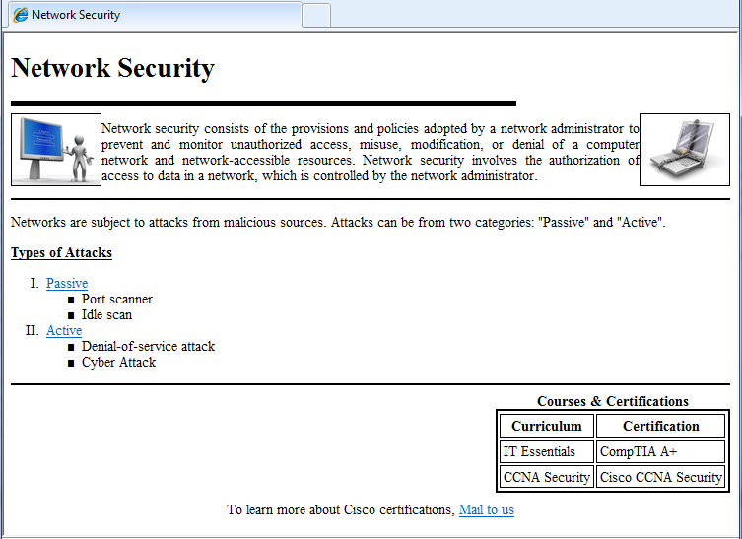
Consider the following points while writing the HTML code:
      - Title of the web page is Network Security.
      - The Background colour of the web page is orange.
      - Text style of main heading is Arial and that of the rest of the page is Comic Sans MS.
      - The line is green in colour and 4 pixels thick.
      - The table has a blue colored border that is 4 pixels thick.
      - Use the concept of nested lists for creating the given list.
      - The link at the bottom is an e-mail link to the address “info@cicso.com”.

  - Write the HTML code to generate a From in the format given below : [4]
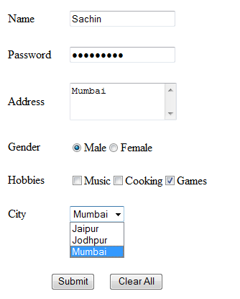

Mr. Sunil Nehra
sknehra07@gmail.com

