Sample Paper- 2016
Subject: Multimedia And Web Technology
Class 12th

Note :
- Please check that this question paper contains 7 questions.
- Answer the questions after carefully reading the text.
- All questions are compulsory.
Q1.
- Name the data types used for 1
    - On/off or true/false
    - Drop down list
- Identify the following views used to create a database in Access. 1
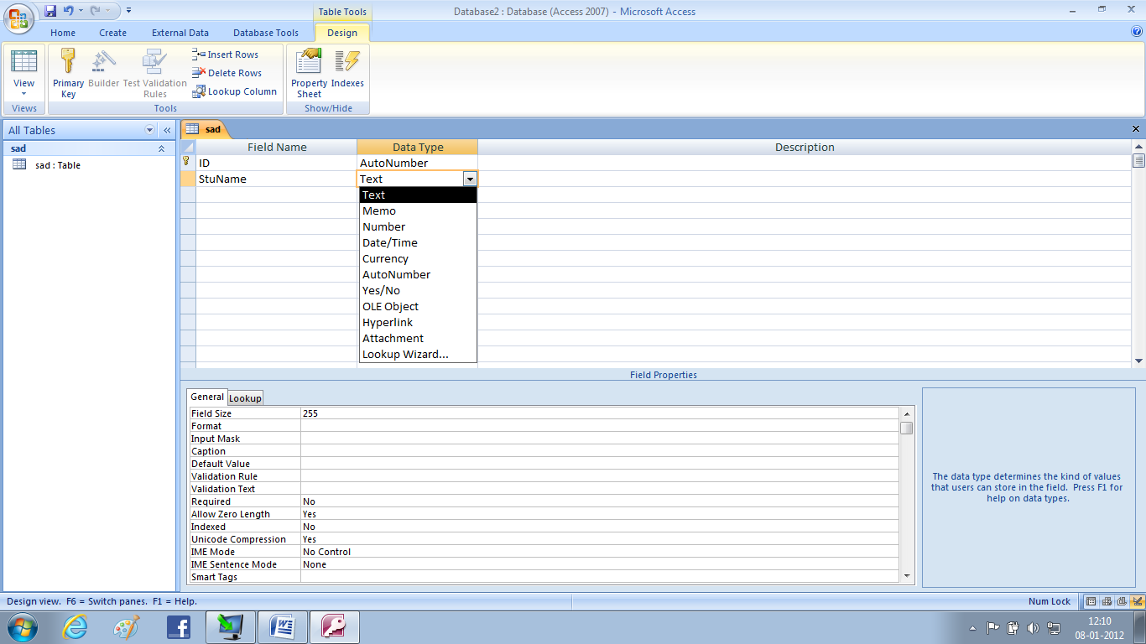

- Study the following data and answer the questions given below :
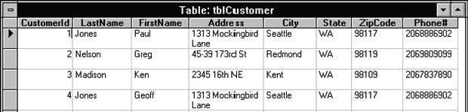
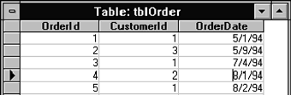
- What is the degree and cardinality of the table “tblcustomer”. 1
- Name the two fields that have the text data type in the above table 1
- Write the possible relationship between “tblcustomer” and “tblorder” table. 1
- Name the field that can act as a foreign key in tblOrder table. 1
d) Differentiate between flash file and GIF file. 1
e) Srishti wants to able to embed the flash movie created by her in her website. Which option is better suited for her- exporting or publishing? Also mention the extension of the web page file created if default setting are used. 2
f) Enumerate any two applications of multimedia in entertainment. 1
Q2.Questions given below are based on Macromedia Flash:
- Study the figure given below and identify the areas encircled. 2
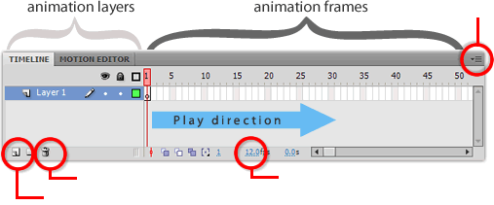

- What are panels? How are they different from the toolbars? 1
- Name the extension of exporting flash movie into 1
    - Macintosh projector
    - Real player
- Differentiate between 1
  - Stage level and overlay objects
- How the arrow tool is different from subselect tool? 1
- Observe the figure given bellow and do as directed : 4

The image on the left side shows the position and size of the image for frame 1.
The image on the right side shows the position and size of the image for frame 77.
Assume that the image of bird is stored in the flash library by the name bird .
The curve shows the path followed by the bird to reach from frmae1 to frame 77.
Write the procedure and property setting for animating the above scenario.

Q3 . Question given below are based on HTML:
- What is the use of following types of <Input> Tag ? 2
    - File
    - Hidden
- Write the HTML code to generate a Web Page in the format given below : 8
Consider the following while writing the HTML code
1. Background color of the page should be “Magenta”, text color should be “Maroon” .
2. Title of the page is “CBSE new attempt”.
3. Text color of main heading on the page should be “Blue”.
4. Font face of text in the page should be “Arial”.
5. Picture used in the page is the file “class12.jpg”.
6. Use the concept of list .
7. Pages linked to :
Multimedia--m.html , Internet--int.asp , Vedioconferencing--ve.avi , Animated courses--ac.jsp
8. multimediaandwebtech@aol.com mail id should be linked properly.
9. Table border is 1px thick and of green color.
10 Bottom message is of size 2 and link to an e-mail id.

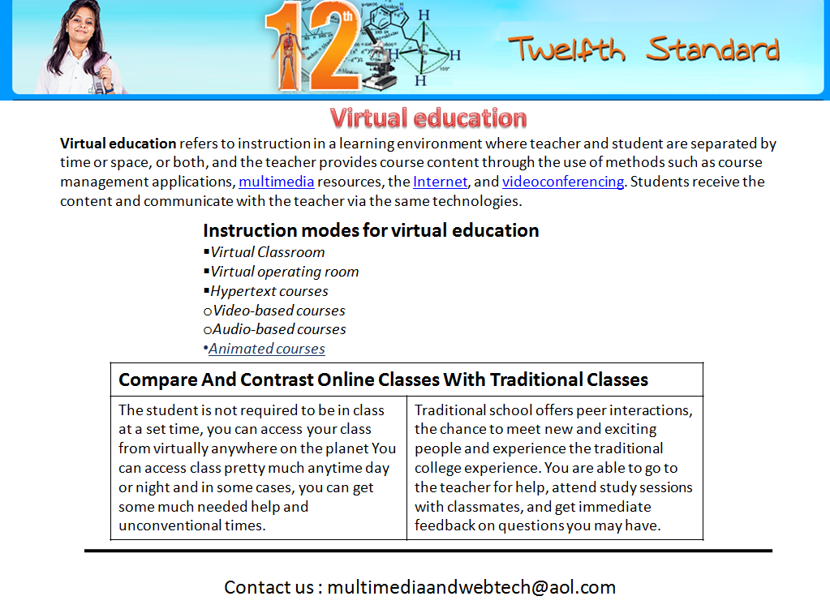

Q4 Answer the following questions based on ASP:
- Identify which is implicit and which is explicit declaration of variables. 1
    - City = “calcutta”
    - Dim City
City = “Delhi”
- How do you retrieve information from form that is submitted using the post method? 1
- Explain the use of the Remove and RemoveAll methods of the Session object. 1
- Write the ASP statements to create a cookie named “Order” and store the value of “Pizza” in it and retrieve the value stored in the cookie named “Order”. 1
- Name the object used for the following; 3
    - To obtain information about an error condition that has occurred in the script.
    - To share information among all users of a given application.
    - To control information sent back to the browser from the server.
f) Give output of the following statements: 3
- Response.write(mid (strreverse (“Write answer in sequence”),11,6))
- Response.write(instr(“movement against corruption” , “ove”)
- Response.write( right (“page background color”, hour(#1:30pm#)))
Q5. Answer the following questions based on ASP:
- What is a record set? How do you open a recordset? 1
- Study the code given below and answer the questions that follow:
<HTML>
<BODY>
<CENTRE><H1> Swach Bharat </H1></CENTER>
<HR>
<%
Set myway=server.createobject(“MSWC.ContentRotator”) %>
<P ALIGN = “LEFT”>
<%=myway.choosecontent(“Gandhiways.txt”) %>
Must follow to be a proud Indian.
</BODY>
</HTML>
- What is the significance of the delimiters <% %> in the above code? 1
- Give one special feature of the Content Rotator component of ASP. 1
- Name any two ASP COMPONENT apart from Content Rotator. 1
- Name any one ASP object used in the above code and its three methods. 1
c) Give the output for the following code segment: 2
<html>
<body>
<%
Mytext = “AaBbCcDd”
Max= len(mytext)
For i= 1 to max step 2
changedtext=left(mytext,i)
Response.write (strreverse(changedtext))
Response.write (“<br>”)
Next
%>
d) Write the asp code that will read the text file called friends.txt count the number of lines in the file and then display the same. 3

Q 6. Answer the following questions based on VBScript:
- What do you understand by the term EVENT? When is the blur event of an element called? 1
- Study the code given below and answer the questions that follow:
<HTML>
<HEAD><TITLE> board question</TITLE>
<SCRIPT LANGUAGE=”VBScript”>
Sub Display (message) ‘ Beginning of subroutine
Document.write(message)
End sub
</SCRIPT></HEAD>
<BODY>
<SCRIPT LANGUAGE=”VBScript”>
Display “Hello! Welcome to VBScript”
Call Display (“ Have a nice day”)
</script>
</body>
</html>
- Identify and name the argument used in the above code segment. 1
- What is the usages of the (‘single quote) character in the above code segment? What is the alternate way of achieving the same effect in VBScript? 1
- How many times will the subroutine Display be executed? 1
- What will be the output of the above code? 1
- Give the output of the following code segment: 2
<html>
<body>
<script language = “vbscript”>
Dim x
Document.write(“WELCOME”)
Call MYVAL(3)
Document.write(“hello”)

Sub MYVAL(num)
x=2
Document.write x & “<br>”
Document.write num *x
End sub
</Script >
</body>
</html>
- . write the HTML CODE to generate the following 3
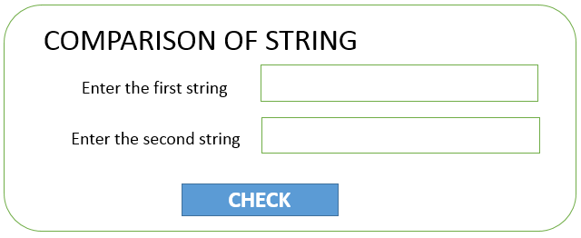
Write the VBscript code to display appropriate message as to which string is smaller on the click of the CHECK button. The message should be display in the message box (as soon above).
Q7. Answer the following questions based on the unit Web Technologies:
- Which of the following are not a feature of Networking? 1
  - Resource sharing
  - Reliability
  - Uninterrupted power supply
  - Reduced cost
- Write the use of 1
    - PostgreSQL
    - Python
- What is localization? Name one website which provide information about open source software. 1
- Define following terms 2
    - Cyberlaw
    - TELNET
- List the area where the satellite wireless communication media is being used. 1
- AVPSchool of ANJANI SEN TEHRI GARHWAL is setting up the network between its different houses. There are 6 houses named as house1 to house 6 as shown below: 4
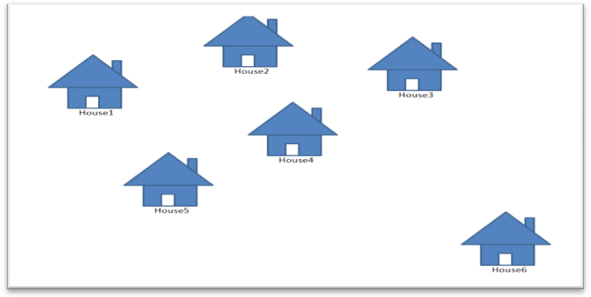
The distances between the different Houses are given below :
House 1 to House 2 150 m
Number of computers
House 1 5
House 2 1
House 3 6
House 4 10
House5 21
House6 45
House 2 to House 3 60 m
House 3 to House 4 155 m
House 4 to House 5 5 m
House 5 to House 6 505 m
House 6 to House 1 105 m
House 6 to House 2 7 m
House 4 to House 1 17 m
House 1 to House 3 15 m
House 2 to House 4 90 m
Answer the following questions based on the above given information :
(i) Suggest the most suitable topology for connecting these Houses.
(ii) Where do you think the server should be placed. Justify your choice ?
(iii) APVSchool is planning to link its House situated in the different part of the same small village, which type of network will be formed .Give reason.
(iv) Where and why should repeaters and hub/switch be used ?

Multimedia And Web Technology
2015-16
Solution

Tips:
1.. always start with punch line(direct answer)
2. explain the answer given by you in punch line
3. draw diagram or write example

Q1. a)
i)YES/NO
ii)lookup wizard

b) Design View
c)
i)degree =8
cardinality=4

ii)LastName & FirstName

iii)one to many

iv)CustomerId

d)Flash file and gif file

Flash File

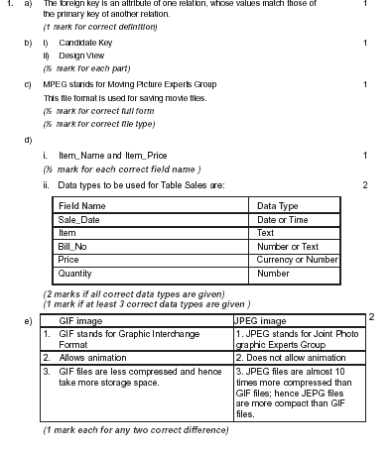

Flash files
- It can be opened and edited at any point of time.
- It take less storage space .

e)Publishing
.html
f) Multimedia in entainment
1.Cartoon Movies
2. Games

Q2. A from left to right
Add a new Layer
Delete layer
Frame rate (Speed of movie)
Menu

b) PANELS: panels are the small windows that let us to see and make change in the properties of objects and work with color, text, instances etc.
panels allows us to control specific actions or effects.
Toolbar contains shortcuts to various options.

c) i) .hqx ii) .smil

d)
Stage Object | Overlay Object
Objects are the simplest and comprise of anything drawn with the drawing tools. | Objects group together to act as a single unit .

e) Arrow tool : Used to grab, select and move items on the Stage.
Subselect tool : Displays edit points that can be adjusted to change the shape of a line.
f)
STEPS TO CREATE GUIDE LAYER:
i)create an instance of the bird from flash library on layer1 at frame 1st and press ctrl+G till 77th frame of layer 1. 0r
ii) click on frame 77. right click and choose insert key frame.
iii) drag the image from frame 1st to frame 77th as given in scene .
iv) right click anywhere in between and choose create motion tween.
v)Select insert – add motion guide
vi) Flash creates a new layer above the selected layer1; named as guide layer.
vii)On the guide layer, place the playhead at the 1st frame
viii)Then using pencil tool, draw the motion path as shown with solid line in the scene .
ix)Select control – play

Q3.
- i)<input type = file> is used to select file from browse option as an attachment.
ii) HIDDEN creates an invisible text control that allows the user to store values within
a Web page without being seen by the user

b)<html>
<head>
<title> CBSE new attempt</title>
</head>
<body bgcolor =”magenda” text = “maroon” >
<center><img src = “class12.jpg” height=30 width =100></center>
<font color = “blue”><h1> Virtual education </h1></font>
<br>
<basefont face = “arial”>
<p> Virtual education… ……………………………………………………………………………………………………………………………………………………………………………….. <a href=m.html> multimedia</a> resources, the <a href=int.asp> Internet </a> and <a href=ve.avi> videoconferencing</a>. Students……………………………………………………………………………………………………………………………….technologies<br></p>

<b> Instruction modes for virtual education</b>
<ul type = square >
<li> virtual classroom
<li> virtual operating room
<li> hypertext courses
<li type= circle> video based courses
<li type=circle> audio based courses
<li type=disc><a href=ac.jsp> Animated courses </a>
</ul>

<table border =1 bordercolor=green>
<tr><th colspan =2 > Compare and contrast………………… </tr>
<tr><td> The student is not …………………….
<td>Traditional school offers…………….
</tr>
</table>
<br>
<hr size=3>
<br>
<font size =2> Contact us: <a href=mailto: multimediaandwebtech@aol.com>
</body>
</html>

Q4.
- I) implicit ii) explicit
- Form collection of request object
- Remove and RemoveAll methods of the Session object ………………
- <%response.cookies(“order”)=”pizza”
Response.write(“order”) %

- ASPerrors
- Session
- request

- i rews
- 2
- kground color

Q5.
- Recordset is a collection of records retrieved from database. In ADO , a record set is represented using a RecordSet object. Once the object is created, the record set is opened by , using the open method
SYNTAX
<%recordset.open source, connection, cursortype, locktype%>

  - It display ASP codeing
  - Is used to randomly display different HTML content string on the web page
  - Adrotator , pagecounter
  - Object—server, methods execute,getlasterror , transfer

A
BaA
CbBaA
DcCbBaA
- <%dim ch
set fileobj = server.createobject(“scripting.filesystemobject”)
set myfile= fileobj.opentextfile(“friends.txt”)
while not myfile. AtENDOfStream
myfile.readline
countline=countline+1
response.write(countline)
wend
myfile.close
myfile.nothing
%>

Q6. a. An event describes actions that occur as the result of user interaction with a web
page. When…

b.
i) message
ii) comment , REM
iii) 2 times
iv) Hello! Welcome to VBScript Have a nice day

c. WELCOME 2
6 hello

d). VBscript code

<html>
<head><title> String comparison</title>
<script language = “VBscript”>
sub result()
DIM A,B
A=LEN(f1.t1.value)
B=LEN(f1.t2.value)
IF A<B then
Document.write( “the first string is smaller”)
Else
Document.write( “the second string is smaller”)
End if
End sub
</script>
</head>
</script>
<body>
<form name=:”f1” method = “post”>
<center><h1> COMPARISON OF STRINGS</H1></CENTER>
Enter the first string. < input type =”text” name=”t1” ><br>
Enter the Second string. < input type =”text” name=”t2” ><br>

<input type= “button” name = “btn” value = “CHECK” onclick= “result()”>
</form>
</body>
</html>

Q7.
- Uninterrupted power supply
- i) free object-relational database server
ii)a programming language
c)it is a process of translating software user interface from one language to another and adapting it to suit a foreign culture.
d) i)it refers to the set of laws governing the usage of Internet.
ii)it is a general purpose client server internet facility that facilitates remote login.
- Remote area, Antarctica , ship, etc

- I) BUS topology
II) house 6
Reason: i) number of computer is more than any other wing.
ii) more computer will get good communication speed.

III) LAN

- Repeater is used to boost the speed of signal and only used if the cable length (if coaxial) is more than 60m.
repeater should not be used .

Switch except in house 2 in every wing as the number of computer more than one in every wing .A switch is used to connect multiple computer with the server using a device HUB or SWITCH.

Mr. Sudhir Kumar Dwivedi
sudhirdwi@gmail.com

