Sample Paper- 2016
Subject: Multimedia And Web Technology
Class 12th

Time allowed : 3 hours Maximum Marks : 70
Note :
- Please check that this question paper contains 7 questions..
- Answer the questions after carefully reading the text.
- Please write down the serial number of the question before attempting it .
Q1
- Name the following: 2
  - The number of fields in a relation.
  - A data type which can be used to automatically store monetary values with appropriate sign, commas and decimals.
  - The view in which we can add, edit and view records in MS-Access.
  - A part of the Microsoft Office suite that is used to create and manage databases
- Define DBMS. Name any two software used to manage database. 2
- Observe the two tables – correspondent & addressee of a databse named Mail given below and answer the questions that follow : 3

Table : correspondent
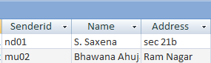
Table: addressee
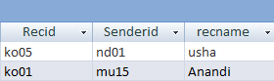
    - Identify the above views used to create a database in Access.
    - Identify any one data item from the table addressee.
    - Identify a tuple from the table correspondent.
    - Name the foreign key for the table addressee.
    - Mention the cardinality of the table correspondent.
    - What type of relationship will exist between these two tables?
- Differentiate between MPEG and AVI file formats. 2
- Write a short note on Video conferencing. 1
2. Question below are based on Macromedia Flash:
. a) Study the figure given below and answer the question that follow:
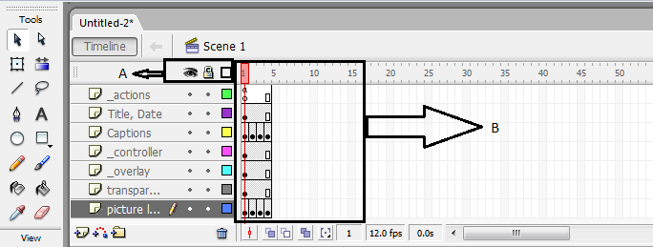
- Identify the areas labeled as A and B in the above figure. 1
- Explaining the term stacking order of layers and name the layer that will be shown on the top in the final movie. 1
- What will be the effect of increasing the frame rate of this movie from 12.0 fps to 5fps? 1
b) What do you understand by tweening?Name two types of tweening. 2
c) Differentiate between stage object and overlay object. 1
d) Observe the figure given bellow and do as directed : 4
The image except spacecraft and its path on the stage shows the position of the image form frame 1 to frame 50 of layer 1.
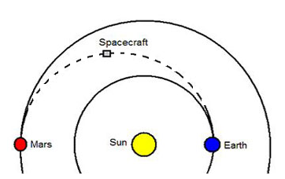

- The image(spacecraft) on the right side shows the position of the image for frame 1 of layer 2.
- The image (spacecraft) on the left side shows the position of the image for frame 50 of layer 2.
- The dotted line shows the path of motion of spacecraft.
Write procedure and property setting for animating the above scenario.
3.Questions given below are based on HTML :
- What is the use of TEXTAREA ? write all the attribute of textarea. 2
- Write the HTML code to generate a Web Page in the format given below : 8
Consider the following while writing the HTML code :
1. Background of page pink , link colour is green , active link color is blue and visited
link colour is red .
2. Title of the page is “Republic Day”.
3. Heading of the page is red.
4. image used is “inc1987.jpg”
5. caption of table is blue.
6. table border is blue and of size 3.
7. First row of table has background color “cyan”
8. Pages linked to :
New Delhi as “nd.html”
Faridabad as “fbd.html”
Dehradun as “ddn.html”
9 .Image used at the bottom is try1.gif and it acts as a link to Ryanfaridabad.html .the link
for “ table of contents ” is also same .

Q4. Answer the following based on ASP.
- Write the difference between lock and unlock method of Application object . 2
- What do understand by the cursortype of a recordset? What are the different values that a user can specify for the cursortype? 2
- Find output 3
i)Response.Write(INSTR(LTRIM(“ ActiveX Data object”), “obj”))
iiResponse.Write(strreverse (MID(“Hello There” ,7,3)))
iii) Response.Write(isnumeric(MONTHNAME(MONTH(“12-12-2009”))))
d) Identify the following: 3
- The collection used to retrieve the values of form elements sent using the GET method.
- To show the number of visitors visiting a web page.
- To Show banner Advertisements on the web page

Q5. Answer the following based on ASP.
- What is ADO ? What is the significance of OLEDB with reference to ADO in ASP? 2
- Differentiate between optimistic and pessimistic locking of a record set. 2
- Study the codes given below and answer the questions that follow:
Exam.txt
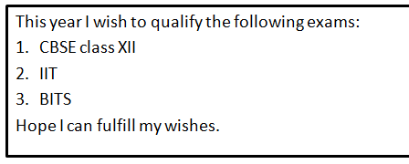
Exam.asp
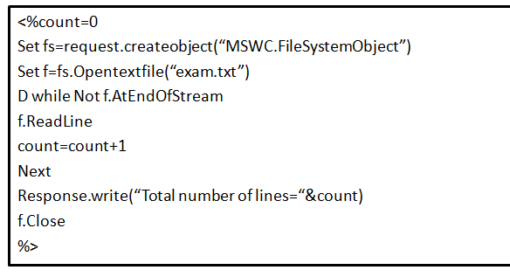

- Identify the errors in exam.asp and rewrite the corrected code. 1
- What is the use of the AtEndOfStream method? 1
- Give the output of the exam.asp file. 1
- What will be the output if the f.readline is replaced by f.readall? 1

- Study the code given below: 2
<% Set ad= ______.createobject(“_____.contentrotator”)
________.write(ad.______ ________(ads.txt”)) %>
Fill in the blanks to complete the above code fragment to create an ASP file used to display HTML content (i.e. tips of the day) stored in the ads.txt file dynamically using the content rotator component.

6. Question given below are based on VBScript :

(a) Define array. What is the significance of array? How is it declared? 1
(b) Change the following script using For……… next without affecting the output: 2
dim name , i
i=1
name= “ARYAN”
do while I <= len (name)
document.write instr(mid(name,i),”A”)
i=i+1
loop

c) Give the output for the following script code: 2
dim x,y
y=10
for x= 1 to 4 step 1
if (x mod 2 ) = 0 then
y=y-x
else
y=y+2*x
end if
document.write (y)
next

d)Rewrite the following code after removing errors with each correction underline: 2
<script>
sub result()
dim K,M
while (K<10 and M>5)
if K % 3 = = 0
K=K+M
else
K=K-M
M=M+3
Loop
Document.print(“K=” +K)

</script>
e ) Write the HTML code for creating the form given below and also write the embedded VBScript code for the click event of the verify button, such that it displays a required message.. 3
Apply the following validations :
Enrollment number must be of 4 digit
The charge per semester are as follows
Facility Course
Library Rs 5000 MCA Rs. 50000
Hostel Rs. 15000 MBA Rs. 56000
Calculate the charges per semester (six months) for the facility availed.

Q7.
- Write one advantage of Bus Topology of network. Also, illustrate how 4 computers can be connected with each other using star topology of network. Name all the devices used in connection. 2
- Differentiate between star and bus topology . 1
- Differentiate between message and packet switching. 1
- Mr. Ganpati prasad is an entrepreneur who has recently set up a new business. he needs to create a lot of documents, presentations, databases and spreadsheets to maintain data and spread his business. However, he does not have the money to purchase any of the proprietary software which offers all these packages. Can you suggest what software can Mr. Ganpati use for which he has to pay no licensing fee?
2

- V.A associate is a big organisation and has 5 wings where it runs its operations (shown below):
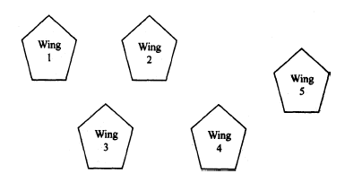 4
The distances between the different wings are given below :

Between 1 and 2 40 mts.
Between 2 and 4 25 mts.
Between 2 and 5 68 mts.
Between 3 and 4 03 mts.
Between 3 and 5 13 mts:
Between 4 and 5 195 mts.

Between 1 and 3 40 mts.
Between 1 and 4 55 mts.
Between 1 and 5 130 mts:
Between 2 and 3 95 mts.

Each wing contains following number of computers :

Wing No. of Computers

1 70
2 35
3 13
4 50
5 160

Answer the following questions based on the above given information:

(i) Suggest suitable cable layout(s) for connecting the wings.
(ii) Where do you think the server should be placed and explain why?
(iii) Suggest the type of cable should be used if the organisation wants the most economical option.
(iv) Where and why should repeaters and switch be used?

Multimedia And Web Technology
Solution

Q1. a)
- Degree
- Currency
- Datasheet View
- MS Access
b) Definition: A software that allows a computer to perform database functions of storing, retrieving, adding, deleting and modifying data. Relational database management systems (RDBMS) implement the relational model of tables and relationships.
Examples:
Microsoft Access, MySQL, Microsoft SQL Server, Oracle
c) 1. Datasheet View
2. ko05
3. nd01 , S.Saxena , sec 21b , Faridabad
4. Senderid
5.. 2
6.. one to one

d)..
AVI (audio video interleave) | MPEG(moving pictures expert group)
It is a coded file format which requires special software to play the files . | Most widely used media file format which easily plays on all platforms.
AVI is relatively low quality with a limiting frame rate and mono sound. | MPEG files offer extremely high compression rates with little loss of quality.
e) Videoconferencing is the conduct of a videoconference by a set of telecommunication technologies which allow two or more locations to communicate by simultaneous two-way video and audio transmissions.

Q2.
- (i)A- Layer mode (visible , lock and outline)
B- Timeline (components )
(ii) Stacking order means the order in which the layers will be displayed. actions layer will be displayed on the top.
(ii) it will decrease the speed of movies when we decrease the frame rate from 12.0 fps to 5 fps.
- TWEENING: in tweening we select the starting and finishing points for an object and flash animates it by filling in between , tweened animation is called tweening.
Two types of tweening:
There are two types of animation that can be performed in flash
Frame By Frame Animation
Ii) Tweening Animation
  - Shape Tweening
  - Motion Tweenig
c)
Stage Object | Overlay Object
Objects are the simplest and comprise of anything drawn with the drawing tools. | Objects group together to act as a single unit .
d) STEPS TO CREATE GUIDE LAYER:
i)draw an object, say a solar system with the help of tool on layer1 at frame 1st and press ctrl+G till 50th frame of layer 1. 0r
ii) click on frame 50. right click and choose insert key frame.
iii) insert layer 2
iv) draw spacecraft on frame 1 of layer 2 at right position near Earth
v) click on frame 50. right click and choose insert key frame.
vi)drag the image from frame 1st to frame 50th near Mars to the left side of Earth.
iv) right click anywhere in between and choose create motion tween.
v)Select insert – motion guide
vi) Flash creates a new layer above the selected layer2; named as guide layer.
vii)On the guide layer, place the playhead at the 1st frame
viii)Then using pencil tool, draw the motion path as shown with dotted line in the question.
ix)Select control – play
Q3.
- TextArea: this tag is used to accept multiple lines of text from a user. For example feedback , report etc.
attributes of text Area: following are the attribute of text Area.
name = “ variable_name”
rows = “number”
cols= “number”

HTML CODE TO GENERATE THE GIVEN WEB PAGE
<html>
<head><title> republic day <.title></head>
<body bgcolor =”pink” link = “green” Alink = “blue” value = “red”>
<h1><font color = “red”><u> republic day </u></font></h1>
<br>
<img src =”inc1987.jpg” align =left height = 300 width = 150>
<p> is india’s important national event celebrated <br>
on January 26th every year. January 26 was </br>
not some random date picked out of the <br> calendar. It was on this date in 1927, that the <br> Indian national congress , then fighting its non <br> violent war for freedom. Voted for complete <br> independence as against dominion status” , it <br> was the date when members of the INC took <br> democratic republic’ of India. <br>
<table border = 3 bordercolor = blue>
<caption color = blue align = bottom><b> security </b></caption>
<tr bgcolor = “cyan <th rowspan = 2> the army
<th colspan = 4> the president </tr>
<tr><th colspan=2> paramilitary force <th colspan=2> police
<tr><th>the navey <td>25sL<td>125L<td>75L<td>15L
<tr><th>Air force <td>250sL<td>65L<td>65L<td>85L
</table><br>
<ol type=1 start = 1>
<l1 ><a herf-nd.html”> new delhi </a>
<ol type = ‘disc’>
<l1>republic day parade
<l1> delhi marching on the rajpath
</ul>
<l1 ><a fbd.html”> faridabad </a>
<l1 ><a ddn.html”> dehradun </a><br>
<a href = rhyanfaridabad.html><img src =”try1.gif” align=color><br>
table of content
</a>
</body>
</html>

Q4.

Application.Lock() | Application.UnLock()
The Lock method prevents other users from modifying the variables in the Application object when one user is modifying it.  Used to ensure that the only one client at a time can modify the Application variables.  Needs to be explicitly called. | The UnLock method enables other users to modify the variables stored in the Application object .  Used to ensure that all users have access to the variable. It used after Application variable has been locked using the Lock method.  It is not called explicitly, the web server unlocks the Application object when the asp file ends or times out.

- Curror type of a record set.
It is an optional parameter and specifics what sort of curror the recordset will have on opening.
Different values that a user can specify for the cursortype.
i) adopenforwardonly: i) default
ii) user can only scroll forward
ii) adopenkeyset; i) data changed by other user are visible
ii) data added by other username not visible etc.
iii) adopen dynamic: i) all type of movement allowed
ii) add, change, delete are visible
iv) adopensetatic: i) addition, change , deletion are not visible.

i)14
ii)ehT
iii)False

(i) Query String collection
(ii) Page Counter Component
iii)Adrotator Component

Q5.
- ADO: “active data object”
An ADO can be used within ASP to access a database and make the web browser to act as an interface between data and the end user

SIGNICICANCE OF OLEDB WITH REFERENCE TO ADO
ADO , however does not communicate directly with the data source. It communicate through an intermediate interface called . OLE DB. It provide a system level interface to a data source.

- optimistic locking pessimistic locking
locking record by record . the provider locking record by record the provider lock
lock records only when calling update records immediately after editing.
Method.

- Set fs=server.createobject(MSWC.FileSystemObject”)

Do while
loop
- Atendofstream read the file till the end.
- Total numbers of lines = 5
- Total numbers of lines = 1
d)<% Set ad= _server_.createobject(“MSWC.contentrotator”)
Response.write(ad.choosecontent(“ads.txt”)) %>

Q6.
array: an array is a collection of elements of same data type. All the elements in an array are identified by the same name but are differentiated by their index value.
Significance of Array:
all elements of an array are stored in adjacent memory location.
All elements are identified by the same name.
Way of declaration:
Syntax
Dim arrayname (fileofarray)
Example
Dim marks(4)
conversion into for……..next
dim name, i
name=”ARYAN”
for i=1 to ten(name) step 1
document.write instr(mid(name,i), “A”)
next
output
12
10
16
12
wrong code
<script>
sub result()
dim k. m
while(K<10 AND M>5)
if K % 3 = = 0
K=K+M
Else
K=K-M
M=M+3
Loop
Document .print (“K=” + K)
</script>
correct code
<script language=”VBScript”>
sub result()
dim K, M
do while(K<10 AND M>5)
if K mod 3= 0 then
K=K+M
Else
K=K-M
M=M+3
End if
Loop
Document.write(“K” & K)
End sub
<script>

VBscript code
<html>
<head><title></title>
<script language = “VBscript”>
sub result()
Dim rollno, chargesm rno
Rollno = cdbl(document.form1.txt1.value)
Rno=len(cstr(rollno)
If rollno < 4 or rollno >4 then
Msgbox(“rollno must be of 4 digit”)
End if
If form1.op(0).checked then
Charges = 56000
Elseif from1.op(0).checked AND from1.chk1.checked then
Charges= 56000 + 5000
Elseif from1.op(0).checked AND from1.chk2,checked then
Charges= 56000 + 15000
Elseif from1.op(0).checked AND from1.chk1.checked AND from1.chk2,checked then
Charges= 56000 + 5000 + 15000
End if
If form1.op(1).checked then
Charges = 56000
Elseif from1.op(1).checked AND from1.chk1.checked then
Charges= 56000 + 5000
Elseif from1.op(1).checked AND from1.chk2,checked then
Charges= 56000 + 15000
Elseif from1.op(1).checked AND from1.chk1.checked AND from1.chk2,checked then
Charges= 56000 + 5000 + 15000
End if
Msgbox(“total charges for one semester=”& charges)
End sub
</head>
</script>
<body>
<form name=:form1” method = “post”>
enrollment no. < input type =”text” name=”text 1” value= “0”><br>
course <input type= “redio” value = “MBA” name=op>
<input type= “redio” value = “MCA” name=op><br>
facility available input type= “checkbox” value = “libarary” name=chk1>
<input type= “checkbox” value = “hostel” name=chk2><br>
<input type= “button” name = “btn” value = “verity” onclick= “result()”>
</form>
</body>
</html>

Q7.
- ADVANTAGE BUS TOPOLOGY
short cable length.
Easy to extend

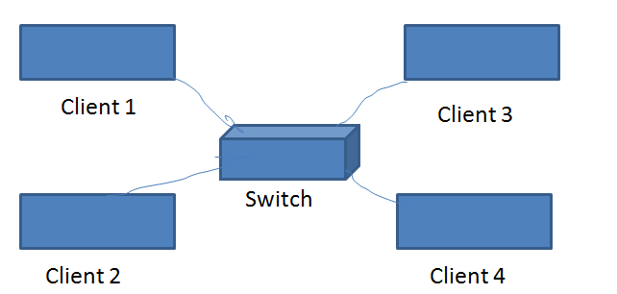

STAR | BUS
- Easy to install and wire (even for multifloor plans of network) long cable length  - Expensive as compared to bus, one device per connection.  - Easy to detect fault and to remove part.  - Central node dependency | - East to connect a computer or peripheral short cable length  - Slower as compare to star  - Difficult to identify the problem if the entire network shuts down.

- Similar to the post office mailing system  - Message switching is also know as store and forword  - Message stored in disk | - Long messages are subdivided into short packets  - Each packet may be sent to its destination separately  - All the packets are stored in the main memory instead of disk.
- Mr. Ganpati prasad can use Free open source software to save on licensing fee.

On the basis of the shortest cable length (BUS Topology)

On the basis of the server (Star Topology)

II) Wing 5
Reason: i) number of computer is more than any other wing.
ii) more computer will get good communication speed.

III) coaxiala cable: though the most economic is twisted paired but the number of computer is more so it is not suitable to use twisted pair.
Coaxial is more suited for five wing having above 300 computer.

- Repeater is used to boost the speed of signal and only used if the cable length (if coaxial) is more than 60m.
repeater should be used between
- wing 4 and wing 5
- wing 2 and wing 4

Switch in every wing as the number of computer more than one in every wing .A switch is used to connect multiple computer with the server using a device HUB or SWITCH.

****
Mr. Sudhir Kumar Dwivedi
sudhirdwi@gmail.com

