Sample Paper- 2016
Subject: MATHEMATICS
Class 9th
LINEAR EQUATION IN TWO VARIABLES

Q1: Find the value of K if x=2 and y=1 is a solution of the equation (k-2)x + 4y = 10 and have the graph of the equation. Write the co-ordinate of the point where the graph cuts the y-axis.
Q2: Express y in terms of x in the equation 2x-3y = 12. Find the points where the line represented by this equation cuts x-axis and y- axis.
Q3: The equation of x-axis is of the form (A) x = 0 (B) y = 0 (C) x + y = 0 (D) x = y
Q4: IF ( 2, 3+K ) is the solution of the equation 2x-3y = 12 , find the value of K .
Q5: If the points A(3,5) and B(1,4) lie on the graph of the line ax+by = 7, find the values of a and b.
Q6: Draw the graphs of 2x+ y=6 and 2x-y +2 =0. Shade the region bounded by these lines and x-axis. Find the area of the shaded region.
Q7: At what point does the graph of the linear equation 2x+3y=9 meet a line which is parallel to the y-axis, at a distance of 4 units from the origin and on the right of the y-axis.
Q8: Ravish tells his daughter Aarushi, “Seven years ago, I was seven times as old as you will be”. If present ages of Aarushi and Ravish are x and y respectively, represent this situation algebraically as well as graphically.
Q9: Give the representation of 2x +9 =0 as an equation in
a) One variable b) Two variable
Q10: The taxi fare in a city is as follows: For the first kilometer, the fare is
Rs.20 and for the subsequent distance it is Rs. 6 per km. Taking x km as the distance covered and Rs. y as the total fare, write a linear equation for this information and draw its graph.
Q11 Indicate the values of a, b and c in each case:
- 2x + 3y = 4 (ii) x-4 = 3y (iii) 4= 5x-3y
Q12 For what value of k the point (k,5) lies on the line 4x-5y=10 ?
Q13 The taxi fare in a city is as follows: For the first km, the fare is Rs.8 and for every subsequent Km it is Rs. 5. Taking the distance travelled as x and the total fare as y, represent the equation graphically.
Q14 Find out which of the following equation have x=2, y=1 as solution.
(1) 2x+ 5y= 7 (2) 5x+ 3 y=14 (3) 2x+ 3y= 7
Q15 The points (2,0), (-3,0) and (4,0) lie On the origin (b) On the X-axis (c) Y-axis (d) parallel to X-axis
Q16 What these graph shows and also write the equation
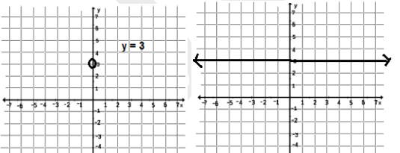
Q17 The linear equation 3x – y = x – 1 has :
- A unique solution (B) Two solutions (C) Infinitely many solutions (D) No solution
Q18 A linear equation in two variables is of the form ax + by + c = 0, where
- a ≠ 0, b ≠ 0 (B) a = 0, b ≠ 0 (C) a ≠ 0, b = 0 (D) a = 0, c = 0
Q19 The graph of the linear equation 2x + 3y = 6 cuts the y-axis at the point
(A) (2, 0) (B) (0, 3) (C) (3, 0) (D) (0, 2)
Q20 x = 5, y = 2 is a solution of the linear equation
(A) x + 2 y = 7 (B) 5x + 2y = 7 (C) x + y = 7 (D) 5 x + y = 7
Q21 How many solution(s) of the equation 2x + 1 = x – 3 are there on the :
(i) Number line (ii) Cartesian plane
Q22 The following values of x and y are thought to satisfy a linear equation Draw the graph
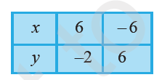
At what points, the graph cuts the x-axis and the y-axis.
Q23 Determine the point on the graph of the equation 2x + 5y = 20 whose abscissa is 5/2 times its ordinate
Q24 Write any four solutions of the equation 4= 5x-3y

