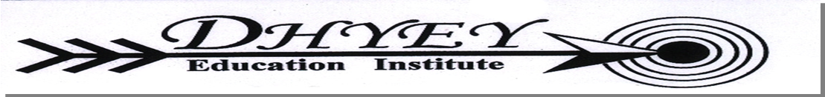
Sample Paper- 2016
Subject: Accountacy
Class 12th

Q.1 Calculate cost of goods sold from the following information: Sales Rs.12,00,000, Sales (4)
Returns Rs.80,000, operating expenses Rs.1,82,000, operating ratio 92%

Q.2 From the following details, Calculate Inventory on the end: (2)
 |  | Revenue from operations (credit 80%) - 5,00,000 Net profit - 1,60,000,administration
 |  | expenses - 30,000,Depreciation - 30,000,office expenses - 5,000.The inventory
 |  | conversion period is of 73 days.
Q.3 From the following prepare Cash Flow Statement:
 |  | Particulars |  | Note no. |  |  | ` 2013-14 |  |  | ` 2012-13
 |  | Equity And Liabilities
 |  | Shareholders funds
 |  | a) Share capital |  | 1 |  |  | 14,00,000 |  |  | 10,00,000
 |  | b)reserves & Surplus |  |  |  |  | 5,00,000 |  |  | 4,00,000
 |  | 2.Non-Current Liabilities
 |  | Long Term borrowings |  |  |  |  | 5,00,000 |  |  | 1,40,000
 |  | 3.Current Liabilities::
 |  | Trade payables |  |  |  |  | 1,00,000 |  |  | 60,000
 |  | Short term Provisions |  |  |  |  | 80,000 |  |  | 60,000
 |  | TOTAL |  |  |  |  | 25,80,000 |  |  | 16,60,000
 |  | Assets
 |  | 1.Non Current Assets
 |  | a..Fixed assets:
 |  | (i) Tangible assets |  |  |  |  | 16,00,000 |  |  | 9,00,000

(ii) Intangible Assets |  | 1,40,000 | 2,00,000
2.Current Assets
a. Inventories |  | 2,50,000 | 2,00,000
b. Trade Receivables |  | 5,00,000 | 3,00,000
c. Cash & Equivalents |  | 90,000 | 60,000
TOTAL |  | 25,80,000 | 16,60,000

- Short Term provisions are for Taxation. Provision made during the year was ` 50,000.

- Intangible assets denote copyrights.

(iii) Depreciation charged on tangible assets was ` 1,00,000. (6)

Dhyey Institute
Chintan Shah
M: 9825018985

