COMPUTER SCIENCE (Theory)
Class-XII
Time Allowed: 3hours Maximum Marks: 70
Note. (i) All questions are compulsory.
(ii) Programming Language: C+ +

Ques 1.
(a)What do you mean by identifier? Find the correct identifier out of the following in a C++ program.
While, for, this, Delete, A&B, _Counter, 12class [2]
(b) Observe the following program very carefully and write the names of those header file(s), which are essentially needed to compile and execute the following program successfully: [1]
typedef char TEXT[80];
void main()
{
TEXT Str = “Peace is supreme”;
int Index=0;

while (Str[Index]!=’\0’)
if (isupper(Str[Index]))
Str[Index++]=’#’;
else
Str[Index++]=’*’;
puts(Str);

}
(c) Observe the following C++ code very carefully and rewrite it after removing any/all syntactical errors with each correction underlined.
Note : Assume all required header files are already being included in the program. [2]
#define float Max=70.0;
Void main()
{
int Speed
char Stop=’N’;
cin>>Speed;
if Speed>Max
Stop=’Y’;
cout<<Stop<<end;
}
(d) Find the output of the following program: [2]
Note : Assume all required header files are already being included in the program.
void Position(int &C1,int C2=3)
{
C1+=2;
C2+=4;
}
void main()
{
int P1=20, P2=4;
Position(P1);
cout<<P1<<”,”<<P2<<endl;
Position(P2,P1);
cout<<P1<<”,”<<P2<<endl;
}
(e)Write the output of the following C++ program code : [3]
Note : Assume all required header files are already being included in the program.
class Calc
{
char Grade;
int Bonus;
public:
Calc()
{Grade=’E’;Bonus=0;}
void Down(int G)
{
Grade–=G;
}
void Up(int G)
{
Grade+=G;
Bonus++;
}
void Show()
{
cout<<Grade<<”#”<<Bonus<<endl;
}
};
void main()
{
Calc C;
C.Down(2);
C.Show();
C.Up(7);
C.Show();
C.Down(2);
C.Show();
}
(f) Study the following program and select the possible output(s) from the options (i) to (iv) following it. Also, write the maximum and the minimum values that can be assigned to the variable NUM. [2]
Note :
– Assume all required header files are already being included in the program.
– random(n) function generates an integer between 0 and n – 1.
void main()
{
randomize(); int NUM; NUM=random(3)+2;
char TEXT[]=”ABCDEFGHIJK”;
for (int I=1;I<=NUM; I++)
{
for(int J=NUM; J<=7;J++) cout<<TEXT[J];
cout<<endl;
}}

- FGHI (ii) BCDEFGH (iii) EFGH (iv) CDEFGH
FGHI BCDEFGH EFGH CDEFGH
FGHI EFGH
FGHI EFGH

Ques.2
(a) What is the difference and similarity between private and protected data members of a class? [2]
(b) Observe the following C++ code and answer the questions (i) and (ii) :
class Traveller
{
long PNR;
char TName[20];
public :
Traveller() //Function 1
{cout<<”Ready”<<end1;}
void Book(long P,char N[]) //Function 2
{
PNR = P; strcpy(TName, N);
}
void Print() //Function 3
{
cout<<PNR << TName <<end1;
}
~Traveller() //Function 4
{
cout<<”Booking cancelled!”<<end1;
}
};
(i) Fill in the blank statements in Line 1 and Line 2 to execute Function 2 and Function 3
respectively in the following code: [1]
void main()
{
Traveller T;
_________ //Line 1
_________ //Line 2
}//Stops here
(ii) Which function will be executed at}//Stops here? What is this function referred as? [1]

(c)Write the definition of a class PIC in C++ with following description: [4]
Private Members
– Pno //Data member for Picture Number (an integer)
– Category //Data member for Picture Category (a string)
– Location //Data member for Exhibition Location (a string)
– FixLocation //A member function to assign Exhibition Location as per category
//as shown in the following table
Category Location
Classic Amina
Modern Jim Plaq
Antique Ustad Khan
Public Members
– Enter() //A function to allow user to enter values //Pno, category and call FixLocation() function
– SeeAll() //A function to display all the data members

(d) Answer the questions (i) to (iv) based on the following: [4]
class Exterior
{
int OrderId;
char Address[20];
protected:
float Advance;
public:
Exterior();
void Book(); void View();
};
class Paint:public Exterior
{
int WallArea,ColorCode; protected:
char Type; public:
Paint(); void PBook(); void PView();
};
class Bill : public Paint
{
float Charges; void Calculate();
public : Bill();
void Billing(); void Print();
};
(i) Which type of Inheritance is illustrated in the above example?
(ii) Write the names of all the data members, which are directly accessible from the
member functions of class Paint.
(iii) Write the names of all the member functions, which are directly accessible from an
object of class Bill.
(iv) What will be the order of execution of the constructors, when an object of class Bill is declared?

Ques 3.
(a) Write a function in C++, which accepts an integer array and its size as arguments and exchanges the values of the first half side with the second half side elements of the array. [2]
Example: if an array of eight elements initially contains the elements as
2,4,1,6,7,9,23,10
Then the function should rearrange the array as
7,9,23,10,2,4,1,6
(b) A two dimensional array P[20] [50] is stored in the memory along the row with each of its element occupying 4 bytes, find the address of the element P[10] [30], if the element P[5] [5] is stored at the memory location 15000. [3]
(c) Write the definition of a member functions Push( ) and Pop( ) in C++, to insert and to delete a book from a dynamic stack of TEXTBOOKS considering the following code is already included in the program. [4]
struct TEXTBOOKS
{
char ISBN[20]; char TITLE[80]; TEXTBOOKS *Link;
};
class STACK
{
TEXTBOOKS *Top; public:
STACK(){Top=NULL;} void Push();
void Pop(); ~STACK();
};

(d) Write a function SWAPARR() in C++, to swap (interchange) the first row elements with the last row elements, for a 2D array of integers passed as argument of the function. [3]
Example: if the two dimensional array contains

5 | 6 | 3 | 2
1 | 2 | 4 | 9
2 | 5 | 8 | 1
9 | 7 | 5 | 8
After swapping of the content of first row and last row, it should be as follows:

9 | 7 | 5 | 8
1 | 2 | 4 | 9
2 | 5 | 8 | 1
5 | 6 | 3 | 2

(e) Evaluate the following postfix notation of expression. Show contents of stack after every step. [2]
True, False, AND, True, True, NOT, OR, AND

Ques. 4
(a) Find the output of the following C++ code considering that the binary file CLIENTS.DAT exists on the hard disk with records of 100 members. [1]
class CLIENTS
{
int Cno;char Name[20];
public :
void In(); void Out();
};
void main()
{
fstream CF;
CF.open(“CLIENTS.DAT”,ios::binary|ios::in);
CLIENTS C;
CF.read((char*) &C, sizeof(C));
CF.read((char*) &C, sizeof(C));
CF.read((char*) &C, sizeof(C));
CF.read((char*) &C, sizeof(C));
int POS=CF.tellg()/sizeof(C);
cout<<”PRESENT RECORD:”<<POS<<end1;
CF.close();
}
(b) Write a function C_Digit() in C++ to count the word containing digits in it in a text file PASS.TXT. [2]
Example : If the content of the file “PASS.TXT” is as follows:
Nowadays password must have atleast one digit and a special symbol in it. For instance Ram@123 and Sch#99 are good passwords.

The function will display the following message:
Count of words in file: 2

(c) Write a function in C++ to search for a required BookNo from a binary file "BOOK.DAT", assuming the binary file is containing the objects of the following class. [3]
class Book
{
int Bno;
char Title[20];
public:
int RBno()
{
return Bno;
}

void Enter()
{
cin>>Bno;gets(Title);
}
void Display(){
cout<<Bno<<Title<<endl;
}
};

Ques.5
(a)What do you understand by Candidate and Foreign Key in relational algebra? [2]
(b) Consider the following DEPT and WORKER tables. Write SQL queries for (i) to (iv) and find
outputs for SQL queries (v) to (viii) : [6]

Table : DEPT

DCODE | DEPARTMENT | CITY
D01 | MEDIA | DELHI
D02 | MARKETING | DELHI
D03 | INFRASTRUCTURE | MUMBAI
D05 | FINANCE | KOLKATA
D04 | HUMAN RESOURCE | MUMBAI

Table : WORKER

WNO | NAME | DOJ | DOB | GENDER | DCODE
1001 | George K | 2013-09-02 | 1991-09-01 | MALE | D01
1002 | Ryma Sen | 2012-12-11 | 1990-12-15 | FEMALE | D03
1003 | Mohitesh | 2013-02-03 | 1987-09-04 | MALE | D05
1007 | Anil Jha | 2014-01-17 | 1984-10-19 | MALE | D04
1004 | Manila Sahai | 2012-12-09 | 1986-11-14 | FEMALE | D01
1005 | R SAHAY | 2013-11-18 | 1987-03-31 | MALE | D02
1006 | Jaya Priya | 2014-06-09 | 1985-06-23 | FEMALE | D05

Note : DOJ refers to date of joining and DOB refers to date of Birth of workers.
(i) To display Wno, Name, Gender from the table WORKER in descending order of Wno.
(ii) To display the Name of all the FEMALE workers from the table WORKER.
(iii) To display the Wno and Name of those workers from the table WORKER who are born between ‘1987-01-01’ and ‘1991-12-01’.
(iv) To count and display MALE workers who have joined after ‘1986-01-01’.
(v) SELECT COUNT(*), DCODE FROM WORKER GROUP BY DCODE HAVING COUNT(*)>1;
(vi) SELECT DISTINCT DEPARTMENT FROM DEPT;
(vii) SELECT NAME, DEPARTMENT, CITY FROM WORKER W,DEPT D WHERE W.DCODE=D.DCODE AND WNO<1003;
(viii) SELECT MAX(DOJ), MIN(DOB) FROM WORKER;

Ques 6.
(a) State and verify Absorption Laws using truth tale. [2]
(b) Write the equivalent Boolean Expression for the following Logic Circuit [2]
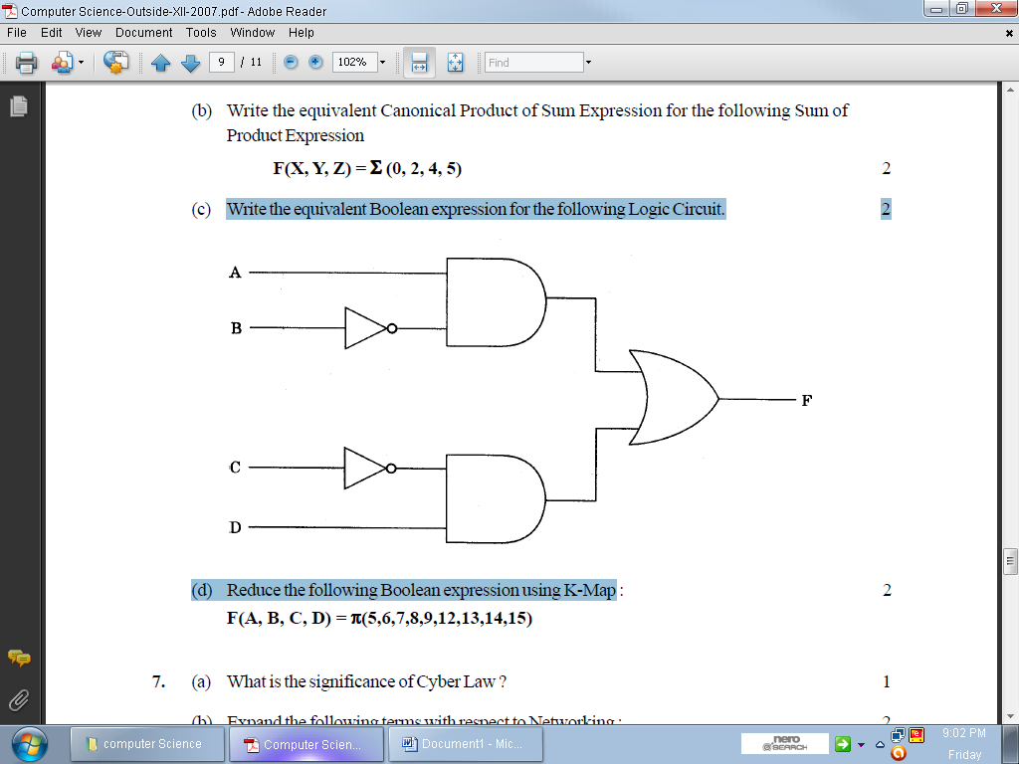

(c) Write the SOP form of a Boolean function G, which is represented in a truth table as follows: [1]
U | V | W | G
0 | 0 | 0 | 1
0 | 0 | 1 | 1
0 | 1 | 0 | 0
0 | 1 | 1 | 0
1 | 0 | 0 | 1
1 | 0 | 1 | 1
1 | 1 | 0 | 0
1 | 1 | 1 | 1

(d) Reduce the following Boolean Expression using K-Map: [3]
F(U,V,W,Z)= ∑(0,1,4,5,6,7,11,12,13,14,15)

Ques 7
(a) Differentiate between http and ftp. [1]
(b) Out of the following, which is the fastest (i) wired and (ii) wireless medium of communication?
Infrared, Coaxial Cable, Ethernet Cable, Microwave, Optical Fiber [1]
(c) What is Virus? How is it removed? [1]
(d) Out of the following, which all comes under cyber crime? [1]
(i) Stealing away a brand new computer from a showroom.
(ii) Getting in someone’s social networking account without his consent and posting pictures on his behalf to harass him.
(iii) Secretly copying files from server of a call center and selling it to the other organization.
(iv) Viewing sites on a internet browser.
(e) Indian Public School in Darjeeling is setting up the network between the different wings. There are
4 wings names as Senior(S), Junior(J), Admin(A) and Hostel(H). [4]
Distance between various wings
Wing A to Wing S | 100m |  | Wing A | 10
Wing A to Wing J | 200m |  | Wing S | 200
Wing A to Wing H | 400m |  | Wing J | 100
Wing S to Wing J | 300m |  | Wing H | 50
Wing S to Wing H | 100m
Wing J to Wing H | 450m

- Suggest a suitable Topology for Networking the computer of all wings
- Name the wing where the server is to be installed. Justify your answer.
- Suggest the placement of Hub/Switch in the network.
- Mention an economic technology to provide internet accessibility to all wings.
(f) What do you mean by Cyber law? [1]
(g) What do you mean by free software? Give one example of such software. [1]

Sunil Kumar
Computer Science
Vaish Model Sr. Sec. School
Bhiwani Haryana
Mob. 9812100604
Email: mrparmarsunil@gmail.com

