
Class – 9th
Math Test
Time – 2 Hour
Marks – 60

(Chapter -12)
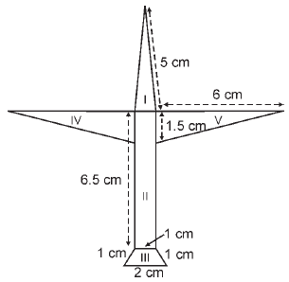
Q1) Radha made a picture of an aeroplane with coloured paper as shown in the figure. Find the total area of the paper used.(iii)

Q2) A field is in the shape of a trapezium whose parallel sides are 25 m and 10 m. The non-parallel sides are 14 m and 13 m. Find the area of the field.(iii)
Q3) A triangular park has sides 120 m, 80 m and 50 m. A gardener has to put a fence all around it and also plant grass inside. How much area does he need to plant ? Find the cost of fencing it with barbed wire at the rate of Rs 20 per metre leaving a space 3 m wide for a gate on one side.(iii)

(Chapter - 1)
Q1) Find six rational numbers between 4/7 and 5/8.(3)
Q2) Represent √ 17 on number line.(2)
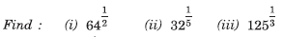
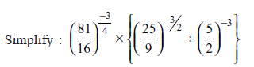
Q3) (3)

Q4) (3)

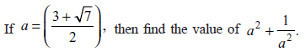
Q5) (3)
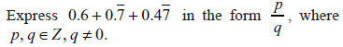
Q6) (3)

(Chapter - 2)
Q1) Divide the polynomial 3x⁴ – 4x³ – 3x –1 by x – 1.(3)
Q2) Find the value of k, if x – 1 is a factor of 4x³ + 3x² – 4x + k.(2)
Q3) Expand (4a – 2b – 3c)².(2)

Q4) Without actually calculating the cubes, find the value of each of the following: (3)
(i) (–12)³ + (7)³ + (5)³
(ii) (28)³ + (–15)³ + (–13)³
Q5) Factorise:- (3)

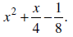

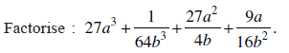
Q6) (3)

(Chapter 5)
Q1) In the figure, if PS = RQ, then prove that PR = SQ.(ii)
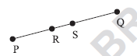
Q2) In the figure, AE = DF, E is the mid point of AB and F is the mid point of DC. Using an Euclid's axiom, show that AB = DC (ii)
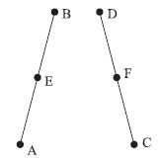
Q3) Write Euclid’s five postulates.Also define parallel lines.(iii)

(Chapter - 3)

Q1) Plot the points P (1, 0), Q (4, 0) and S (1, 3). Find the coordinate of the point R such that PQRS is a square.(2)
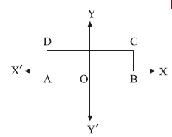
Q2) Plot the points A (3, 0), B (3, 3) and C (0, 3) in a cartesian plane. Join OA, AB, BC and CO. Name the figure so formed and write its one property.(3)
Q3) In the figure, ABCD is a rectangle with length 6 cm and breadth 3 cm. O is the mid point of AB. Find the co-ordinates of A, B,C and D. (2)

Q4) (i) Plot each of the points A (–2, 4), B (–2, – 3), C (4, –3) and D (4, 4). (4 marks)
(ii) Draw the segments AB, BC, CD and DA. What is the name of the figure ABCD ?
(iii) What are the coordinates of the point where the segment AD cuts the y-axis ?
(iv) What are the coordinates of the points where the segment CD cuts the x-axis ?

Website:- www.educominstitute.com Email:- educominstitute@live.com
Phone:- +919891542258

