Sample Paper -2015

Subject: Political Science
Class : XII – Arts

TIME: 3 hrs M.M. 100

General Instructions :-
- All questions are compulsory
- Question No. 1-5 are 1 mark. Answer them upto 20 words.
- Questions from 6 to 10 are 2 marks. Answer them in 40 words.
- Question from 11-16 are 4 marks their answer should not exceed 100 words.
- Question No. 17-19 are passage based carrying 5 marks.
- Question No.20and 21 are map questions/picture based carrying 5 marks.
7. Question no.22-27 are long answers carrying 6 marks. Write their answers from 120-150 words.

1. Who was P.C. Mahalnobis?
2. What is ‘Amnesty International’ responsible for?
3. How far is it correct to say that globalization results in the erosion of State sovereignty?
4. Correct and rewrite the following:
Eight temporary members of the UN Security Council are elected by the General Assembly for a
period of three years.
5. Who signed the Tashkent Agreement and when?
6. What is meant by ‘one party dominance’ in the Indian context?
7. What was Bandung Conference? Describe its outcome.
8. What is meant by decentralized planning ?
9. What was the role of Sardar Patel in the integration of princely states into the Indian union ?
10. Define Geo politics.
11. Explain any three challenges for nation building faced by India at the time of its independence.
12. The phrase ‘Aaya Ram Gaya Ram’ signifies which concept? Explain its impact on the Indian political
system.
13. Describe the basic principles of the foreign policy of India.
14. What is India’s attitude on C.T.B.T.? Why has India not signed C.T.B.T.?
15. How would you support India’s candidature for the permanent membership of the Security Council?
16. What is the difference between traditional and non-traditional security?
17. Read this passage and answer the following questions:
“If globalization is about the flows of ideas, capital, commodities and people, it is perhaps
logical to ask if there is anything novel about this phenomenon. Globalization in terms
of these four flows has taken place through much of human history. However, those who
argue that there is something distinct about contemporary globalization point out that it
in the scale and speed of these flows that account for the uniqueness of globalization.

(a) Give an example of each of these four flows that distinguishes globalization from
similar flows in earlier times. 2
(b) Can we conclude from this way looking at globalization that is essentially economic and always positive? give examples to support your position. 3 18 Read the given paragraph and answer the following questions :
“Way back in the late sixties, the dominance of the congress party was challenged; but the congress
under the leadership of Indira Gandhi, managed to re-establish its predominant position in politics,
The nineties saw yet another challenge to the predominant position of the congress, it did not ,
however, mean the emergence of any other single party to fill in its place.”
(i) Give two reasons for the decline of the congress. 2
(ii) A new party system emerged in 1989. What is it ? Explain. 2
(iii) Suggest any two solutions which give a stable government. 1

19. Read the paragraph given below carefully and answer the following questions :
We have a Muslim minority who are so large in numbers that they cannot, even if they want ,
go anywhere else. That is a basic fact about which there can be no argument. Whatever the
provocation from Pakistan and whatever the indignities and horrors inflicted on non-Muslims
there, we have got to deal with this minority in a civilized manner. We must give them security
and the rights of citizens in a democratic State. If we fail to do so, we shall have a festering
sore which will eventually poison the whole body politic and probably destroy it.
Jawaharlal Nehru, Letter to Chief Ministers

(a) Why Jawaharlal Nehru wanted to deal with Muslim minority in a civilized way ? 2

(b) Why this minority should be given the security and rights on the same footing as to all other in
a democratic system. 2
(c) If this minority was not provided security and rights what kinds of scenario is envisaged ? 1

20. On the given political map of India , five states of tensions related to integration from 1947 to
2006 have been marked as A, B, C, D, E. Identify these states and write their names in your answer
book against A, B, C, D, E respectively. 5

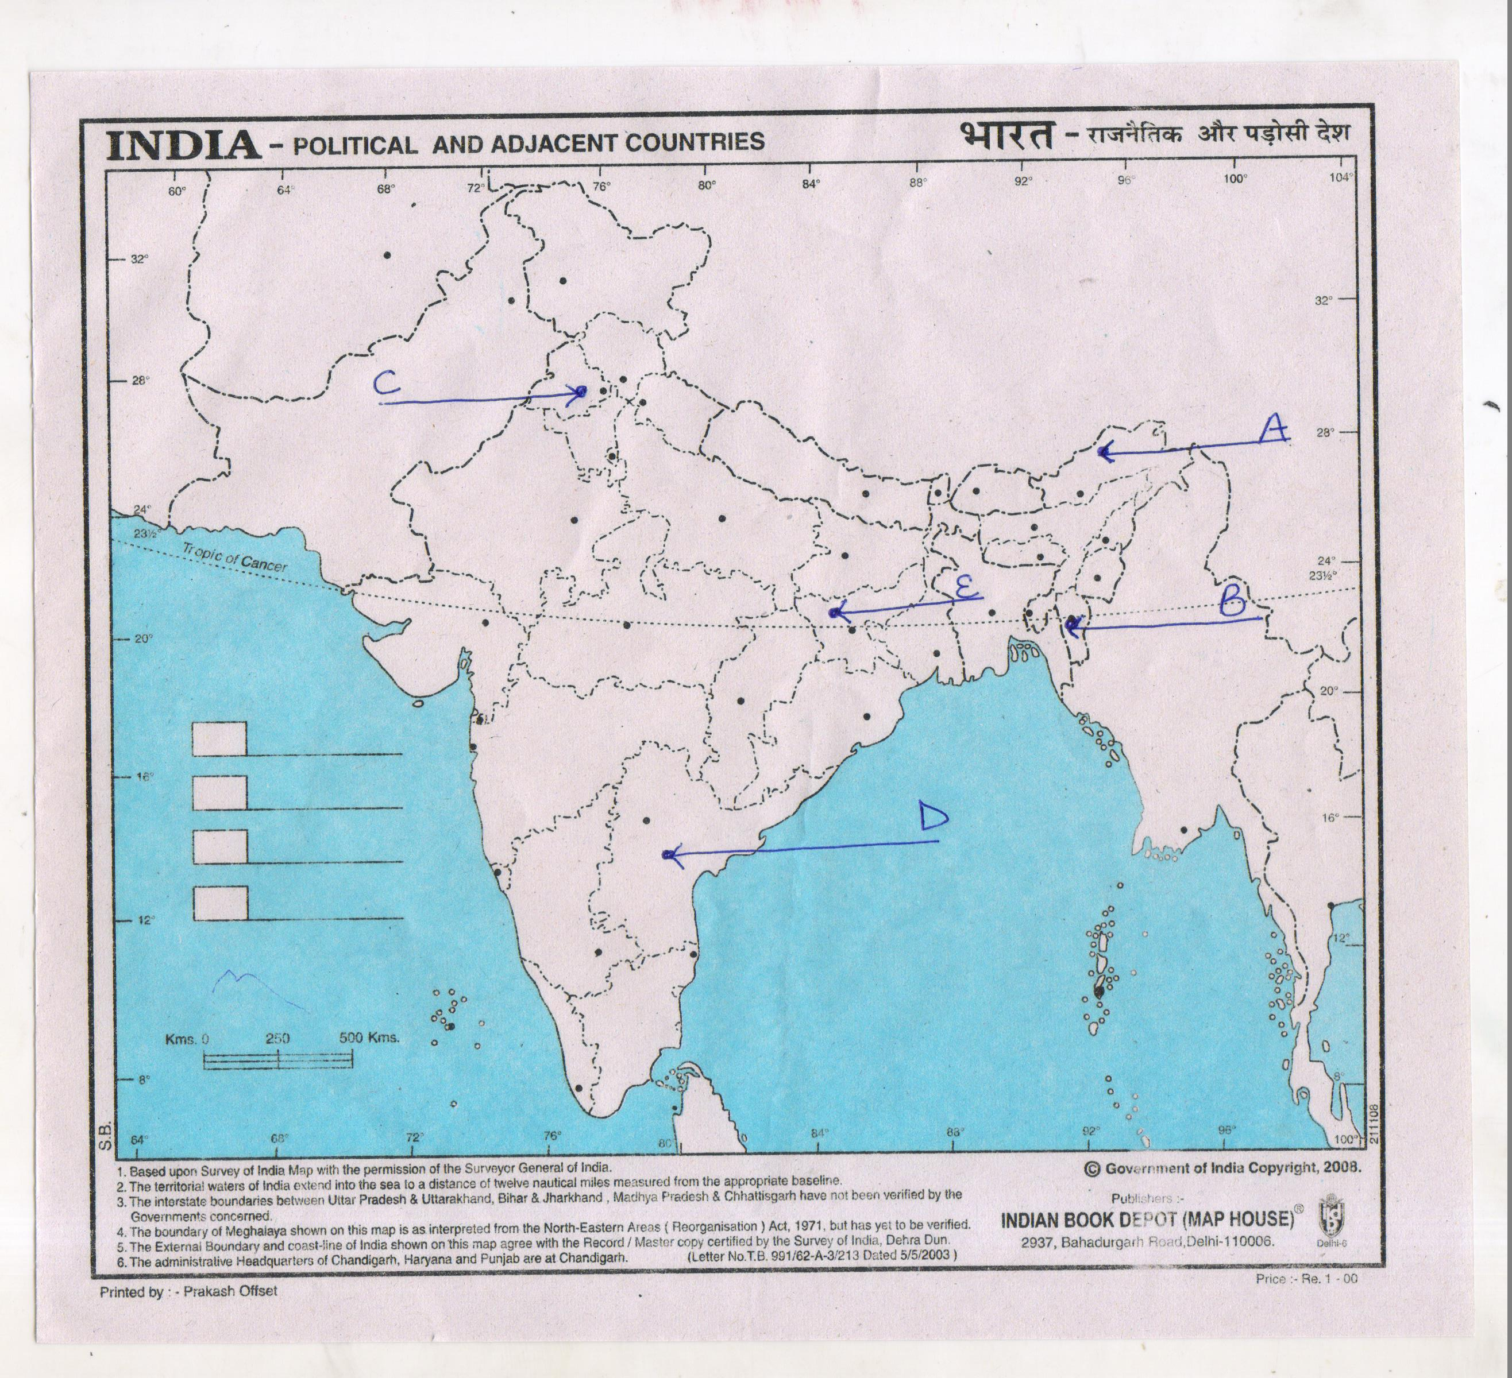

20. Study the cartoon given below and the following questions:-

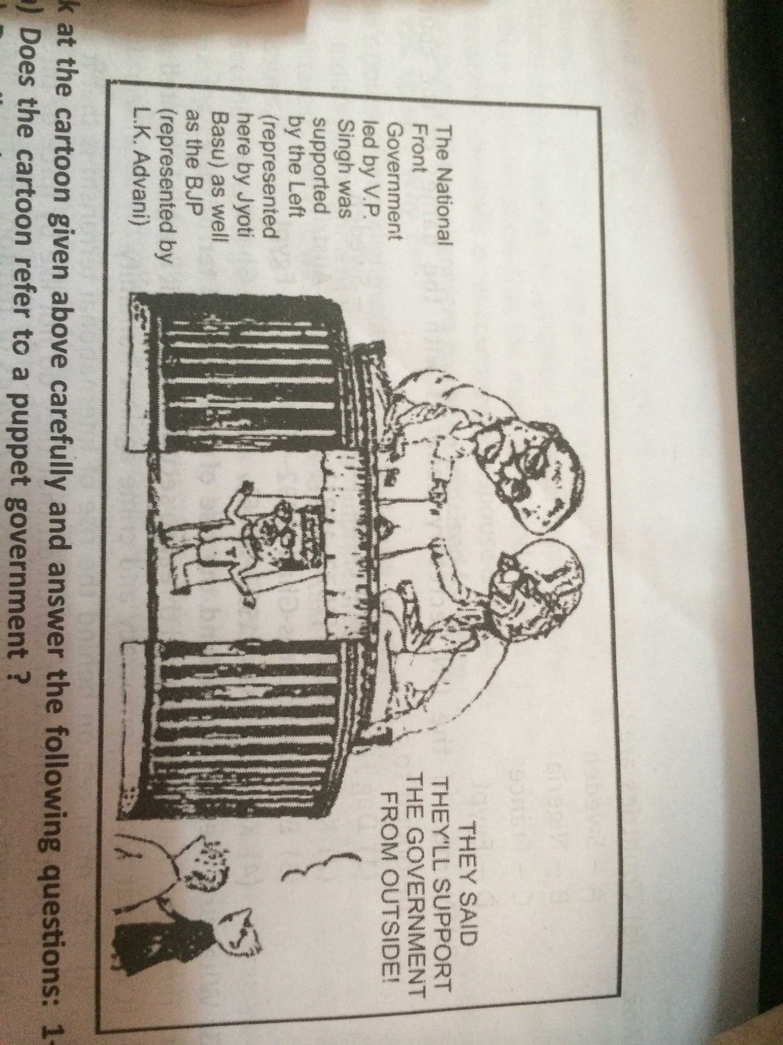

(a) Does the cartoon refer to a puppet government ? 1+2+2=5
(b) Describe the role of such a government in the Indian democratic set up.
(c) What is meant by ‘Support the government from outside’?

22. Explain peaceful and conflicting relations with India and China. 6
OR
Define globalization. What are its causes? Assess any three basis on which globalization is being
resisted in India.

23. Analyze any three reasons for imposing emergency on 25th June,1975. Did the government misuse its
emergency powers? Give any three arguments in support of your answer 6
OR
Examine the grave economic crisis prior to the 4th general elections of 1967. Assess the verdict of the electorate based on the election.

24. Assess any six steps suggested since 2005 to make the UN more relevant in the changing world. 6
OR
What is meant by security ? Evaluate the role of any new sources of threat to security.

25. What was Green Revolution ? Mention its three positive and three negative consequences. 6
OR
How did the dominance of Congress Party affect the democratic nature of Indian politics?

26. Assess any two causes of the partition of India in 1947. Explain any four of its consequences.6
OR
Assess the outcome of planned development towards the foundation of India’s economic growth and
land reforms.
27. Explain the concept of ‘common but differentiated responsibilities’. How and where was it emphasized upon? 6
OR Analyze India’s stand on environmental issues.

Submitted by: Manita Bishnoi
Email: manitabishnoi@gmail.com

