Guess Paper 2013
Class- XII

Subject – Physics

General Instructions:
- All questions are compulsory.
- There is no overall choice. However, an internal choice has been provided in one question of two marks, one question of three marks and all questions of five marks. You have to attempt only one the choices in such questions.
- Question numbers 1 to 8 are very short answer type questions, carrying one mark each.
- Questions numbers 9 to 16 are short answer type questions carrying two marks each.
- Question numbers 17 to 25 are also short answer type questions, carrying 3 marks each.
- Question numbers 26 value based type question, carrying four marks each.
- Question numbers 27 to 29 are long answer type questions, carrying five marks each.
- Use of calculators is not permitted. However, you may use log tables, if necessary.
You may use the following physical constants wherever necessary.
c = 3 x 10⁸ ms⁻¹
h = 6.6 x 10⁻³⁴ Js
e = 1.6 x 10⁻¹⁹C
µ_{o} = 4π x 10⁻⁷ TmA⁻¹
1/4πε_{o} = 9 x 10⁹ N m²C⁻²
Avogadro number N_{A} = 6.023 x 10²³ mol⁻¹
Mass of the neutron = 1.675 x 10⁻²⁷ kg
Boltzmann constant, k = 1.38 x 10²³ J K⁻¹

      - An electron beam projected along +X axis, experiences a force due to a magnetic field along the
+ Y-axis. What is the direction of the magnetic field?
      - The instantaneous current from an ac source is I = 6 sin 314t. What is the rms value of the current?
      - A bulb connected in series with a solenoid is lit by ac source. If a soft iron core is introduced in the solenoid, will the bulb glow brighter?
      - Which part of the electromagnetic spectrum is used in operating RADAR? Give its wavelength range.
      - Two thin lenses + 6D and -2D are in contact. What is the focal length of the combination?
      - The ionization potential of hydrogen is 13.6 V. calculate the energy of its first excited state.
      - How does the collector current change in a junction transistor, if the base region has larger width?
      - How does the conductivity change of a semiconductor with increase of temperature?
      - Define the term temperature coefficient of resistivity. Draw a graph showing the variation of resistivity with temperature for copper.
      - 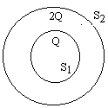S₁ and S₂ are two hollow concentric sphere enclosing charges Q and 2Q respectively as shown in fig.
(a)What is the ratio of electric flux through S₁ & S₂?
(b)How will the electric flux through the sphere change, if a medium of dielectric constant 5 is introduced in the space inside S₁ in place of air?
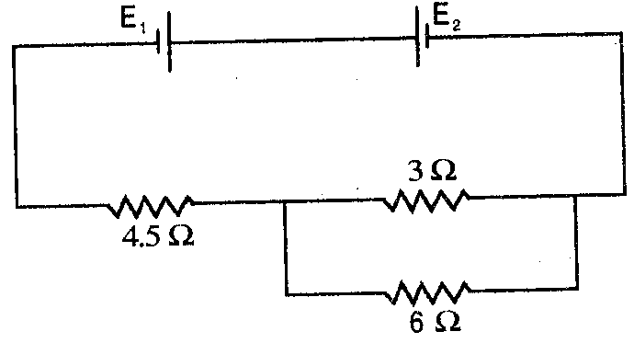
      - Two cells E₁ and E₂ in the given circuit diagram have an emf of 4V and 8V and internal resistance 0.5Ω and 1.0Ω respectively. Calculate the current flowing through the resistance of 3Ω.

      - How will a dia & ferro magnetic material behave when kept in a non-uniform external field? Give two examples each.
      - A double concave lens of glass of RI 1.6 has radii of curvature of 40cm, 60cm. Calculate its focal length. Also find the focal length of the lens if the lens is immersed in a liquid of RI 1.3.
      - Show that the de-Broglie wavelength λ of electrons of energy E is given by the relation
λ =
      - If the frequency of light on metal surface is doubled, will the kinetic energy of photoelectrons be doubled. Explain ?
      - Define half life. Derive the relation between half life and decay constant.
      - Define electric dipole. Derive an expression for eclectic potential on the axis of dipole.
      - State Guass’s theorem in electrostatics. Derive an expression for electric field intensity produced by charged thin sheet using this theorem.
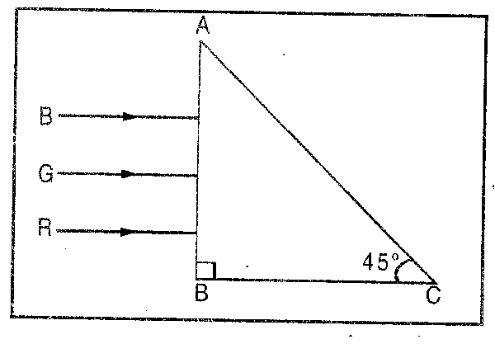
      - Write the principle of potentiometer. Explain with diagram how will you measure internal resistance of a cell using potentiometer.
      - Derive a relation between root mean square value and peak value of alternating current.
      - Three rays of light red (R), green (G) and blue (B) are incident on the face AB of a right angled prism ABC. The refractive indices of the material of the prism for red, green and blue wavelengths are 1.39, 1.44 and 1.47 respectively. Trace the path of the rays through the prism. How will the situation change if these rays were incident normally on one of the faces of an equilateral prism?
      - State radioactive disintegration law and deduce the relation N = N₀e^{-λt} where symbols have their usual meaning.
      - Define mutual inductance. Derive an expression for mutual inductance of two long co-axial solenoid of sane length wound over the other.
      - Draw a labeled ray diagram to show the image formation by an astronomical telescope when final image is forms at least distance of distinct vision. Derive an expression for its magnifying power.
      - (a) With the help of block diagram, briefly explain the function of a receiver for detection of amplitude modulated wave.
(b)A radio can tune two any stations in 7.5MHz to 12MHz band. What is corresponding wavelength band.
- Monica had come from Singapore on a holiday to her grandmother’s place. She had heard a lot about Tirupathi temple and so she went to Tirupathi with her grandmother. She walked through a metal detector and heard a beep sound as she walked through it. When she went back to Singapore she asked her father about the metal detector and its working. Her father explained the working in detail and also the need for installing metal detectors in places where
people visited in huge numbers.
a) Name the components present in the detector .
b) What is the phenomenon involved?
c) What value can be attached with this?
      - Draw a graph to show the variation of the angle of deviation with that of the angle of incidence for a monochromatic ray of light passing through a glass prism of refracting angle A and deduce the relation for its refractive index in terms of refracting angle and minimum deviation. Also explain Angular dispersion and Dispersive power.
OR
Define the term wave front. Draw the wave front and corresponding rays in the case of a (i) diverging spherical wave, (ii) plane wave.
Using Huygen’s postulates explain the refraction of a plane wave front at a plane surface and hence verify Snell’s law.

      - Draw a circuit diagram to study the input and output characteristic of an n-p-n transistor in common emitter mode. Explain these characteristics graphically.
OR
(a)Explain the use of Zener diode as voltage regulator.
(b)The output of an OR gate is connected to both the inputs of a NAND gate. Draw the logic circuit of this combination of gates and write its truth table.
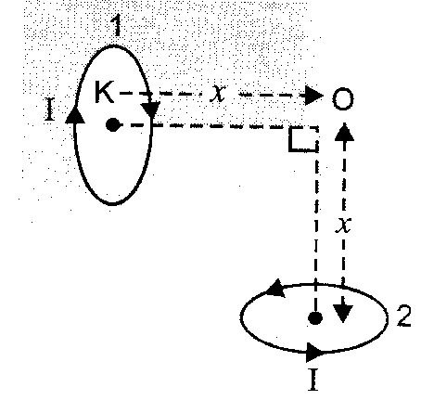
      - (a) Using Biot- Savart’s law derive an expression for magnetic field intensity on the axis of a circular coil carrying current.
(b) To small circular loops each of radius R marked 1 and 2 carrying equal currents are placed with the geometrical axis perpendicular to each other as shown in fig. find the magnitude and direction of the net magnetic field produced at the point O.

OR
State Ampere circuital law, A long solenoid with closely wound turns has n turns per unit length. A steady current I flows through this solenoid. Use ampere circuital law, how to obtain an expression for magnetic field at a point on its axis and close to its mid point.

GURUKUL ACADEMY

Time – 3hr. Test – Full Syllabus. M.M – 70. Question no 1 to 8 – [1 Marks each]. Question no 9 to 16 – [2 Marks each].
Question no 17 to 25 – [3 Marks each]. Question no 27 to 29 – [5 Marks each].
Question no 26 – [4 Marks, Value based question ]
E-mail –gurukulacademy@gmail.com
GURUKUL ACADEMY Test paper based on C.B.S.E Exam 2013
By – A.K.Pandey, 9958655311, 100% Success guaranty in board exam.

