SAMPLE PAPER-2013
CLASS-XII
SUBJECT- PHYSICS

Time allowed: 3 hours Maximum Marks: 70
General Instructions:
(i) All questions are compulsory..
(iii) Q.No. 1 to 8 are very short answer type questions, carrying one mark each.
(iv) Q.No numbers 9 to 18 are short answer type questions, carrying two marks each.
(v) Q.No. 19 to 27 are also short answer type questions, carrying three marks each.
(vi) Q.No. 28 to 30 are long answer type questions, carrying five marks each.
(viii) You may use the following values of physical constants wherever necessary
c=3x10⁸ m/s h=6.6 x 10⁻³⁴ Js e=1.6 x 10⁻¹⁹ C N_{A} = 6.023 x 10²³ /mole m_{n} = 1.67 x 10⁻²⁷ kg µ₀ =4π x 10⁻⁷ T-m/A me = 9 x 10⁻³¹ kg

- Write two energy losses in a Transformer.

- Define electric susceptibility. How its related to dielectric constant?

- An alpha particle enters a region of electric and magnetic field and passes without deviation in its path. What is the net force acting on the particle in the region?

- Draw a spherical wave front by a point source of light.

- The electric field between two parallel plates of capacitor changes with time, a current begins to flow in between the plates. Write the related law.

- How a wavelength of light is associated with the stopping potential. Draw a graph between them.

- What is gamma decay? Give an example.

- Name two optoelectronic devices .Write on use of each

- State gauss theorem in electrostatics. Draw the graph between electric field intensity and distance for an thin linear charged rod.

- What is the effective capacitance across XY of the capacitor of capacitance if the capacitor with air/vacuum between the plates of area A each and distance d apart was C_{o}.
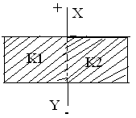

- State laws which are used for calculating equivalent resistance of unbalanced wheat stone bridge.
OR
Calculate the equivalent resistance of the following circuit.
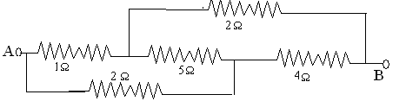

- Define current sensitivity and voltage sensitivity of a galvanometer. Increasing the current sensitivity may not necessarily increase the voltage sensitivity of a galvanometer. Justify.

- When 100 volts d.c is applied across an inductor, a current of 1A flows through it. If the same inductor is connected across 100 v a.c. source, a current reduces to 0.5 A. Why is the current reduced in later case? Calculate the reactance.

- Draw the diagram of an AC generator. Write its working

- Two students A and B prepare the following table about the electromagnetic waves. Rewrite this table in its corrected form.

- How a rainbow is formed .Draw the diagram of secondary and primary rainbow showing the difference of order of colours.

- The energy levels in an atom of an element are shown in the following diagram. Which one of the level transition will result in the emission of photon of wavelength 620nm? Support your answer with mathematical calculation.
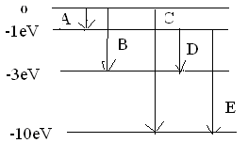

- Write the function of (i) Transducer and (ii) Repeater in the context of communication system.
OR
Why can’t we transmit modulating signals using antenna? Give two practical reasons.

- Derive the expression for the electric potential due to an electric dipole at any point. Justify that the electric potential remains zero at the equatorial line of the dipole.
OR
A parallel plate capacitor is charged by a battery. If the distance between the plates is decreased. How would (i) the capacitance, (ii) the electric field between the plates and (iii) the energy stored in the capacitor, be affected? Justify your answer.

- State Lenz’s law. Predict the direction of induced current in the situations described by the following Figs.

- In Young’s double slit experiment, monochromatic light of wavelength 630 nm illuminates the pair of slits and produces an interference pattern in which two consecutive bright fringes are separated by 8.1 mm. Another source of monochromatic light produces the interference pattern in which the two consecutive bright fringes are separated by 7.2 mm. Find the wavelength of light from the second source.What is the effect on the interference fringes if the monochromatic source is replaced by a source of white light?

- Define stopping potential. X -ray of wavelength λ falls on photosensitive surface emitting electron. Assuming that the work function of the surface can be neglected, prove that de-Broglie wavelength of electron emitted will be [ h λ/2mc]^{1/2}

- (i) Draw a labeled ray diagram to show the formation of image in an astronomical telescope for a distant object
(ii) Write two distinct advantages of a reflecting type telescope over a refracting type telescope

- Define decay constant. Give the mass number and atomic number of elements on the right hand side of the decay process. ₈₆Ru²²⁰ → Po + He The graph shows how the activity of sample of radon-220 changes with time. Using this graph calculate (1) half life (2) decay constant

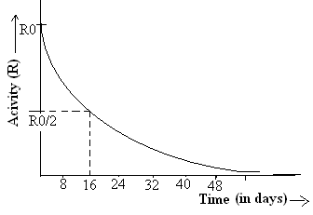

- (a)Draw voltage – current characteristics and circuit of a reverse biasing diode.
(b)Why a zener diode is heavily doped. Write its working

- Ramesh an electrician was called by the people of a NGO in a village to inform people about the safety measures of AC electrical devices and being used in daily life. He game the demonstration of charging and discharging of battery of a solar light. The people of village appreciated the steps of NGO.
- List three values of NGO displayed in informing the villagers about the safety measures.
- What is the standard voltage and frequency used for AC in India?
- Write one difference between charging and discharging of a battery

- A modulating signal is a square wave as shown in the figure. The carrier wave is given by y(t) = 4 sin (6πt) volts. Draw the amplitude modulated wave.
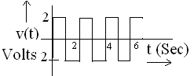

- Draw a schematic sketch of a cyclotron. Explain briefly how it works and how it is used to accelerate the charged particles. (i) Show that time period of ions in a cyclotron is independent of both the speed and radius of circular path. (ii) What is resonance condition? How is it used to accelerate the charged particles?
OR

State the principle of working of galvanometer. In galvanometer (i) concave shaped poles are used (ii) phosphor-bronze alloy is used for the suspension wire. Explain why? The current sensitivity of moving coil galvanometer is 5 divisions/mA and voltage sensitivity is 20 division/volt. Calculate the resistance of galvanometer.

- Draw the variation of intensity with angle in single slit diffraction experiment. Derive the expression for the central fringe width .How ray optics is a limiting case of wave optics. Determine angular separation between central maximum and first order maximum of the diffraction pattern due to a single slit of width 0.25mm when light of wavelength 5890 A⁰ is incident on it normally.
Or

(a)Define fringe width. Derive the expression for the fringe width of a bright band.
(b)The intensity, at the central maxima(O) in a Young’s double slit set up is I₀ .If the distance OP equals one third of the fringe width of the pattern, show that the intensity, at point P., would equal I₀/4

- (a) Explain input and output characteristics of a common emitter transistor graphically. Draw the circuit diagram.
(b)Two amplifiers are connected one after the other in series (cascaded).The first amplifier has a voltage gain of 10 and the second has a voltage gain of 20. If the input signal is 0.01 volt, calculate the output ac signal.
OR
How a junction diode is formed. Explain the working when it is reverse and forward biased with circuital and graphical diagram. A given table is represented with voltage and current values calculate dynamic forward and reverse bias resistance resistance

Forward biasing | 2V  4V | 60mA  80mA
Reverse biasing | 0V  -2V | 0µA  -0.25µA

Shailendra Rawat
Academic director –VECTOR CLASSES (The classes with a direction)
Email -Vectorclasses2003@gmail.com
papercopyright@vectorclasses(The classes with a direction)

