SAMPLE PAPER-2013
CLASS-XII
SUBJECT- PHYSICS

Time allowed: 3 hours Maximum Marks: 70
General Instructions:
(i) All questions are compulsory..
(iii) Q.No. 1 to 8 are very short answer type questions, carrying one mark each.
(iv) Q.No numbers 9 to 18 are short answer type questions, carrying two marks each.
(v) Q.No. 19 to 27 are also short answer type questions, carrying three marks each.
(vi) Q.No. 28 to 30 are long answer type questions, carrying five marks each.
(viii) You may use the following values of physical constants wherever necessary
c=3x10⁸ m/s h=6.6 x 10⁻³⁴ Js e=1.6 x 10⁻¹⁹ C N_{A} = 6.023 x 10²³ /mole m_{n} = 1.67 x 10⁻²⁷ kg µ₀ =4π x 10⁻⁷ T-m/A me = 9 x 10⁻³¹ kg

- On what two factors the inductance of a long solenoid depends?

- Draw equipotenial surface due to a electric dipole.

- An electron an a proton, having equal momenta, enter a uniform magnetic field at right angles to the field lines. What will be the ratio of the radii of curvature of their trajectories?

- A convex lens of refractive index n₁ is dipped in a medium of refractive index n₂ .If n₁ < n₂ than what will happen to the nature of lens

- Why infra red waves are the heating waves.

- How a wavelength of light is associated with the stopping potential. Draw a graph between them.

- Write the radius of a nuclei (R) is related with the mass number (A).

- Name the device which shows the variation of current (I) with voltage (V) as shown:

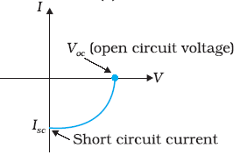

- State gauss theorem in electrostatics. Draw the graph between electric field intensity and distance for an thin linear charged rod.

- What is the effective capacitance across XY of the capacitor of capacitance if the capacitor with air/vacuum between the plates of area A each and distance d apart was C_{o}.
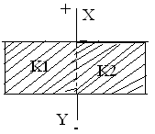

- State laws which are used for calculating equivalent resistance of unbalanced wheat stone bridge.
OR
Calculate the equivalent resistance of the following circuit.
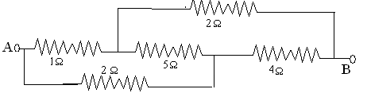

- Define radial magnetic field. Write two characteristics of suspension coil.

- When 100 volts d.c is applied across an inductor, a current of 1A flows through it. If the same inductor is connected across 100 v a.c. source, a current reduces to 0.5 A. Why is the current reduced in later case? Calculate the reactance.

- Draw the diagram of an AC generator. Write its working

- Two students A and B prepare the following table about the electromagnetic waves. Rewrite this table in its corrected form.

- Using Huygen’s geometrical construction to show the behavior of a plane wavefront.
- Passing through a biconvex lens;
- Reflecting by a concave mirror

- How long can an electric lamp of 100W be kept glowing by fusion of 2.0 kg of deuterium? Take the fusion reaction as
₁H² + ₁H² → ₂He⁴ + n + 3.27 MeV 3
(OR)
Calculate the binding energy per nucleon of ₂₀Ca⁴⁰ nucleus. Given: m (₂₀Ca⁴⁰) = 39.962589u
Mass of a neutron = 1.008665u and mass of a proton = 1.007825u. 1u = 931MeV

- Why can’t we transmit modulating signals using antenna? Give two practical reasons.

- Derive the expression for the electric potential due to an electric dipole at any point. Justify that the electric potential remains zero at the equatorial line of the dipole.
OR
A parallel plate capacitor is charged by a battery. If the distance between the plates is decreased. How would (i) the capacitance, (ii) the electric field between the plates and (iii) the energy stored in the capacitor, be affected? Justify your answer.

- State Lenz’s law. Predict the direction of induced current in the situations described by the following Figs.

- In Young’s double slit experiment, monochromatic light of wavelength 630 nm illuminates the pair of slits and produces an interference pattern in which two consecutive bright fringes are separated by 8.1 mm. Another source of monochromatic light produces the interference pattern in which the two consecutive bright fringes are separated by 7.2 mm. Find the wavelength of light from the second source.What is the effect on the interference fringes if the monochromatic source is replaced by a source of white light?

- Define stopping potential. X -ray of wavelength λ falls on photosensitive surface emitting electron. Assuming that the work function of the surface can be neglected, prove that de-Broglie wavelength of electron emitted will be [ h λ/2mc]^{1/2}

- (a) A microscope is focused on a dot at the bottom of a beaker. Some oil is poured into the beaker to a height of ‘α ’ cm and it is found necessary to raise microscope through a vertical distance of ‘β’ cm to bring the dot again into focus. Express refractive index of oil in terms of ‘α’ and ‘β’.(b) How optical fibers follow principle of total internal reflection.
- Define decay constant. Give the mass number and atomic number of elements on the right hand side of the decay process. ₈₆Ru²²⁰ → Po + He The graph shows how the activity of sample of radon-220 changes with time. Using this graph calculate (1) half life (2) decay constant

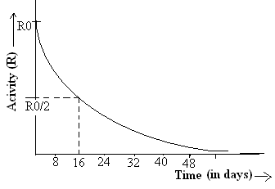

- (a)Draw voltage – current characteristics and circuit of a reverse biasing diode.
(b)Why a zener diode is heavily doped. Write its working

- Two cells of the same emf E, but different internal resistance r_{l} and r₂ are connected to an external resistance R as shown. in the figure. The voltmeter V reads zero. Obtain an expression for R in terms of r_{l} and r₂. Calculate the voltage across the cell of internal resistance r₂. (Assume that the voltmeter V is of infinite resistance).
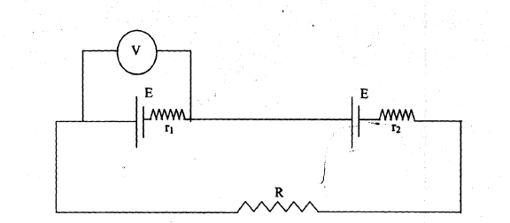

- (a) Show mathematically, an amplitude modulated signal contains the frequencies ω_{c}, ω_{c}+ω_{m} and ω_{c} - ω_{m}, where the symbols have their usual meanings. (b) Draw the block diagram to illustrate the process of amplitude modulation.

- (a) Draw a schematic sketch of a cyclotron. Explain briefly how it works and how it is used to accelerate the charged particles.
(b)An electron emitted by a heated cathode and accelerated through a potential difference of 2.0 kV, enters a region with uniform magnetic field of 0.15 T. Determine the trajectory of the electron if the field (i) is transverse to its initial velocity, (ii) makes an angle of 30º with the initial velocity.

OR

- State Biot-Savart’s law. Using the law derive the expression for the magnetic field due to a current carrying circular loop at a point on the axis of the coil.
- At what distance from the centre on the axis of the coil will the magnetic field be 1/8th of its value at the centre.

- Draw the variation of intensity with angle in single slit diffraction experiment. Derive the expression for the central fringe width .How ray optics is a limiting case of wave optics. Determine angular separation between central maximum and first order maximum of the diffraction pattern due to a single slit of width 0.25mm when light of wavelength 5890 A⁰ is incident on it normally.
Or

(a)Define fringe width. Derive the expression for the fringe width of a bright band.
(b)The intensity, at the central maxima (O) in a Young’s double slit set up is I₀ .If the distance OP equals one third of the fringe width of the pattern, show that the intensity, at point P., would equal I₀/4

- (a) Explain input and output characteristics of a common emitter transistor graphically. Draw the circuit diagram.
(b)Two amplifiers are connected one after the other in series (cascaded).The first amplifier has a voltage gain of 10 and the second has a voltage gain of 20. If the input signal is 0.01 volt, calculate the output ac signal.
OR
How a junction diode is formed. Explain the working when it is reverse and forward biased with circuital and graphical diagram. A given table is represented with voltage and current values calculate dynamic forward and reverse bias resistance resistance

Forward biasing | 2V  4V | 60mA  80mA
Reverse biasing | 0V  -2V | 0µA  -0.25µA

Shailendra Rawat
Academic director –VECTOR CLASSES (The classes with a direction)
Email -Vectorclasses2003@gmail.com
papercopyright@vectorclasses(The classes with a direction)

