Sample Paper – 2013
Class – X
Subject – Science

VATSALYA PUBLIC SCHOOL, MANDSAUR
SUMMATIVE ASSESSMENT – I (2012-13) CLASS-X TIME: 3HRS
SCIENCE M.M. = 90
General Instructions:-

- The question paper comprises of two sections A and B. You are to attempt both the sections.
- All questions are compulsory.
- All questions to section A and B are to be attempted separately.
- Question no. 1 to 3 in section A are one mark each.These are to be answered in one word or one sentence.
- Question no. 4 to 7 are two mark each, to be answered in about 30 words.
- Question no. 8 to 19 are three mark each, to be answered in about 50 words.
- Question no. 20 to 24 are five mark each, to be answered in about 70 words.
- Question 25 to 42 in section B are multiple choice questions based on practical skills.Each question is a one mark question.You are to choose one most appropriate response out of four options.

SECTION –A

1. Name the physical quantity whose SI unit can be written as ‘J/C’. 1
2. Write the name and the chemical formula of organic compound which is present in vinegar. 1
3. Name the gland which secretes growth hormone. 1
4. Write an example of any co-valent compound. Why these compounds are named so? Explain formation
of the compound that you have given the example for it. 2
5. Sometime we do require substances with extra properties which can not be shown by a single metal or
non metal, name the category of these substance. Write any one example, its composition and its use. 2
6. What are the advantages of nuclear energy? 2
7. (a) Why is biogas considered as an ideal fuel?
(b)What are the qualities of an ideal source of energy? 2
8. Write balanced chemical equation for following :
a) Zinc metal reacts with aqueous solution of hydrochloric acid to form zinc chloride solution and hydrogen gas.
b) Magnesium ribbon is burnt.
c) Aqueous solution of sulphuric acid and sodium hydroxide react to form aqueous sodium sulphate and water. 3

9. Identify the type of chemical reaction taking place in each of the following–
- White silver chloride turns grey in sunlight.

- Hydrogen gas reacts with chlorine gas to give hydrogen chloride gas.
c) Electricity is passed through water. 3
10. A person wanted his house to be whitewashed. He bought 15 Kg of quick lime and dissolved it in 30 liters of water. On adding lime to water he noticed that the water started boiling even when it was not being heated. Give reason for his observation. Write the corresponding chemical equation and name product formed. 3
11. Answer the following questions –
i. Why is the formula of Plaster of Paris written as CaSO₄.½H₂O? How is it possible to have half of water molecule attached to CaSO₄?
ii. Why is sodium bicarbonate an essential ingredient of most antacids?
iii. When electricity is passed through aqueous solution of NaCl, three products are obtained. Why this process is called chlor-alkali process? 3
12. Two lamps, one rated 100 W at 220 volts and the other 80W at 220 volts are connected in parallel to a
220 V supply. What current is drawn from the supply line? 3
13. A coil of insulated copper wire is connected to a galvanometer. What will happen, and why, if a bar magnet is
(i). Pushed into the coil,
(ii). Withdrawn from inside the coil,
(iii). Held stationary inside coil. 3
14. A rectangular coil ABCD is placed between the poles of a horseshoe magnet as shown –
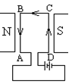
- What is the direction of force on each arm?
ii) What is the effect of the forces on the coil?
iii) How is the effect of forces on coil changed if the terminals of battery are interchanged? 3
15. Your are given ‘n’ resistors of resistance ‘R’ each. These are first connected in series to get R_{s} then connected in parallel to get R_{p.} Show that
R_{s} + R_{p} = (n² + 1) R/n 3

16. . (a) How are fats digested in our body? Where does this process occurs?
(b) What are the methods used by plants to get rid of excretory products? 3
17. (a) Why are some patient of diabetes treated by giving injection of insuline?
(b) How does phototropism occurs in plant? 3
18. What are reflex actions? Represent reflex arc with the help of a flow chart. 3
19. Describe how hydro-energy can be converted into electrical energy? Write any two limitation of it. 3
20. Give reason for the following :
.i. While diluting an acid, it is recommended that the acid should be added to the water and not water to acid.
ii. Generally acids react with metals and liberates hydrogen gas, but nitric acid does not do so.
iii. Plaster of Paris should be stored in a moisture proof container.
iv. Distilled water does not conduct electricity whereas rain water does.
v. Curd and sour substances should not be kept in brass or copper vessels.
OR
- A calcium compound yellowish white in colour is used as disinfectant and also in textile industry. Name the compound. How is it prepared? Give chemical reaction involved. Write its another use.

- A compound which is prepared from gypsum has the property of hardening when mixed with a proper quantity of water. Identify the compound. Write the chemical equation for its preparation. For what purpose it is used in hospitals? 5
21. In the diagram shown alongside-
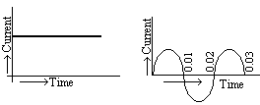
a) b)
a. Name the type of current in two cases.
b. Identify any one source for each type of these currents.
c. What is the frequency of current in case (b) in India?
d. Use above graphs to write two differences between the current in two cases.
OR
What is the principle behind the working of electric generator? Explain its working with the help of well labeled diagram. 5
22. What do you mean by metallurgy? Draw the chart for various steps envolved in extraction of metals for their ores. Differentiate between roasting and calcination. Write an example each for carbonate and sulphide ore.
OR
- Write the basic property which distinguishes metals from non metals.

- Why is it suggested to convert carbonate and sulphide ore into oxide ore?

- Explain the purification of copper from its ore also draw the suitable diagram. 5
23. a) How do you connect a voltmeter and ammeter in a circuit? What should be the resistance in the ideal case?
b) What is the value from electric current drawn from a battery of 20 V, if a resistor of resistance 5 Ω is connected to it.
c) Why do we connect all appliances in parallel in our home?
d) Write one advantage and one disadvantage of short circuiting.
OR
- State Ohm’s law. Express it mathematically.

- Write the symbols used in electric circuit to represent.

- Variable resistance ii) Connected wires
- Write any two properties of charge.

- An electric bulb is rated 220 V and 10 W. When it is operated on 110 V, what will be the power
consumed? 5
24. (a) What is double circulation in human-being? Explain its pathway.
(b) Why is it necessary? Draw a label diagram of human heart.
OR
- Explain the process of digestion of food in mouth, stomach & intestine in human.

- Draw structure of stomata & label it. 5

SECTION -B

25. Which of following is most reactive?
(a) Al (b) Au (c) Mg (d) Ag
26. What does the word “aq” represent in a chemical equation?

a) Water Solution b) Solid State c) Gaseous State d) Precipitation

27. Which of following equation is balanced?
(a) CaCO₃ + HCl CaCl₂ + CO₂ +H₂O
(b) 2H₂O 2H₂ + 2O₂
(c) 6CO₂ + 6H₂O C₆H₁₂O₆ + 6O₂
(d) H₂O + Cl HCl + O

28. Which of the following can not be used as a to find pH of a given solution ?

a) pH Paper b) Litmus Paper c) Universal Indicator d)Standard pH value chart
29. Rusting of iron can be occurred in presence of
a) Moisture only b) Air only c) Both Air and Moisture d) Either of Air or Moisture
30. While doing an experiment a student observed that the blue colour of the aqueous copper sulphate
solution was changed to pale green by immerging a metal rod in it. The metal of the rod used by the
student is
a) Iron b) Zink c) Silver d) Aluminium
31. Which graph shows Ohm‘s law for conductors?
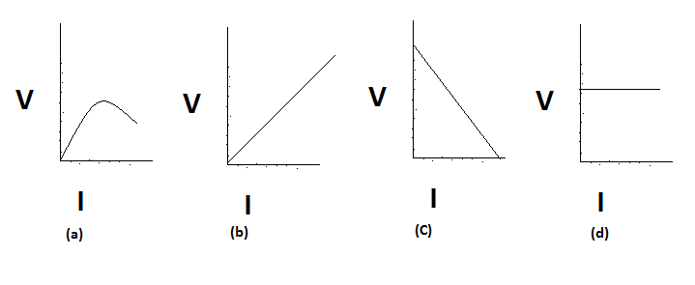
32. Commercial unit of electrical energy is
(a) Joule (b) Coulomb (c) Watt (d) kWh
33. Out of the four circuits shown for studying the dependence of the current on the potential difference across a resistor, the correct circuit is

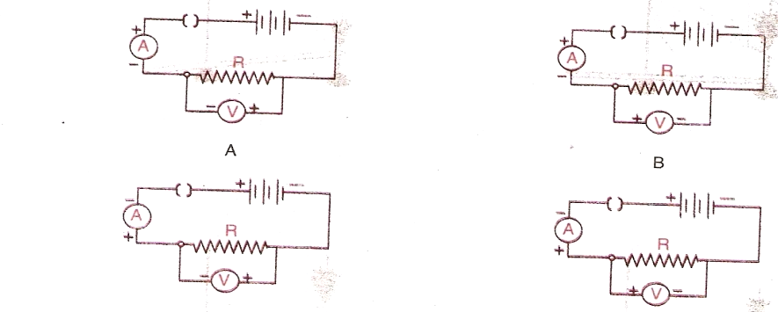

a) A b) B c) C d) D
34. During verification of Ohm’s law in laboratory, it is suggested to switch off battery after every observation,
because
- It will not last longer b) For keeping the temperature same for every reading
c) Teacher will scold you d) None of these
35. Connecting wire are made up of copper,
a) Copper is very reactive b) Copper has low conductivity
c) Copper has low resistivity d) Copper has high resistivity
36. On increasing the temperature resistivity of conductors
a) Increases b) Decreases
c) Remains constant d) Becomes zero
37. In the experimental set-up, KOH absorbs CO₂ in conical flask & there is rise of water-level in bent tube because:
a) Diffusion b) Creation of partial vacuum
c) Concentration difference d) All of these
38. When student observe a stained epidermal peel of a leaf under the microscope, it appeared pinkish red. The stain used was:
a) Iodine b) Acetocarmine c) Colchicines d) Safranine
39. In which of the following plant rate of respiration is highest
a) Leaves b) Stem c) Germinating seed d) Roots
40. Which of the following solvent is used to decolourise the leaf?
a) Starch solution b) Alcohol c) Water d) Iodine solution
41. The slide is first focused under compound microscope at:
a) High power b) 100x c) Low power d) None of these
42. Identify the part of leaf, which will not have starch even when exposed to sunlight:

Paper Submitted By:

Name: Vinod Kumar Indora
Email: indoracrystal@gmail.com
Phone No. 8962518300

33ee

