Roll No. _______ Half Yearly Examination 2006

- Please check that this question paper contains 4 printed pages with map
- Code number given on the right hand side of the question paper should be written on the title page of the answer book by the candidate.
- Please check that the question paper contains questions.
- Please write down the Set of the question paper before attempting it.

GEOGRAPHY
XI
Time allowed: 3 hours Maximum Marks: 70

General Instructions:
1. There are 19 general questions
2. All questions are compulsory
3. Marks for each question are indicated against it
4. Question numbers 1 to 10 are short answer questions carrying 3 marks each. Answer to each of these questions should not exceed 80 words.
5. Question numbers 11 to 15 are also short answer questions carrying 4 marks each. Answer to each of these questions should not exceed 120 words.
6. Question numbers 16, 17 and 18 are long answer questions of 5 marks each. Answer to each of these questions should not exceed 150 words.
7. Question no. 19 contains test items of very short answer i.e. answers. It is of 5 marks.
8. Outline maps of the World provided to you must be attached with your answer book.
9. Use of templates or stencils for drawing outline maps is allowed.
----------------------------------------------------------------------------------------------
Q.1 State the three steps for biodiversity conservation as stated by World conservation strategy. 3*1=3
Q.2 Which one of the following regions tropical and temperate the salinity of ocean water is highest? Explain the any two major factors which affect ocean salinity. 1+2=3
Q.3 Describe the major cause of Global warming. Examine any two effects of global warming. 1+2=3
Q.4 Name the most common element of the earth crust. Name the type of rock, to which limestone belongs. Give two characteristics of this type of rock. 1+1+1=3
Q.5 What are the three types of plate boundaries? Give two characteristics of each. 3*1=3

Q.6 Define biogeochemical cycles. Describe the carbon cycle. 1+2=3
Q.7 Draw a suitable diagram for the structure of the atmosphere and label its major features. 3*1=3
Q.8 List the stages in the evolution of the earth and explain each stage in brief. 3*1=3
Q.9 Study the figure showing the heat budget and answer the following questions:

- What is the total amount of solar radiation which reaches the earth surface?
- How much radiation is emitted by earth in the form of condensation?
- What is ‘albedo of the earth’? 1+1+1=3
Q.10 Study the table of geological time scale given below and answer the questions that follows:
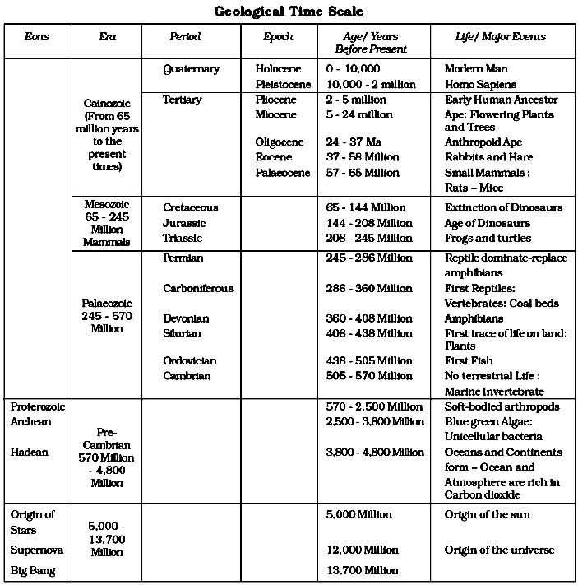
1+1+1=3
- How many years ago the sun originated from supernova?
- Name the era and time when the first life on the earth appeared?
- Name the Era, Period and Epoch in which do the Modern man lives in?
Q.11 What are tides? Give two reasons of occurrence of tides and also state two importances of tides. 1+2+1=4
Q.12 Which type of cloud is extremely dense and opaque to the rays of the sun? Describe the characteristics of the three types of rainfall on the basis of origin. 1+3=4
Q.13 Explain any four factors which control the temperature of air at any place. 1*4=4
Q.14 Describe the two characteristics each of the three stages of landscape development in the running water regimes. What is the basic difference between an alluvial fan and a delta? 3+1=4
Q.15 What are earthquakes? How do earthquake waves provide indirect information about the interior of the earth? State any two effects of earthquakes. 1+2+1=4
Q.16 What is soil? Explain the four factors which control the formation of soils. 1+4=5
Q.17 Give five differences between tropical cyclones and extra-tropical cyclones.
1*5=5
Q.18 Who gave the comprehensive argument in the form of ‘the continental drift’? Give four evidences in support of the continental drift. 1+4=5
Q.19 On the given political map of World provided to you, locate and label the following with appropriate symbols: 5*1=5
- Western Ghats ecological hot spots, India
- Labrador cold current
- Kuroshio warm current
- Galapagos volcanic islands
- Yellowstone National park

