Guess Paper – 2012
Class – XII
Subject – PHYSICS
MARKS 70 TIME 3 HRS
GENERAL INSTRUCTIONS:
1.All questions are compulsory
2. There are 30 questions in total.
3. There is no overall choice. However an internal choice has been provided in one question of 2 mark , one question of 3 mark and all 3 questions of 5 mark each.
4. use of calculator is not permitted. Use log table wherever necessary.
------------------------------------------------------------------------------------------------------------------------------------
I 1x8=8
1.Define dielectric polarization of electric field. Is it scalar or vector?
2. Four cells of same emf E and internal resistance r’ are connected in series to a variable resistor R. Draw a graph to show the variation of terminal voltage of the combination with the current output
3. Magnetic field arises due to charges in motion. Can a system have magnetic moments even though its net charge is zero? Justify
4.Name two places in India where the magnetic needle shows true north quite accurately
5. Define Foucault current. Name the insulating material which is used for minimizing this current
6. Name the part of em waves which can be detected by a) Bolometer b) point contact diodes.
7. What colour will be seen adjacent to central maxima in Young’s double slit experiment if source light is a white light? Why?
8. Anode voltage of photocell is kept constant . Draw a graph to show the variation of wavelength λ with photo current.
II 2x10 =20

9. Find electric field Intensity on the surface of a charged conductor and define electric flux.
(OR)
Two long straight parallel wires carry charges λ₁ and λ₂ per unit length. The separation between their axes is ‘d’. Find the magnitude of force exerted on unit length of one due to charge on the other.
10. Two insulating infinitely long conductors carrying current I₁ and I₂ lie mutually perpendicular to each other in the same plane . Find the locus of the point at which the net magnetic field is zero.
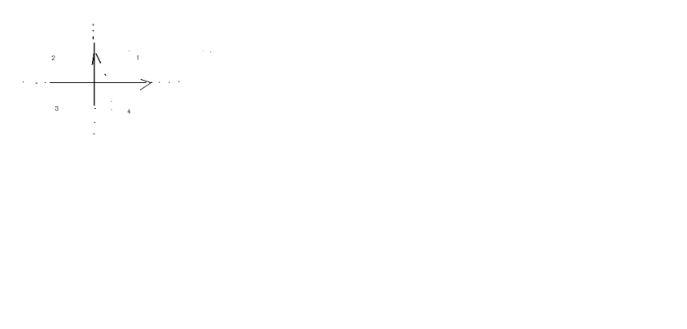
11. Find an expression for Time period T of a small magnetic compass needle of Magnetic moment M’ oscillating in external uniform magnetic field B.
12 Fig. shows a wire of mass ‘m’and length ‘l’ which can slide on pair of parallel smooth horizontal rails placed in a vertical magnetic field B. The rails are connected by a capacitor of capacitance C. The electric resistance of rails and the wire is zero. If a constant force F acts on the wire as shown. Find the acceleration of the wire in terms of B and C.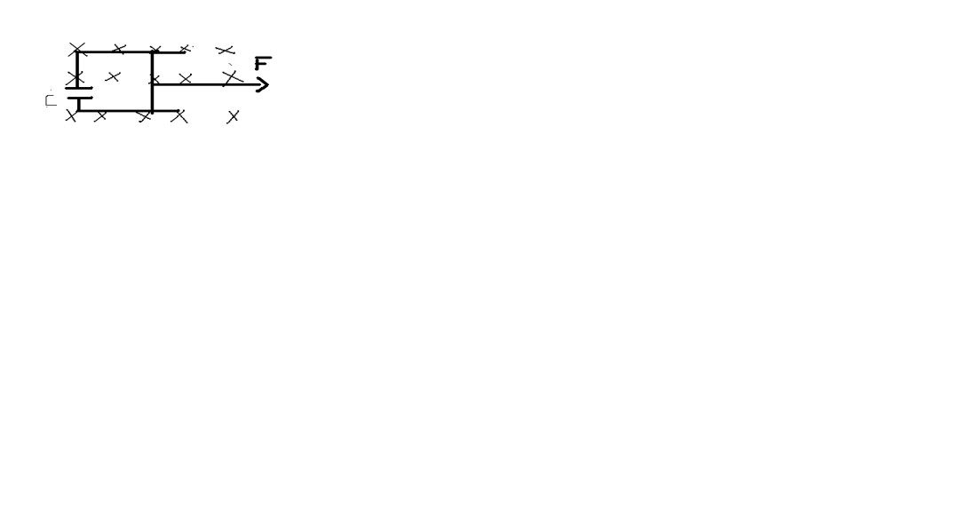
13. Draw Resonance graph of series LCR circuit .Mark the Bandwidth region and hence write an expression for Quality factor in terms of Bandwidth.Mark the region of capacitive dominated and inductive dominated in resonance graph.
14. a) write the equation of Modified Ampere’s law involved in em wave. b) Draw the pattern of plane em wave propagating along x-axis.
15. Draw the Intensity pattern of Actual double slit pattern obtained in an envelope of single slit diffraction pattern. On what factor does the number of interference fringes occurring the broad diffraction peak depend on?
16.Draw a schematic diagram of a Nuclear reactor based on thermal neutron fission and label its parts. What is the purpose of using reflector in nuclear reactor?
17. a) Explain why V-I characteristic curve of Solar cell is drawn in fourth quadrant . b) On what critieria material used for making solar cell is selected?
18. What is a gate? Why are they called as logic gate? Draw logical symbol of Inverter
III 3x9=27

19. When a resistor of 5Ω is connected across a cell its terminal Potential difference is balanced by 150cm of potentiometer wire and when a resistor of 10Ω is connected across a cell, the terminal potential difference is balanced by 175cm of potentiometer wire. Find the internal resistance.
20. Derive Ohm’s law in vector form. Draw V-I graph of Gallium Arsenide which depict non ohmic behavior.
21. A long straight wire of finite cross section carrying current I. The current I is uniformly distributed across the cross section of radius ‘a’ Find the magnetic field B’ in the region r>a and r<a. Draw a graph between B and ‘r’ to show its variation from the centre of wire.
22. a) explain why a capacitor is used in the primary circuit of an induction coil. B) An applied voltaqge signal consists of superposition of a d.c voltage and an a.c voltage of high frequency. The circuit consists of an inductor and a capacitor in series. Show that d.c signal will appear across C’ and a.c signal across ‘L.
23. a)Draw a labeled diagram of an Astronomical refracting Telescope forming the image at infinity.b)How do the light gathering power change if the aperture of objective lens is doubled? C) In modern Telescopes why mult icomponent lenses are used?
24. a) A plano convex lens with (refractive index µ)its convex surface silvered . Calculate its focal length
b) A concave lens has focal length ‘f’. How does it power change if incident blue light is replaced by orange light?
Why do sometimes we observe haloes(rings) round the sun or moon?
25. Explain with neat diagram an experiment to prove the wave nature of electron and compare its result with theoretical result. (OR)
What are the sailent features of Einstein photoelectric emission . An em wave of wavelength λ is incident on a photo sensitive surface of negligible work function. If photo electron emitted from this surface have Debroglie wavelength λ₁. P.T λ= (2mc/h)λ₁² .
26 The ground state of energy of an atom is -13.6eV. The photon emitted during the transition of electron from 2nd excited state to ground state is incident on phot material of unknown work function. The kinetic energy of emitted photoelectron is 9eV. Find the threshold wavelength of material used.
27. a) draw a block diagram of simple modulator b) draw frequency spectrum of Am wave. c) Broadcast frequencies should be sufficiently spaced out why?
IV 5x3=15
28. Explain with neat diagram principle and working of a device producing a very high potential difference which is used to accelerate charged particles. B) electric potential on the surface of a charged spherical shell is 10V. what will be the potential at its centre. (OR)
a)state the principle of capacitor b) X and Y arte two parallel plate capacitors in series having same area of cross section and separation between the plates . X has air between the plates and Y has dielectric having dielectric constant 5. Calculate the potential difference between the plates of x and y and find the ratio of energy stored in x and y.c) Draw electric field pattern for a positive charge placed in the vicinity of an uncharged metal plate.
29.In YDSE deduce the condition for constructive and destructive interference pattern obtained on the screen. In YDSE slits are 0.2mm apart and the screen is 1.5m away. The distance between the central bright fringe and the 4th dark fringe is 1.8cm. find the wavelength of light used. (OR)
What is diffraction? Explain with neat diag the single slit diffraction pattern and deduce the condition of maxima and minima. Find the angular spread of central maxima if angular position of first minima from the central maxima is 30˚
30 Explain with neat circuit diagram the principle and working of transistor oscillator in CE mode.draw its graph. (OR) Explain with circuit diagram the working of transistor as an amplifier in CE mode. Write the mathematical expression to show the phase relation of input output voltage.

By
MRS. SIVESHWARI BHASKER . M.Sc., B.Ed., M.Phil.,
Senior PGT physics , CHETTINAD VIDYASHRAM
91-9840270721 meghabhasker@gmail.com

