Guess Paper – 2012
Class – X
Subject – Mathematics

CHP 10 CIRCLES F.M: 25

- The length of a tangent from a point A at a distance of 5 cm from the center of the circle is 4 cm. What will be the radius of the circle? (1)
- In Fig., if TP and TQ are the two tangents to a circle with centre O so that ∠POQ = 110 °, find ∠PTQ. 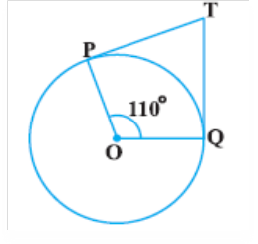 (2)
- Two tangents TP and TQ are drawn to circle with centre O from an external point T, and ∠PTQ = 60⁰, find ∠OPQ. (2)
P
T
Q
O

- In the figure given below, AQ and AR are a tangent to the circle drawn from an external point A. CB is third tangent touching the circle at P. If AQ=15 cm, and CP=4cm.What is the length of AC. (2)
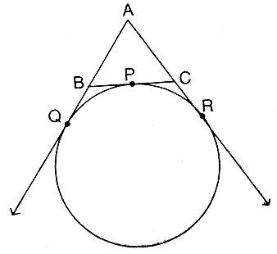
- Prove that the tangent at any point of a circle is perpendicular to the radius through the point of contact. (3)

- In given figure XY and $X^{'}Y^{'}$are two parallel tangents to a circle with centre O and another tangent AB with point of contact C intersects XY at A and $X^{'}Y^{'}$ at B. Prove that $∠\text{AOB}={\text{90}}^{0}$ (3)
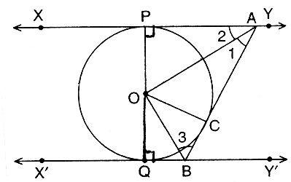
- In given figure PQR is a right angled triangle with PQ = 12 cm and QR = 5 cm. A circle with centre O and radius x is inscribed in$Δ\text{PQR}$. Find the value of x. (3)
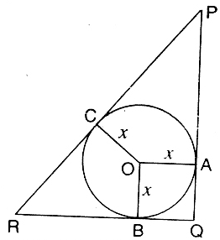
- A
A circle is touching the side BC of ΔABC at P and is touching AB (3)
and AC when produced at Q and R respectively.
Prove = ½ ( Perimeter of Δ ABC ).
B P C
Also if AQ = 5cm, find the perimeter of ΔABC.
Q R
- Prove that the lengths of tangents drawn from an external point to a circle are equal. PQ is a chord of length 8 cm of a circle of radius 5 cm. The tangents at P and Q intersect at a point T. Find the length TP. (6)

Paper Submitted By:
Name: Amit Vaghela 9898143552
Email: amitsirinstitute@gmail.com

