Guess Paper – 2012
Class – X
Subject – Mathematics
(Trigonometry and triangles)
Maximum marks: 40

- If, evaluate

- In , right angle at B,if , find the value of (4)

- (cos A cos C-sin A sin C)

- , find the values of all T- ratios of . (2)

- Evaluate: (2)

- Prove that: (6)

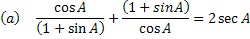

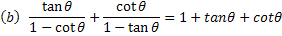

- Without using trigonometric table ,evaluate the following: (4)

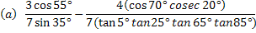
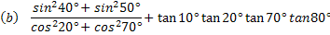

- In the given figure,
Prove that .
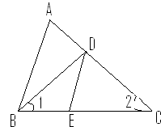 (3)

- Given a ∆ in which and. Prove that. (3)
- Prove that in a right triangle the square of the hypotenuse is equal to the sum of the squares of the
Other two sides
Using the above theorem, do the following:
If ABC is an equilateral triangle with ADBC, then AD² =3DC². (5)
- In triangle ABC, ADBCand BD=3CD. Prove that 2AB²=2AC²+BC². (3)
- If ,show that (3)
- Prove that the ratio of the areas of two similar triangles is equal to tha ratio of squres of their corresponding sides.

Paper Submitted By:

Name: Sujeet Gaud
Email: gaud.sujeet@gmail.com
Phone No. 9928273041

