Guess Paper – 2011
Class – XII
Subject – Mathematics
SECTION-A
Q1 If A is a square matrix of order 3such that |adj A| =64, find |A|.
Q2 If A, B, C are three non –zero square matrices of same order, find the condition on A such that AB=ACB=C.
Q3 Give an example of two non-zero 2x2 matrices A,B such that AB=0.
Q4If the value of the derivative of ^{x}) w.r.t.x at point x=0.
Q5 Find a, for which is increasing.
Q6 Evaluate 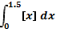(where [x] is greatest integer function).
Q7 write the order and degree of the differential equation,
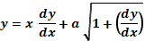²
Q8 If find a unit vector in the direction of .
Q 9 A four digit number is formed using the digits 1,2 3, 5with no repetitions. Find the probability that the number is divisible by 5.
Q10 The probability that an event happens in one trial of an experiment is 0.4. Three independent trials of an experiment are performed. Find the probability that the event happens at least once.
SECTION-B
Q11 Find the value of 2 tan⁻¹ 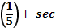⁻¹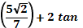⁻¹
Q12 If A=prove that ^{n} = ^{n}n^{n-1} is a unit matrix of order 2 and n is a positive integer.
OR

Using properties of determinants, prove that
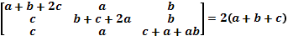³
Q13 If x =a sin Pt and y= b cos pt, find the value of at t =0.
Q14 Find the equations of tangent lines to the curve y =4x³-3x+5 which are perpendicular to the line 9y + x +3 =0.
Q15 Show that the function is continuous at every but fails to be differentiable at x = -2.
Q16 Evaluate: 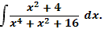
Q17 Evaluate: 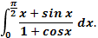 or Evaluate: 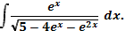
Q18 If are the position vectors of the vertices of a respectively. Find an expression for area of and hence deduce the condition for the point to be collinear.
OR
Show that the points with position vectors 2 respectively, are the vertices of a right triangle. Also find the remaining angles of the triangle.
Q19 Evaluate: 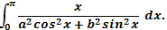
Q20 Solve the differential equation:
2xy +y² – 2x²
OR
Solve the differential equation,
Q21 In a bolt factory machines, A, B and C manufactures respectively 25%, 35% and 40% of the total bolts of their output 5, 4 and 2 per cent are respectively defective bolts. A bolts is drawn at random from the product.]
- What is the probability that the bolt drawn is defective?
- If the bolt is found to be defective, find the probability that it is a product of machine B.
Q22 Two dice are thrown simultaneously. Let X denote the number of sixes, find the probability distribution of X. also find the mean and variance of X, using the probability distribution table.

SECTION-C
Q23 Let X be a non-empty set. P(x) be its power set. Let ‘*’ be an operation defined on elements of P(x) by,
Then,
- Prove that * is a binary operation in P(x)
- Is* is commutative?
- Is*associative?
- Find the identity element in P(x) w. r.t*.
- Find all the invertible elements of P(x).
- If 0 is another binary operation defined on P(x) as AoB= then verify that 0 distributes itself over*
OR
Consider ₊ ² +6x-5. Show that is invertible. Find the inverse of
Q24 A window has the shape of a rectangle surmounted by an equilateral triangle. If the perimeter of the window is 12 m, find the dimension of the rectangle that will produce the largest area of the window.
Q25 Make a rough sketch of the region given below and find its area using integration.
{(x,y): y² 4x, 4x² +4y²9}
Q26 Every gram of wheat provides 0.1g of proteins and 0.25 g of carbohydrates the corresponding values for rice are 0.05 g and 0.5 respectively. Wheat costs Rs. 4 per kg and rice Rs. 6 per kg. The minimum daily requirements of proteins and carbohydrates for average child are 50 grams and 200 gram respectively. In what quantities should wheat and rice be mixed in the daily diet to provide minimum daily requirements of proteins and carbohydrates at minimum cost. Frame an L. P. P. and solve it graphically.
Q27 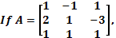 find A⁻¹ and hence solve the system of equations.
x+ 2y +z=4 ; -x +y+z=0 ; x-3y+z=2

Q28 Find the equation of the plane containing the line,
And
Find the distance of this plane from origin and also from the point (1,1,1,).
OR
Find the equation of the plane passing through the intersection of the planes 2x+3y- z+1 =0; X+y-2z+3=0 and perpendicular to the plan 3x-y-2z-4. Also, find the inclination of this plane with the xy-plane.
Q29 prove that the image of the point (3,-2,1) in the plane 3x – y +4z =2 lies on the plane x+y+z+4=0.

ANSWERS
Section-A
(1) (2) B=C. (3) While A and B be non-zero matrices (4) (5) 1+ (6) 0.5 (7) 0rder 1, degree 2
(8) 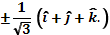 (9) (10) 0.784
Section –B
(11) (12) By P.M.I, P(n) true. Or 2(a+b+c)³ . (13) 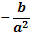
(14)
(15) is C.T.S at every , is not differentiable at .
(16) ⁻¹ 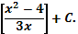 (17)
(18) Area of or ⁻¹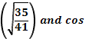⁻¹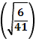 . (19) .
(20) 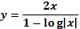. Or or (21) . (22)var = ,mean =
Section-C
(23) [i] No [ii] yes [iii] yes [iv] No [v] No [vi] Yes ,or 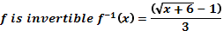 (24)width=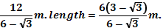
(25) 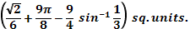
(26) 400 wheat and 200 rice Rs. 2.80. (27) 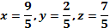 as the required solution. (28) 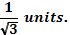 or 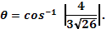 (29) image (0,-1,-3)
Prepared by:
Name Mukta Sawhney
Email sawhney_3@rediffmail.com
Phone No. 9811195640

