Sample Paper – 2011
Class – X
Subject – Mathematics

Time : 1 Hour Set - A MM : 25

- Look at the graphs in figure given below. Each is the graph of y = p(x), where p(x) is a polynomial. For each of the graphs, find the number of zeroes of p(x).Give points why? 2
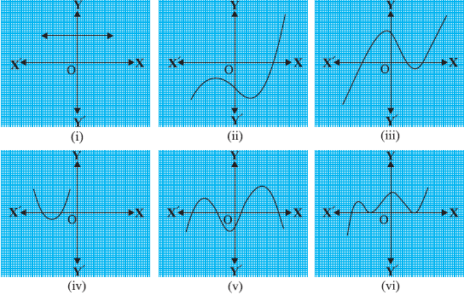

- Find the zeroes of the polynomial x² – 3 and verify the relationship between the zeroes and the coefficients. 3

- Divide 3x² – x³ – 3x + 5 by x – 1 – x², and verify the division algorithm. 3

- Romila went to a stationery shop and purchased 2 pencils and 3 erasers for Rs 9. Her friend Sonali saw the new variety of pencils and erasers with Romila, and she also bought 4 pencils and 6 erasers of the same kind for Rs 18. Represent this situation algebraically and graphically. 3

- Solve 4
(a – b)x + (a + b) y = a² – 2ab – b²
(a + b)(x + y) = a² + b²

- 2 women and 5 men can together finish an embroidery work in 4 days, while 3 women and 6 men can finish it in 3 days. Find the time taken by 1 woman alone to finish the work, and also that taken by 1 man alone. 3

- Prove that in a triangle, if square of one side is equal to the sum of the squares of the other two sides, then the angle opposite the first side is a right angle. 3

- In an equilateral triangle ABC, D is a point on side BC such that BD = 1 / 3 BC. Prove that
9 AD² = 7 AB². 4

By A K Nagar
9990673332

