Guess Paper – 2011
Class – X
Subject - Mathematics

18. Following table gives the scores of 100 candidates in an entrance examination:

Marks | 100-150 | 150-200 | 200-250 | 250-300 | 300-350 | 350-400
No. of Students | 16 | 15 | 14 | 32 | 11 | 12

SECTION-C

19. Show that any positive odd integer is of the form 6p+1 or 6p+5, where p is some integer.
20. show that is irrational number.
OR
Show that
21. A number consists of two digits whose sum is 9. If 27 is added to the number, the digits are interchanged.
Find the number.
22. Obtain all zeros of polynomial if two of its zeros are 2 and -2.
23. prove that: .

24. If , then show that .

25. D is any point on the side BC of ∆ ABC such that .Prove that .

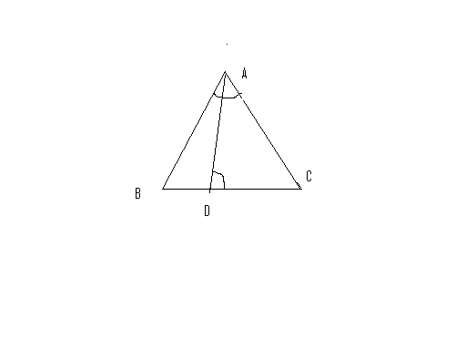

26. ∆ ABC and ∆ DBC are on the same base BC. AD and BC intersect at O. Prove that .
27. Using step deviation method , calculate arithmetic mean of the following:

Class Interval | 0-20 | 20-40 | 40-60 | 60-80 | 80-100 | 100-120
Frequency | 20 | 35 | 52 | 44 | 38 | 31
OR
Find the value of ‘p’ if mean of following data is 53.

Class | 0-20 | 20-40 | 40-60 | 60-80 | 80-100
Frequency | 12 | 15 | 32 | p | 13
AADHARSHILA STUDIES(9871823800)

Name: ASHOK KHUGSHAL
Email: asok_khugshal@yahoo.com
Phone No.: +919871823800

