Sample Paper – 2010
Class –X
Subject – Mathematics
Time: 3 hrs.
M.M.: 80

Section – A
( 1 Mark each )
- Find the missing numbers in prime factors tree.
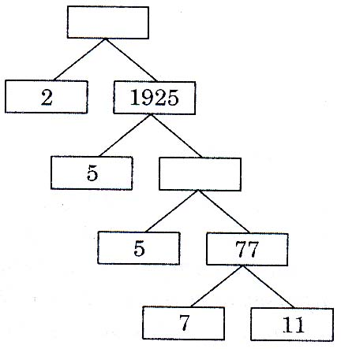

- In figure graph of some polynomial p(x) is given. Find the zeroes of the polynomial.

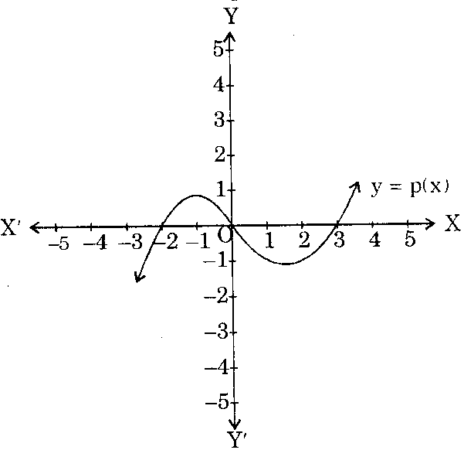

- For what value of k, the following system of equations has no solution:
$\begin{aligned}2x + \text{ky} =5 \\ 6x + 3y =\text{15}\end{aligned}$
- If $\text{sec}(\text{30}\text{°+}x)=\text{cos}\text{ec}(\text{20}\text{°+}x),$find x.
- If sin A =$\frac{8}{\text{15}}$and A + B $=\text{90}°$, then what is the value of cos B?
- Angle of a sector of a circle is $\text{120}°$. What is the ratio of area of the sector of circle and an isosceles right triangle, if diameter of circle is equal to hypotenuse of the triangle.
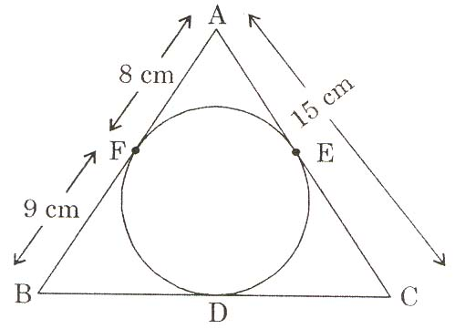
- In figure, $Δ$ABC is circumscribing a circle, Find the length of BC.

- In figure $∠$B = $\text{90}°,$AD = 2DB. Find ${\text{sin}}^{2}θ+{\text{cos}}^{2}θ\text{.}$
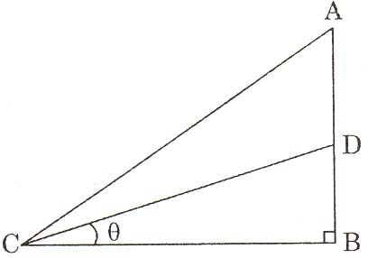

- Find the probability of getting 53 Fridays in a leap year.
- If $Σ f_{i}=\text{101}$and median = 23, find 51st observation of the data.
Section – B
( 2 Marks each )
- Find the sum of first hundred odd natural number divisible by 5.
- All three face cards of spades are removed from a well shuffled pack of 52 cards. A card is then drawn at random from the remaining pack. Find the probability of getting
(i) A black face card (ii) Q queen.
- Solve for x and y : $\frac{2a}{x}+\frac{3b}{y}+1=0,$$\frac{3a}{x}−\frac{b}{y}− 4 =0$
- If area of $Δ$PQR where P (2, 1), Q (x, 1) and R(2, y) is 6 sq. units, then find the relationship between x and y.
- If one root of the equation $4x^{2}−\text{kx}+k=0$is 3, find the value of k. Also, find the other root.
OR
Find the zeroes of the polynomial $\sqrt{3}x^{2}+\text{10}x+7\sqrt{3}\text{.}$
Section – C
(3 Marks each )
- ‘A’ takes 6 days less than the time taken by ‘B’ to finish a piece of work. If both A and B together can finish it in 4 days, find the time taken by B to finish the work.
- There is a circular path around a sports field. Sunita takes 16 minutes to cycle one round of the field. Anamika takes 24 minutes while Jenny takes 32 minutes for the same. Suppose they all start at the same point and at the same moment and go in the same direction. After how many minutes will they meet again at the starting point?
- Solve for x : 2$2\left(\frac{x+2}{2x−3}\right)−9\left(\frac{2x−3}{x+2}\right)=3;x≠\frac{3}{2}, x≠−2\text{.}$
- Draw a pair of tangents to a circle of radius 6 cm which are inclined to each other at an angle of $\text{60}°\text{.}$
- Prove that : $\frac{1}{{\text{cot}}^{2}θ}+\frac{1}{1+{\text{tan}}^{2}θ}=\frac{1}{1−{\text{sin}}^{2}θ}−\frac{1}{\text{cos}{\text{ec}}^{2}θ}\text{.}$
- The base of triangle is 15 cm. Two lines are drawn parallel to the base, terminating in the other two sides and dividing the triangle into three equal areas. Find the length of parallel side closer to the base.
OR
AB is a diameter and AC is a chord of a circle such that
$∠$BAC =$\text{30}°\text{.}$If the tangent at C intersects AB produced in D, prove that BC = BD.
- Two vertices of a parallelogram are the points of intersection of the line A : $y+2x−2=0$with the co-ordinates axis. Another vertex of the parallelogram is the point of intersection of line
B : x – y – 4 = 0 with the x-axis. Find the fourth vertex of the parallelogram.
- Mid points of the sides AB and AC of a $Δ$ABC are (3, 5) and
(–3,–3) respectively. Find the length of the side BC.
- $Δ$BC is a right angled triangle at A. BL and CM are its two medians. Prove that : 4 (BL${}^{2}$+CM${}^{2}$) = 5BC${}^{2}\text{.}$
- The minute hand of a clock is 14 cm long. Find the area on the face of the clock described by minute hand between 10 A.M. and 10.15 A.M. $\left(\text{Take} π=\frac{\text{22}}{7}\right)$
OR
A boy is cycling such that the wheels of the cycle are making 140 revolutions per minute. If the diameter of the wheel is 62 cm, calculate the speed per hour with which the boy is cycling.
Section – D
( 6 Marks each )
- Prove that the ratio of areas of two similar triangles is equal to the ratio of the squares of their corresponding sides.
Using the above, do the following:
If the areas of two similar triangle are equal, prove that they are congruent.
- Form a pair of linear equations in two variables using the following information and solve it graphically :
I am three times a sold a my son. Five years later, I shall be two and a half times as old as my son? How old am I and how old is my son? What was my age when my son was born?
- A balloon moving in straight line passes above the tow point P and Q on the ground. When vertically above P the angle of elevation of the balloon as observed from Q is $\text{60}°$and when the balloon is vertically above the point Q its angle of elevation a P is $\text{45}°\text{.}$Distance between P and Q is 100 m. Find the distance of the point P from the point where the balloon touches the ground. $(\sqrt{3}=1\text{.}\text{73}, \sqrt{2}=1\text{.}\text{41})$
- A bucket has top and bottom diameter of 40 cm and 20 cm respectively. Find the volume of the bucket if its depth is 12 cm. Also, find the cost of tin sheet used for making the bucket at the rate of Rs.1.20 per dm${}^{2}\text{.} \left(\text{use} π=\frac{\text{22}}{7}\right)$
OR
A well of diameter 3 m is dug 14 m deep. The taken out of it has even spread evenly all around it to a width of 4 m to form an embankment. Find the height of the embankment. $\left(\text{use} π =\frac{\text{22}}{7}\right)$
- A survey regarding the heights (in cm) of 51 girls of class X of a school was conducted and the following data was obtained:
Height (in cm.) | No. of girls
Less than 135  Less than 140  Less than 145  Less than 150  Less than 155  Less than 160  Less than 165 | 0  4  11  29  40  46  51

Find the median height.
OR
Draw the less than type cumulative frequency curve.
Daily income (in Rs.) | No. of workers
100 – 120  120 – 140  140 – 160  160 – 180  180 – 120 | 12  14  8  6  10

Paper Submitted By :
Name : Mrs Neeta Das
Email : neetanvi@rediffmail.com
Phone No : 919826038066

