Sample Paper – 2010
Class – X
Subject -Mathematics

General Instructions:
(i) All questions are compulsory.
(ii) The questions paper consists of 30 questions divided into four sections A, B, C, D. Section A contains 10 questions of 1 mark each, Section B is of 5 questions of 2 marks each, Section C is of 10 questions of 3 marks each and Section D is of 5 questions of 6 marks each.
(iii) There is no overall choice in the question paper. However, internal choice has been provided in one question of 2 marks each, three questions of 3 marks each and two questions of 6 marks each.
(iv) All questions in Section A are to be answered in one word, one sentence or as per the exact requirement of the question.
(v) In question on construction, drawings should be neat and exactly as per the given measurements.
(vi) Use of calculator is not permitted. However you may ask for mathematical tables.

SECTION – A

1. State the Euclid division lemma.
2. Find the quadratic polynomial whose one of the zeros is $\frac{\sqrt{3}}{4}$and the product of the zeros is $−\frac{1}{2}$.

3. Give an example of polynomials f(x), g(x), q(x), and r(x) satisfying
f(x) = g(x) × q(x) + r(x) where deg r(x) = 0.

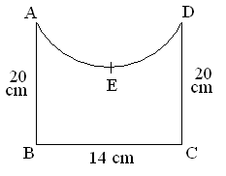
4. Solve by factorization method : abx² + (b² − ac) x − bc = 0.

5. Find the perimeter of the given figure,
where $\overset{}{\overbrace{\text{AED}}}$is a semi-circle and ABCD is a rectangle.

6. From a point P, 10 cm away from the centre of a circle, a tangent PT of length 8 cm is drawn. Find the radius of the circle.

7. Which measure of central tendency is given by the x-coordinate of the point of intersection of the ‘more than’ ogive and ‘less than’ ogive ?

8. Find the probability that a number selected at random from the numbers 1, 2, 3, 4, 5,
6, 7, 8, 9, 10, 11, 12, 13, 14, 15 is a prime number.

9. If sin θ = $\frac{1}{3}$, then find the value of (2 cot² θ + 2).

10. A cylinder and a cone are of same base radius and of same height. Find the ratio of the volume of cylinder to that of the cone.

SECTION – B

11. If the sum of first n terms of an A.P. is given by Sn = 3n² + 2n, find the nth term of the A.P.

12. Prove that: sec² θ + cosec² θ = sec² θ cosec² θ.

or
If A, B, C are interior angles of a ΔABC, then show that
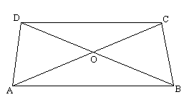
cos $\left(\frac{B+C}{2}\right)=\text{sin}\frac{A}{2}$.

13. In the given figure, ABCD is a trapezium in which
AB ⏐⏐ DC. The diagonals AC and BD intersect at O.
Prove that $\frac{\text{AO}}{\text{OC}}$ = $\frac{\text{BO}}{\text{OD}}$.

14. Find the values of x for which the distance between the point P (2, −3) and Q (x, 5) is 10 units.

15. All cards of ace, jack and queen are removed from a deck of playing cards. One card is drawn at random from the remaining cards. Find the probability that the card drawn is (a) a face card
(b) not a face card

SECTION – C

16. If it is given that $\sqrt{3}$and −$\sqrt{3}$are two of the zeros of the polynomial
f(x) = 3x⁴ − 8x³ − 12x² + 24x + 9, then find all the zeros of f(x), using the division algorithm.

17. Show that the cube of any positive integer is of the form 9k, 9k + 1 or 9k + 8, where k is some integer.

18. Solve for x and y : $\frac{\text{57}}{x+y}+\frac{6}{x−y}= 5 ;\frac{\text{38}}{x+y}+\frac{\text{21}}{x−y}= 9$

Or

Find the value of k so that the following system of linear equations has an infinite number of solutions :
(k + 1) x + 2ky = k + 3; (4k + 1) x + 12y = 15

19. Find the sum of all three digit numbers which leave the remainder 3 when divided
by 5.
or
If m times the nth term of an A.P. is equal to n times its mth term, find its (m + n) th term.
20. Prove that : $\frac{\text{tan}θ}{1−\text{cot}θ}+$$\frac{\text{cot}θ}{1−\text{tan}θ}=\left(1+\text{sec}θ \text{cos}\text{ec}θ\right)\text{.}$

21. Determine the ratio in which the line 3x + y – 9 = 0 divides the segment joining the points (1, 3) and (2, 7).
or
If A and B are (−2, −2) and (2, −4) respectively, find the coordinates of P such that
AP = $\frac{3}{7}$ AB and P lies on the line segment AB.

22. The vertices of a triangle are (−1,3), (1, −1) and (5, 1). Find the lengths of medians through the vertices (−1,3) and (5, 1).

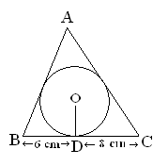
23. Draw two concentric circles or radii 3 cm and 5 cm. Construct a tangent to the smaller circle from a point on the larger circle. Measure the length of this tangent.

24. A triangle ABC is drawn to circumscribe a circle
of radius 4cm such that the segment BD and DC into
which BC is divided by the point of contact D are of
lengths 8 cm and 6 cm respectively (as shown in figure).
Find the sides AB and AC.

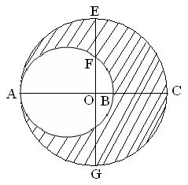
25. In the given figure, O is the centre of the bigger
circle and AC is its diameter. Another circle with
AB as diameter is drawn. If AC = 54 cm and BC = 10 cm,
find the area of the shaded region.

or

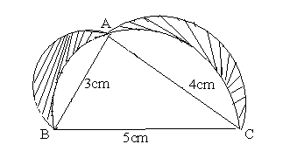

In the given figure, Δ ABC is right-angled at A. Semi-circle
are drawn on AB, AC and BC as diameters. Find the area
of the shaded region.

SECTION – D

26. In a flight of 6000 km, an aircraft was slowed down due to bad weather. Its average speed for the trip was reduced by 400 km/hr and time increased by 30 minutes. Find the original duration of the light.
or
Two pipes running together can fill cistern in $2\frac{8}{\text{11}}$minutes. If one pipe takes 1 minute more than the other to fill the cistern, find the time in which each pipe would fill the cistern.

27. The angle of elevation of an aeroplane from a point on the ground is 60°. After a flight of 15 seconds, the angle of elevation changes to 30°. If the aeroplane is flying at a constant height of 1500$\sqrt{3}$m, find the speed of the aeroplane.

28. Prove that the ratio of the areas of two similar triangles is equal to the ratio of squares of their corresponding sides. Using the above result, prove the following:
In a Δ ABC , XY is parallel to BC and it divides Δ ABC into two parts of equal area.
Prove that $\frac{\text{BX}}{\text{AB}}=\frac{\sqrt{2}−1}{\sqrt{2}}$.
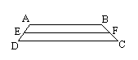
or
If a line is drawn parallel to one side of triangle the other two sides are divided in the same ratio-Prove. Use this result, to prove the following:
In the adjoining figure, if ABCD is a trapezium in which
AB ⏐⏐ DC ⏐⏐EF, then $\frac{\text{AE}}{\text{ED}}=\frac{\text{BF}}{\text{FC}}\text{.}$

29. A right triangle with sides 3 cm and 4 cm is revolved
around its hypotenuse. Find the volume of the double
cone thus generated.
or
A container made up of a metal sheet is in the form of a frustum of a cone of height 16 cm with radii of its lower and upper ends as 8 cm and 20 cm respectively. Find the cost of oil which can completely fill the container at the rate of Rs. 50 per litre. Also, find the cost of metal used, if it costs Rs. 5 per 100 cm². (Use π = 3.14)

30. 100 surnames were randomly picked up from a local telephone directory and the distribution of number of letters of the English alphabet in the surnames was obtained as follows:

No. of letters | 1-4 | 4-7 | 7-10 | 10-13 | 13-16 | 16-19
No. of surnames | 6 | 30 | 40 | 16 | 4 | 4

Determine the median and mean number of letters in the surnames. Also find the modal size of surnames.

Paper Submitted By :
Name : Mr Krishnakant ojha
Email : Krishnakantojha@ymail.com
Phone No. : 9204411279

