Guess Paper – 2010
Class – X
Subject: Mathematics
Time : 3 Hours
Max. Marks : 80

GENERAL INSRTUCTIONS :-

- The question paper consists of 30 questions divided into four sections– A, B, C and D. Section A comprises of ten questions of 1 mark each, Section B comprises of five questions of 2 marks each, Section C comprises of ten questions of 3 marks each, and Section D comprises of five questions of 6 marks each
- All questions in section A are to be answered in one word, one sentence or as per the exact requirement of the question
- In question on construction, the drawings should be neat and exactly as per the given measurements
SECTION – A
- In fig. 1, the graph of the polynomial g(x) is drawn. Find the zeros of g(x).
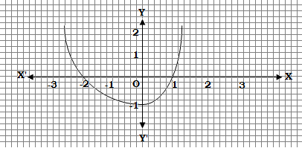

Fig. 1

- Why the number$4^{n}$, where n is a natural number, is not divisible by 5?
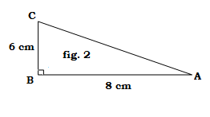
- If one root of a quadratic equation is $\frac{3+\sqrt{5}}{2}$, what will be the other root?
- If $\text{sin}θ=\frac{\sqrt{3}}{2}$ , then what will be the value of $\text{cos}θ?$
- Evaluate : $\text{cos}\text{ec}\text{32}°−\text{sec}\text{58}°$
- In fig. 2, find the value of $\text{sin}A$.
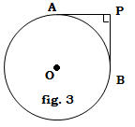
- What do you call an event, whose probability of happening is 1?
- The volume of a cone and a cylinder are equal. If their base
radii are same, find the ratio of their height.
- Write the empirical relation between Mean, Mode and Median.
- In fig. 3, PA and PB are tangents from P to circle with centre O.
If PAPB, find the length of each tangent, given that OA = 3 cm.
SECTION – B

- If the coordinates of the points P and Q are (4, −3) and (−1, 7) respectively, find the coordinates of the point A on the segment PQ such that PA : AQ = 3: 2.
- If a pair of dice is thrown once. Find the probability of getting :
(a) Sum of numbers atleast 10. (b) Sum of numbers less than 10.
OR
From a pack of 52 cards, a card is drawn at random. What is the probability of getting : (a) a red card (b) either a ‘10’ or an ‘ace’ ?
- Find the discriminant of the quadratic equation $3x^{2}−4\sqrt{3}x+4=0$ and hence discuss the nature of the roots.
- How many terms of the A.P. −20, −18, −16, … are needed to make the sum −80? Explain the reason for the double answer, if any?
- If $\text{tan}(A+B)=\sqrt{3}$ and $\text{tan}(A−B)=\frac{1}{\sqrt{3}};\text{ 0}\text{°<}A+B<\text{90}°\text{; A }>\text{B,}$find A and B.

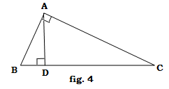
SECTION – C

- Solve by completing the square : $2x^{2}−7x+3=0$.
- In fig. 4, AD⊥BC. If AD² = BD∙DC, prove that $∠$BAC =90°
- Prove that : $(\text{cos}\text{ec}θ−\text{sin}θ)(\text{sec}θ−\text{cos}θ)=\frac{1}{\text{tan}θ+\text{cot}θ}$.
OR
Prove that : $(\text{sin}θ+\text{cos}\text{ec}θ)^{2}+(\text{cos}θ+\text{sec}θ)^{2}=7+{\text{tan}}^{2}θ+{\text{cot}}^{2}θ$.
- Use Euclid’s Division Lemma to show that the cube of any positive integer is of the form 9m, 9m + 1 or 9m + 8 for some positive integer m.
- Find the values of p for which the points (−1, 3), (2, p) and (5, −1) are collinear If the distance of P(x, y) from the points A(2, 7) and B(7, -2) are equal, show that 5x = 9y.
OR
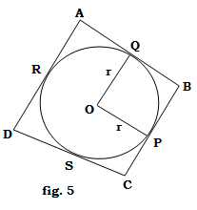
By using coordinate geometry, prove that the diagonals of a rectangle bisect each other and are equal.
- In fig. 5, a circle is inscribed in a quadrilateral ABCD in which $∠$B=90°. If AD=23 cm, AB = 29 cm and DS = 5 cm, find the value of r.
- Construct a circle with radius 2.5 cm. Mark a point P at a distance of 6 cm from the centre of the circle. Draw two tangents from P to the circle. Also write the steps of construction.
- Solve for x and y :
$$\frac{2}{x}+\frac{\text{15}}{y}=\text{17}\text{ and }\frac{1}{x}+\frac{1}{y}=\frac{\text{36}}{5}, x≠0, y≠0$$
OR
Three years ago, Tom was thrice as old as Robert. Seven years hence, Tom will be twice as old as Robert will be then. Find their present ages.

- An A.P. consists of 50 terms of which third term is 12 and last term is 106. Find the 29th term.
- A solid is in the form of a cylinder with hemispherical ends. The total length of the solid is 110 cm and the diameter of the spherical ends is the same as that of the cylindrical portion. The diameter of the cylindrical portion is 14 cm. Find the volume of the solid.
SECTION – D
- Some students planned for a picnic. The budget for food was Rs 1500. But 10 of them failed to go and thus the cost of each member increased by Rs 7.50. How many students attended the picnic?
OR
A motor boat whose speed is 18 km/h in still water takes 1 hour more to go 24 km upstream than to return downstream to the same spot. Find the speed of the stream.

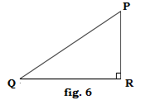
- Prove that in a right angle triangle, the square on the hypotenuse is equal to the sum of the squares on other two sides.
Using the above theorem, prove the following :
In fig. 6, PQR is an isosceles triangle in which $∠$R = 90°. Prove that : PQ² = 2 PR².

- The interior of a building is in the form of a right circular cylinder of radius 7 m and height 6 m, surmounted by a right circular cone of same radius and of vertical angle 60°. Find the cost of painting the building from inside at the rate of Rs 30 per m².

- The angle of elevation of the top of a tower at a point on the level ground is 30°. After walking a distance of 100 m towards the foot of the tower along the horizontal line through the foot of the tower on the same level ground, the angle of elevation of the top of the tower is 60°. Find the height of the tower.

- The following is the distribution of ages of 200 persons. Calculate the average age :
Age (in year) | Below 10 | Below 20 | Below 30 | Below 40 | Below 50 | Below 60
No. of persons | 10 | 25 | 85 | 140 | 190 | 200
OR
A survey regarding the heights of some students of class X was conducted and the following data was obtained :
Heights (in cm) | 135-140 | 140-145 | 145-150 | 150-155 | 155-160 | 160-165
No. of students | 4 | 9 | 18 | 11 | 6 | 5
Find the median and modal heights.
Paper Submitted By :
Name : Mr Dilip Biswas
Email : dilipbiswas2006@gmail.com
Phone No. : 09214927974

