Guess Paper – 2010
Class – XII
Subject – Mathematics

Time: 2H, Max Marks:100
Section A
1.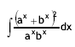 2. 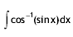
3. $\int_{0}^{π}{}$ sin⁶x cos⁵x dx 4. $\int_{0}^{1}{}$x(1-x)⁵ dx
5. Find the Equation of the curve passing through (1, 1) and satisfying the differential equation 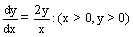
6. What is the order and degree of the differential equation, 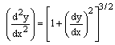
7. Find the projection of the vector î +3 ĵ +7k on the vector 7î – ĵ + 8k.
8. If | a + b | = | a - b | then find the angle between a and b .
9. If the line r = (î - 2ĵ + k)+λ(2î + ĵ + 2k) is parallel to the plane r .( 3î - 2ĵ + mk) = 14, find the value of m.
10. If 4x + 4y – λz =0 is the equation of the plane through the origin that contains the line
x – 1 = y + 1 = z ,
2 3 4

find the value of ‘λ’.

Section B
11. Evaluate: 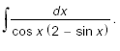 12. Evaluate: 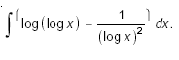

13. Evaluate: 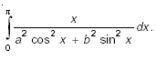 14. Evaluate: 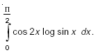
15.
16.
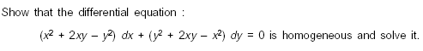
17.
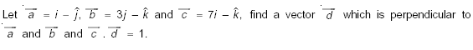
18
19.
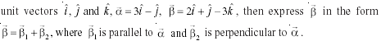
20.
21.
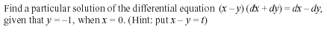
22.
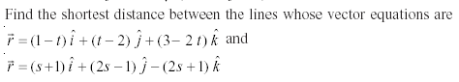
Section C
23. Evaluate:
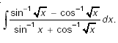
24. Evaluate as a limit of sum :
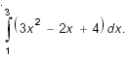
25.
26.
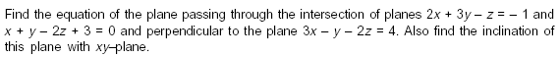
27.
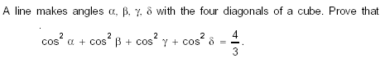
- A dietician has to develop a special diet using two foods P and Q. Each packet (containing 30g) of food P contains 12 units of calcium, 4 units of iron, 6 units of cholesterol and 6 units of vitamin A. Each packet of same quantity of food Q contains 3 units of calcium, 20 units of iron , 4 units of cholesterol and 3 units of vitamin A . The diet requires at least 240 units of calcium, at least 460 units of iron and at most 300 units of cholesterol. How many packets of each food should be use to minimize the amount of vitamin A in the diet ? What is the minimum amount of Vitamin A.
29.
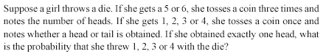

Arun Kumar Shukla

Education Point
B-184 Karam Pura New Delhi-15,ph.9971750

