Sample Paper – 2010
Class – XII
Subject – Mathematics

Time: 2Hrs Max Marks:100
Section A

1.
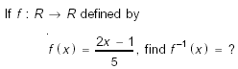
2.
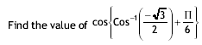
3.
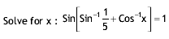
4.
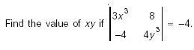
5.
6.
7.

8. Find the derivative of:
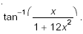
9.

10.

Section B
11.
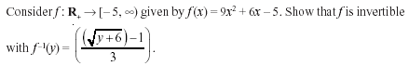
12.
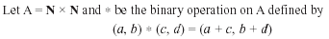

13. Evaluate by using properties of the determinant:
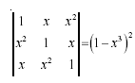

14.

15.
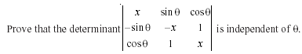
16.
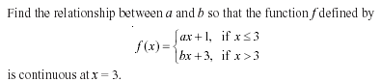

17.
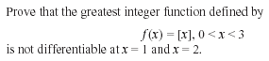

18.
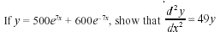
19.

20.
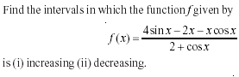
21.
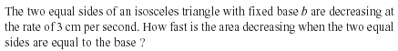
22.
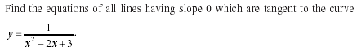
Section C

23.
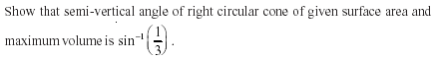
24.
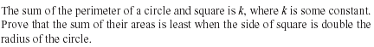

25.
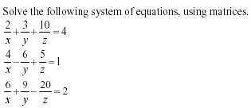

26.
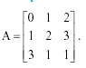
27.
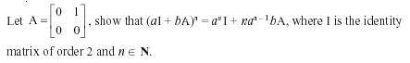

28.
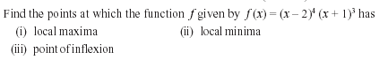
29.
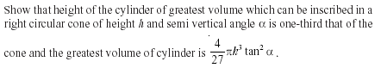

Arun Kumar Shukla

Education Point
B-184 Karam Pura New Delhi-15,ph.9971750

