Guess Paper – 2010
Class – XII
Subject – Mathematics (Integrals)

1. Evaluate:
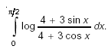

2. Evaluate:
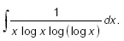

3. Evaluate:
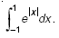

4. Evaluate:
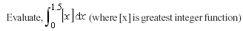

5. Evaluate:
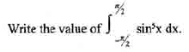
6. Evaluate:
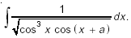

7. Evaluate:
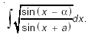

8. Evaluate:
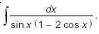

9. Using properties of integrals evaluate:
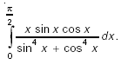

10. Evaluate:
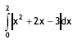

11. Evaluate as a limit of sum:
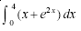

Education Point
B-184 Karam Pura New Delhi-15,ph.9971750366

