Guess Paper – 2010
Class – XII
Subject – Mathematics

1.
2.

3.

4.

5.
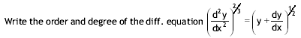

6.

7.

8.
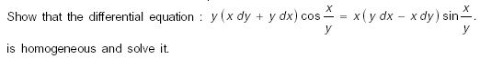

9. Solve:
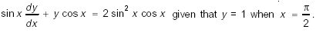
10.
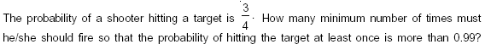

11.
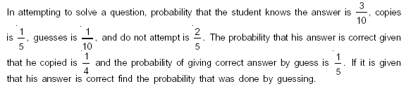
12.

Education Point
B-184 Karam Pura New Delhi-15,ph.9971750366

