Guess Paper – 2010
Class – XII
Subject – Mathematics

1. 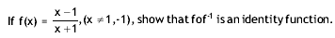
2.
3.
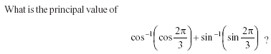
4.
5.
6.
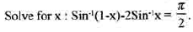
7.
8.

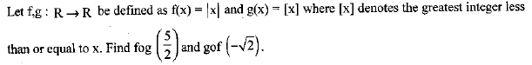
9.
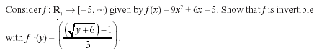

10. solve the equation:
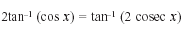
Education Point
B-184 Karam Pura New Delhi-15,ph.9971750366

