Sample Paper – 2010
Class – X
Subject – Mathematics
Time: 3 hours M.M:80

Section-A (1*10=10)

- State the fundamental theorem of arithmetic.
- The graph of y=f(x) is given below. Find the number of zeroes of f(x)

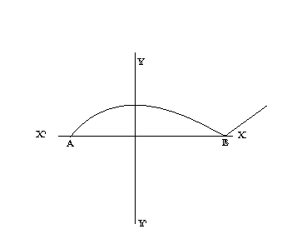
3. For what value of K the quadratic equation x²-kx+4=0 has equal roots.

- Write the next term of AP √ 8,√ 18, √ 32,………….
- If ∆ ABC  ~ ΔDEF and ∟A=97⁰ ∟E=53⁰ then write the measure of ∟C.

6. In figure if ∟ATO=40⁰ find ∟ AOB 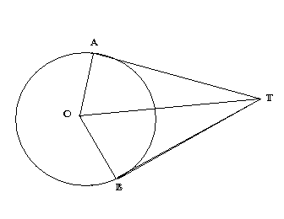
7. Find the value of
Cos 1⁰ cos 2⁰ cos 3⁰……………cos88⁰ cos89⁰ cos 90^{0.}
8. Find the perimeter of shaded region
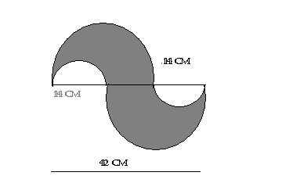
9. Card each marked with one of the numbers 4, 5, 6, 7………….20 are placed in a box and mixed thoroughly one card is drawn of random from box. What is the possibility of getting not prime numbers?

10. If the mean of the following distribution is 27 find the value of p.
Class 0-10 10-20 20-30 30-40 40-50
Frequency 8 p 12 13 10

Section B (2*5=10)

11. If ∟B and ∟Q are acute angles such that sinB=SinQ then prove that ∟B=∟Q.

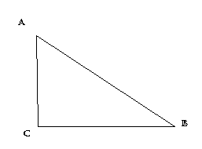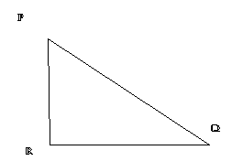

12. Find the roots of the following equation.
(1/x+4)- (1/x-7) =11/30 x ≠ -4, 7
OR
Find the roots of the equation 5x²-6x-2=0 by method of completing the square.

13. In fig ABC and DBC are two triangles on the same base BC. If AD intersects BC at O show that.
Ar ΔABC/ar ΔDBC = AO/DO.

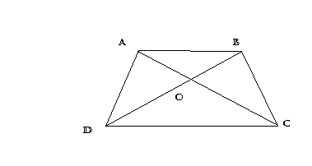 14. The letter is chosen from the word MATHEMATICS. what is the probability that it is not a vowel?

15. Find the value of ‘P’ for which the points (-5, 1), (1, P) and (4,-2) are collinear.
SECTION-C (3*10=30)

16. prove that √ p is irrational number
17. Check whether the polynomial x²+3x+1 is a factor of the polynomial
3x⁴+5x³-7x²+2x+2
OR
If two zeroes of the polynomial x⁴+3x³-20x²-6x+36 are -√2 and √2.Find the other zeroes.

18. For what value of ‘K’ will the following pair of linear equations have infinitely many solutions.
Kx+3y=K-3
12x+Ky=K

19. Find the ratio in which the 3x+y-9=0 divides the line segment joining the point (1, 3) and (2, 7).

20. Find sum of first 25 terms of an AP whose n^{th} term is given by a_{n}=7-3n.
OR
Which term of the AP 3, 15, 27, 39……………will be 132 more than it is 54th term?

21. Find the point on the x axis which is equidistant from (2,-5) and (-2, 9).

22. In a right triangle ABC, right angled at B, if tanA=1 then verify that 2sinAcosA=1.

23. ABCD is a trapezium in which AB║ DC and its diagonals intersect each at the point 0. show that AO/BO=CO/DO.

24. Draw a triangle with BC=6cm, ∟B=60⁰ , ∟A=75⁰ then, construct a triangle whose side are 5/3 times the corresponding side ABC and point C as a common vertex.

25. In fig OACD is a quadrant of a circle with centre o and radius 3.5 cm. If OD=2cm find the area of the shaded region.
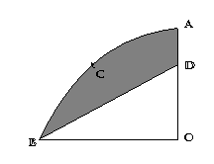
OR
2 cubes each of volume 64cm³ are joined end to end. find the surface area of the resulting cuboids.

Section D (6*5=30)

26. Some students arranged a picnic. The budget for food was Rs.240. because four students of group failed to go, the cost of food to each student got increased by rs.5. how many students went for picnic?
OR
A motor boat whose speed is 18 Km/hr in still water takes 1 hour more to go 24Km upstream than to return down-stream to same spot. find the speed of stream.

27. In a right triangle, the square of the hypotenuse is equal to the sum of the squares of the other two sides. Prove the converse of it

Using the above proved theorem. ∆ ABC is isosceles triangle with AC=BC.if AB²=2AC². Proved that ABC is an rt angled triangle.
OR
The ratio of the areas of two similar triangles is equal to the square of the ratio of their corresponding sides. Prove it.

Use the above theorem the area of two similar triangles is 81cm² and 144cm^{2,} if the largest side of smaller triangle is 27cm. find the largest side of larger Δ.

28. The radii of the ends of the frustum of cone 45cm high are 28cm and 7cm.Find the volume and total surface area.(take π=22/7).

29. If the angle of elevations of a cloud from a point 12 metres above a lake is α and angle of depression of it’s reflection in lake is β. Prove that the height of cloud is h (tanβ+tanα)/ (tanβ-tanα).

30. If the median of distribution given below is 28.5. find the value of X and Y.

Class interval | 0-10 | 10-20 | 20-30 | 30-40 | 40-50 | 50-60 | Total
Frequency | 5 | x | 20 | 15 | y | 5 | 60

Paper Submitted By : MR. MANOJ UPADHYAY
Email : manoj upadhyay
Ph No. : manojupadhyaybsss@gmail.com
BIRLA SCHOOL PILANI,JHUNJHUNU (RAJ.)
09460064263

