Guess Paper – 2010
Class – X
Subject – Maths (Geometry)
Time 1h , Max.M: 22.
Note: Q1 to Q5 , 1 marks each , Q6. 2 marks, Q7 to Q9. 3 marks each , Q10. 6 marks

1. In the following figure what is the length of AE?

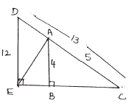
2.
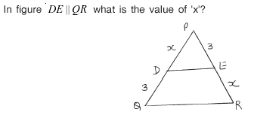
3.
In the semi circle, two chords AB and BC are of length 6cm and 8cm. What is the measure of the diameter AC of the circle?

4.
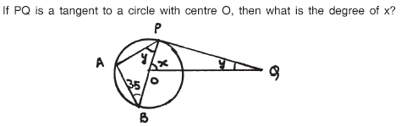

5.
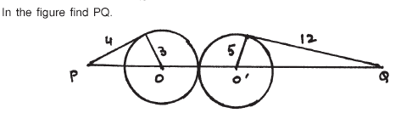
6.
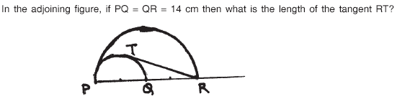
7.
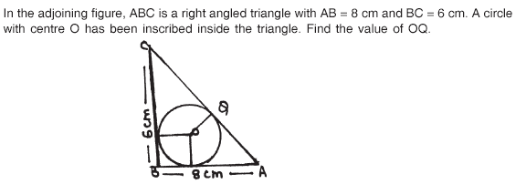
8. BL and CM are the medians of triangle ABC right angled at A. Prove that 4(BL² + CM²) = 5 BC²

9. 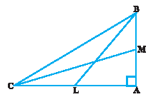

In Fig. 10.13, XY andX’Y’ are two parallel tangents to circle with centre O and another tangent AB with point of contact C intersecting XY at A and X’Y’ at B. Prove That $∠\text{AOB}={\text{90}}^{0}$
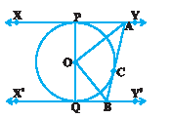
10. The ratio of area of two similar triangles is equal to the ratios of square of their corresponding sides.

Using above result prove that:
Prove that area of an equilateral triangle described on one side of a square is equal to half the area of the equilateral triangle described on one of its diagonals.

Paper Submitted by : Arun Kumar Shukla
Email : arunshukla09@yahoo.in
Phone No. 9971750366

