Guess Paper 2010
Class – XII
Subject – Mathematics

1. $\int_{0}^{π/2}{}$ log [ (4+3sinx) / (4+3cosx)] dx 2. $\int_{π/8}^{3π/8}{}$ cosx/(cosx + sinx) dx
3. $\int_{−1}^{3/2}{}$ | x sin ($π$x) | dx 4. $\int_{{−π}/2}^{π/2}{}$ [ sin |x| + cos |x| ] dx
5. $\int_{π/3}^{π/2}{}$√(1+cosx)/ (1-cosx)^{5/2} dx 6. $\int_{0}^{π}{}$x/ (a²cos²x+b²sin²x) dx
6. $\int_{π/8}^{3π/8}{}$ cosx/(cosx + sinx) dx 7. $\int_{0}^{2π}{}$dx/ (e^{sin x} +1)
8. $\int_{0}^{a}{}$sin ⁻¹ (x/a+x) dx 9. $\int_{0}^{π/4}{}$√ tanx dx 10. $\int_{0}^{e^{2}}{}$ [$\frac{1}{\text{log}x}$ - ${\left(\frac{1}{\text{log}x}\right)}^{2}$] dx
11. 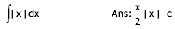 12. 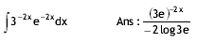
13. 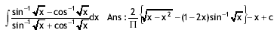
14. 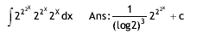
15. 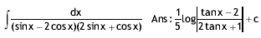
16. 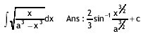17. 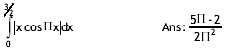 18.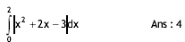19. 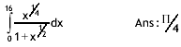
20. 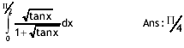21. 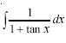22. 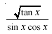23. 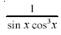
24. 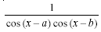 25. 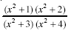26. 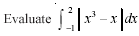 27.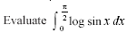28. 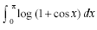29. 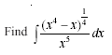 30.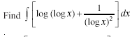31. 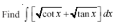32. 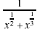33. 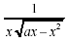
34. 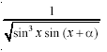35. 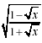36. 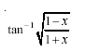37. 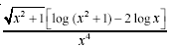
38. 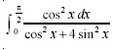39. 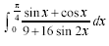40. 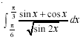 41.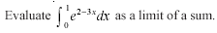
42. 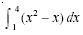 43. 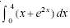
Paper Submitted By:- Arun Kumar Shukla
Email:- arunshukla09@yahoo.in
Ph No. : 9971750366

