Sample Paper – 2010
Class – X
Subject – Mathematics

- All questions are compulsory.
- The question paper consists of 30 questions divided into four sections – A,B,C and D. Section A comprises of ten questions of 1 mark each, Section B comprises of five questions of 2 marks each, Section C comprises of ten questions of 3 marks each and section D comprises of five questions of 6 marks each
- All questions in Section A are to be answered in one work, one sentence or as per the exact requirement of the question.
- There is no overall choice/ However, an internal choice has been provided in one question of 2 marks each, three question of attempt only one of the alternatives in all such questions.
- In question on construction, the drawings should be neat and exactly as per the given measurement.
- Use of calculators is not permitted.
- Write whether the rational number 231/700 will have a terminating decimal expansion or a non-terminating repeating decimal expansion.
- Of – 1 is a zero of the polynomial P (x) = ax² – 3 (a-1) x – 5, then final the value of a
- In a Δ PQR, ST⏐⏐ QR of ST = 1/3 QR and area of ΔPQR = 729cm², find the area of ΔPST
- If cosec A= 17/7 and A + B = 90°, find the value of sec B
- Find the perimeter of a quadrant of a circle whose circumference is 88 cm
- Write whether the following pair of linear equations is consistent or not
x + 2y – 8 = 0
3n + 6y = 24
- Write the nature of roots of quadratic equation 2√3x² – 10 x + √3 = 0
- For what value of P, are the numbers 2a, 3a + P and 4a + 6 three consecutive terms of an.A.P.
- In figure (1) quadrilateral is circumscribing a circle, find the length of BC
A
B
D
C
8cm.
11cm.
9cm.

Section - B
- Find all the zeros of the Section (B)/ Polynomial x⁴- 4x³ – 2x² + 12x – 3, if two of its zeros are 2 ± √3
- Find the sum of first 25 terms of an A.P. whose nth term is given by T_{n} = 7 -3n
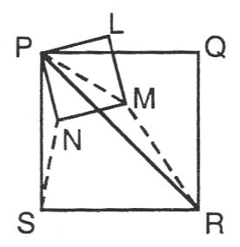
- In the adjoining figure PQRS and PLMN are squares prove that
- PM : PN = PR : PS
- Δ PRM and ΔPSN are similar

- Without using trigonometric tables, evaluate :
5 cos 70° 3 cos 55° cosec 35°
+
2 sin 20 2 tan 4° tan 24° 45°tan 66° tan 86°
or
If tanθ = 8 then evaluate (2+2 cosθ) (1 – cosθ)

15, (1 + sinθ) (2 – 2 sinθ)

- The centre of a circle is (2K – 1, 7) and it passes through the point (-3,-1) if the riding of the circle is 10 units, then find the values of
Section (C)
- Prove that 7 + 3√2 is not a rational number
- Solve for x and y :
x y
+ = 2
a b
ax – by = a² – b²
or
The sum of the numerator and the denominator of a fraction is 12. If the denominator is increased by 3, the fraction becomes ½ find the fraction
- It 9th term of an A.P. is zero , prove that its 29th term is double of the 19th term.
- Prove that (sin A + cosec A)² + (Cos A + Sec A)² = 7 + tan² A + cot² A
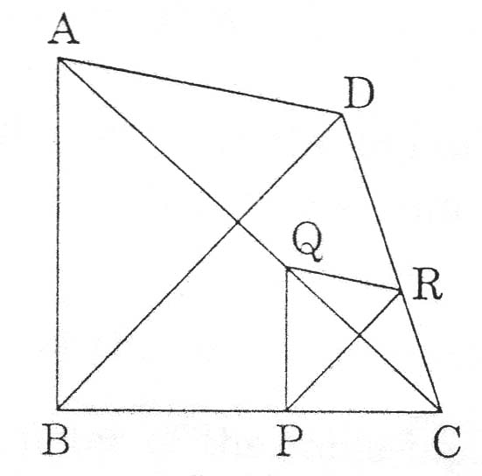
- Draw a circle of radius 3 cm. from a point P 6 cm away from its centre coustruct a pair of tangents to the circle measure the lengths of the tangents.
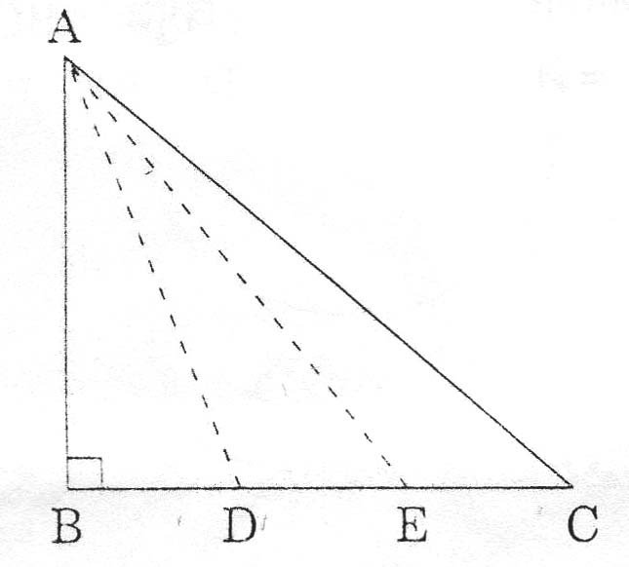
- In figure (2), two triangles ABE and DBC lie on the same side of base BC. P is a point on BC such that PQ⏐⏐ BA and PR ⏐⏐ BD prove that QR ⏐⏐ AD
or
In figure (3) a triangle ABC is right angled at B side BC is trisected at points D and E, Prove that SAE² = 3 AC² + 5 AD²

- Find a relation between x any y such that the point P (x, y) is equidistant from the points A (2,5) and B (-3, 7)
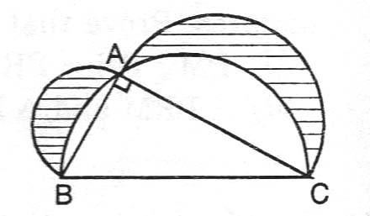
- The area of the triangle is 15 sq. units find the value (s) of K if the vertices of the triangle are (1,K), (4-3) and (-9, 7)
- In the figure (4) ABC is a right triangle ∠A = 90°, AB = 21 cm, and AC = 28cm.AB, BC, and AC as diameters. Find the area of the shaded region.
or
The area of an equilateral triangle is 17320.5cm² with each vertex as centre a circle is described with radius equal to half the length of the side of the triangle find the area of triangle not included in the circle (Take √3 = 1.73205)
- A bag has cards numbered 18 to 98 cards are mixed thoroughly and a card is drawn from the bag at random. Find the probability that the number on the card ,x drawn from the box is
    - c an odd number
    - a cubic number
    - a number divisible by 8
- The diagonal of a rectangular field is 60m. more than the shorter side if the longer side is 3m. more than the shorter side, find the sides of the field
or
Seven years ago atul's age was five times the square of sangeeta's age. Three years hence sangeeta's age will be two fifth of atul's age find their present ages.
- Prove that the ratio of the areas of two similar triangles is equal to the ratio of the squares of their corresponding sides. using the above theorem prove the following.
The area of the equilateral triangle described on the side of a square is half the area of the equilateral triangle described on its diagonal.
- The angle of elevation of the top of an unfinished tower at a point distant 100cm. From its base is 45°, how much higher must the tower be raised so that its angle of elevation at the same point may be 60°? (Take √3 = 1.73)
- Water is flowing at the rate of 5km per hour through a pipe of diameter 14 cm into a rectangular tank which is 25 m. long and 22m wide. Determine the time in which the level of water in the tank will rise by 21cm.
or
The height of a come is 40cm. A same come is cut off at the top by plane parallel to the base. If the volume of the small can be 1/64 of the volume of the given cane, at what height above the base is the section made.
- Find mean, median and mode for the following data
marks obtained : 15-20 20 -25 25-30 30-35 35-40 40-45 45-50 55-55
No. of students : 3 8 9 10 3 0 0 2

Paper Submitted by: AJAY GUPTA
Email : ajaygupta_st.pauls@yahoo.co.in
Ph No.: 9414245161

