Sample Paper – 2009
Class – XII
Subject – Mathematics

INDEFINITE INTEGRALS

## PREVIOUS YEAR’S QUESTIONS
1 MARK

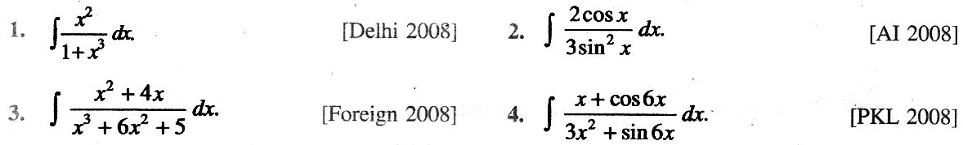

4/6 MARKS

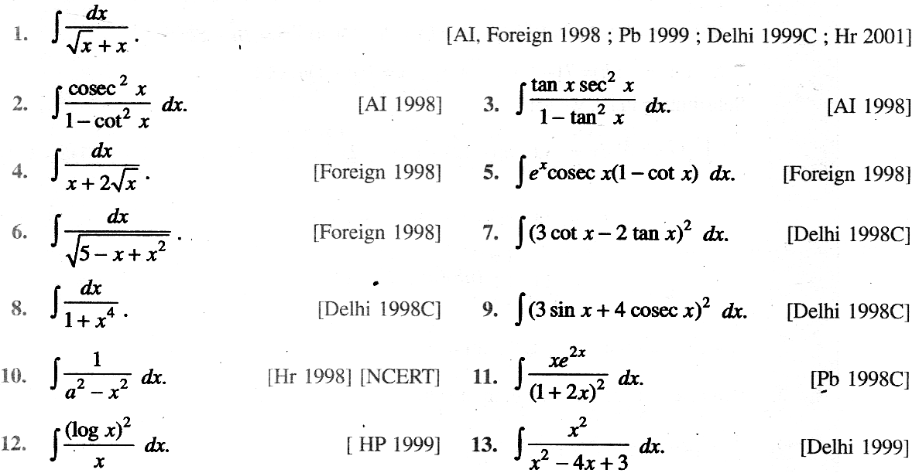
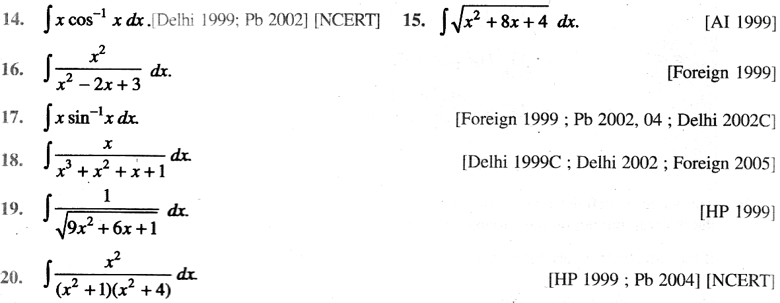
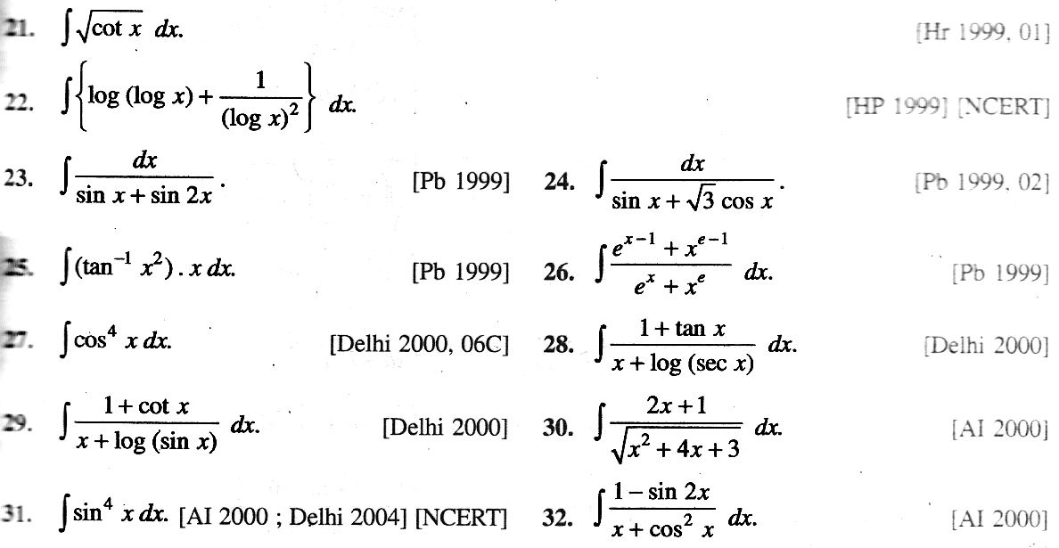
PAGE (1/4)
SEE TO NEXT PAGE …….

Paper Submitted by:
Deepak
Email :- wadhwa_88@yahoo.com
Phone No. 9958411113

DEEPAK TUITION CENTER
A – 98, NEW MOTI NAGAR, NEW DELHI – 110 015 Ph: 25176448

