SAMPLE PAPER – 2009
Class – XI
SUBJECT – PHYSICS
Time : Three Hours Max. Marks: 70
General Instructions:
- All questions are compulsory.
- There are 30 questions in total. Questions 1 to 8 carry one mark each, questions 9 to 18 carry two marks each, questions 19 to 27 carry three marks each and questions 28 to 30 carry five marks each.
- There is no overall choice. However, an internal choice has been provided in one question of two marks, one question of three marks and all three questions of five marks each. You have to attempt only one of the given choices in such questions.
- Use of calculators is not permitted.
Q.1. A boy wishes to row across a river in the shortest possible time. He can row at 10m/s in still water and the river is flowing at 5m/s. At what angle θ should he point the bow (front) of his boat?  (1 mark) |  | 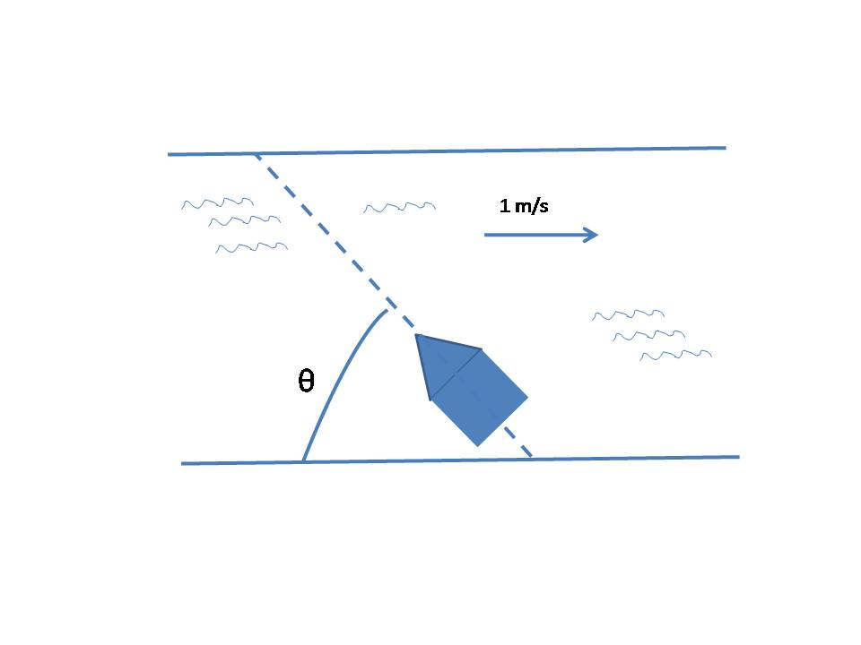
Q.2. During a short interval of time the speed v in m/s of an automobile is given by v = at + bt⁴, where the time t is in seconds. Find out the units of a and b.
(1 mark)
Q.3. A solid cylinder and a circular disc of different materials have equal masses and equal radii. Which one will have a larger moment of inertia about an axis passing through its centre of mass perpendicular to its plane? (1 mark)

Q.4. What is the maximum value of gravitational potential energy ?
(1 mark)

Q.5. If a man in an lift drops his cap but it does not fall to the floor, what can he conclude about the elevator’s motion? (1 mark)

Q.6. Is the average speed of a moving object during a given interval of time is always “total distance travelled during the time interval divided by the total time ”? (1 mark)
Q.7 A heavy metallic bob is suspended as shown. A sudden jerk on the lower rope will break that rope but a slow pull on the lower rope will break the upper rope. Give the reason only in one sentence- Why the first result occurs?.  (1 mark) |  |  |  | 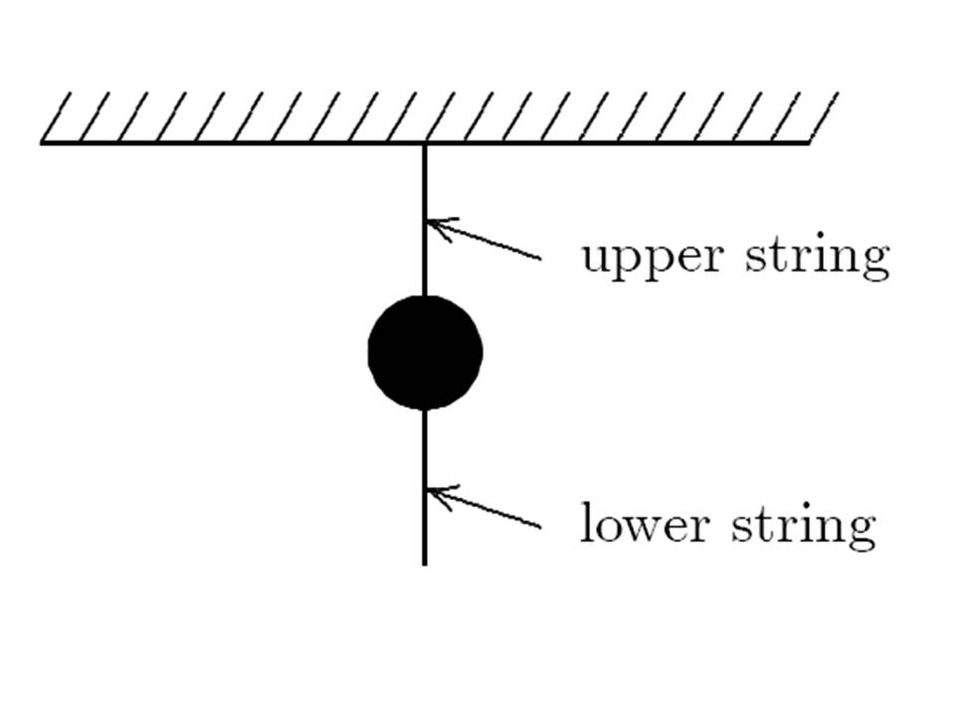
Q.8. Can a body be in equilibrium when only single force acts on it? (1 mark)
Q. 9. Establish equation of continuity of an ideal liquid flow. ( 2 marks)
Q. 10. Why does oil spread over the surface of water? Explain. ( 2 marks)
Q.11. What is a simple harmonic motion? State its characteristics. (2 marks)
Q.12. What is the average kinetic energy of a molecule of a gas at a temperature of 225K? (2 marks)
Q.13. Two forces, one with a magnitude of 4N and the other with a magnitude of 7N, are applied to an object. For which orientations of the forces shown in the diagrams is the magnitude of the acceleration of the object the least? Give the reason for your answer in one line only.  (2 marks) | 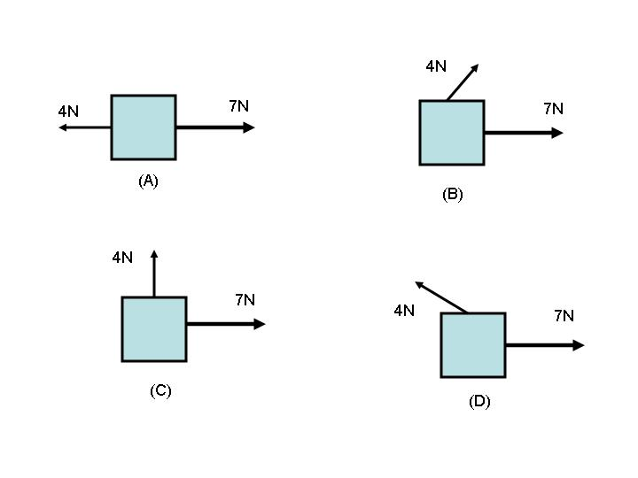
Q.14. Suppose A = B^{p}C^{q}, where A has dimensions [M⁰L⁺¹T⁺¹], B has dimensions [M⁰L⁺²T⁻¹], and C has dimensions [M⁰L⁺¹T⁺²]. Then find out the values of exponents p and q.
(2 marks)

Q. 15. Two bodies on the two sides of an equal-arm Physical balance exactly balance each other. If this physical balance is placed in a lift and given an upward acceleration, do they still balance? Justify your answer.
(2 marks)

Q.16. A solid cylinder rolls without slipping down a plane inclined at an angle ‘θ’ to the horizontal. What is the linear acceleration of its center of mass?
( 2 marks)
OR
Derive an expression for moment of inertia of a uniform rod about an axis perpendicular to the length of the rod and passing through its centre.
(2 marks)

Q.17. Suppose a tunnel is drilled completely through the earth along a diameter. Mass and radius of earth are M_{e} and R_{e}. What is the force acting on a body of mass m at a distance x from the centre of earth? ( 2 marks)

Q.18. Why are rockets usually launched from west to east in the equitorial plane of the earth? (2 marks)
Q.19. Prove that when a very light body makes a perfectly elastic head-on collision with a very heavy body that is at rest, the light one rebounds with its own velocity.
( 3 marks)
Q.20. i) A compressed spring is clamped in its compressed position and it then dissolved in acid, what becomes of its elastic potential energy?

ii) An automobile of mass m accelerates, starting from rest, while the engine supplies constant power ‘ P’ . Show that the velocity ‘v’ is given by equation
( 2 + 1 marks)
Q.21 i) What is meant by degrees of freedom? ( 1 mark)
ii) Find out the degrees of freedom of a molecule of an ideal diatomic gas
( 1 mark)
iii) State law of equipartition of energy. ( 1 mark)
Q.22. Experienced cooks can tell whether an egg is raw or hard-boiled by rolling it down an inclined plane.Explain? (3 marks)

Q.23. Establish the relationship among coefficient of linear expansion (α), coefficient of superficial expansion (β) and coefficient of volumetric expansion ( γ). (3 marks)

Q.24. In the diagram, has magnitude 4m and has magnitude 3m. Find out the x component of .  (3 marks) |  |  | 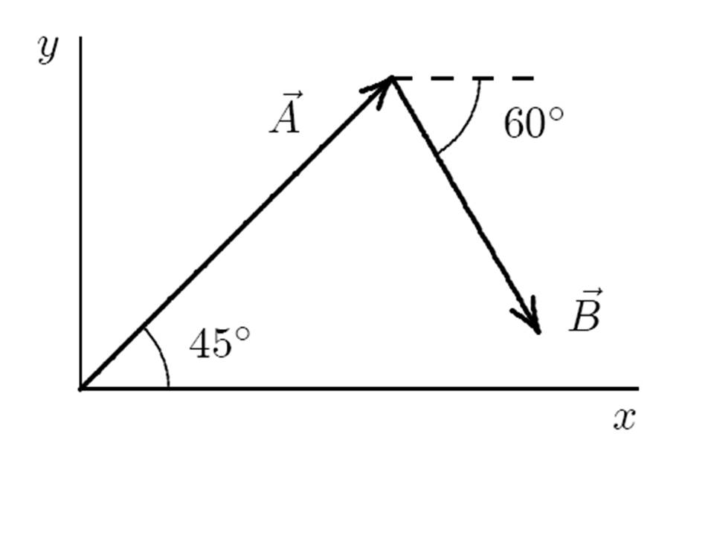
Q.25. The system shown maintains static equilibrium. Each block weighs 20 N. Calculate the force of friction on the Block kept on the inclined plane.  (3 marks) |  |  | 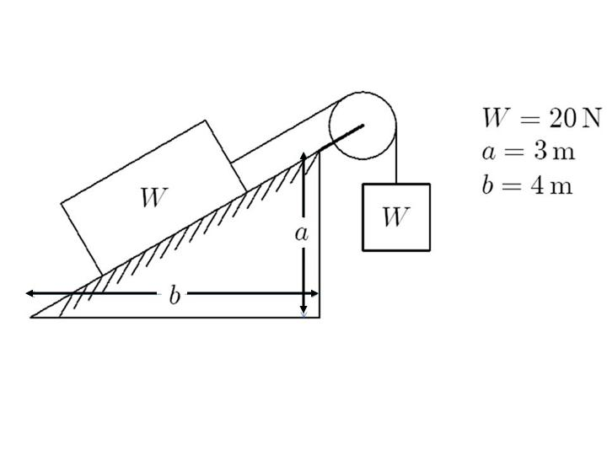
Q.26. Find the expressions for time period and frequency in the oscillations of a floating cylinder. ( 3 marks)
OR

Two identical wires of sitar have a fundamental frequency of 500 Hz, when kept under the same tension. What fractional increase in the tension of one wire will lead to the occurrence of 50 beats/ sec when both wires oscillate simultaneously? ( 3 marks)

Q. 27. i) Stainless steel cooking pans are preferred with extra copper bottoms.
Why? ( 1 mark)
ii) At what temperature is the Fahrenheit scale reading equal to half that
of the Celsius scale? Calculate. ( 2 marks)

Q.28. i) What is a projectile? Give its examples. ( 1 mark)
ii) Show that the path of projectile is a parabolic path when projected
obliquely from a certain point on the ground. ( 3 marks )

iii) At what point of its trajectory, the speed of projectile is minimum?
( 1 mark)
OR
i) The airplane shown is in level flight at an altitude of 1 km and a speed of 200 km/h. At what distance ‘S’ should it release a heavy bomb to hit the target X? Take g = 10 m/s².  ( 3 marks)  ii) Find the angle of projection for a projectile motion whose range R is 4 times the maximum height H.  ( 2 marks) |  |  |  |  | 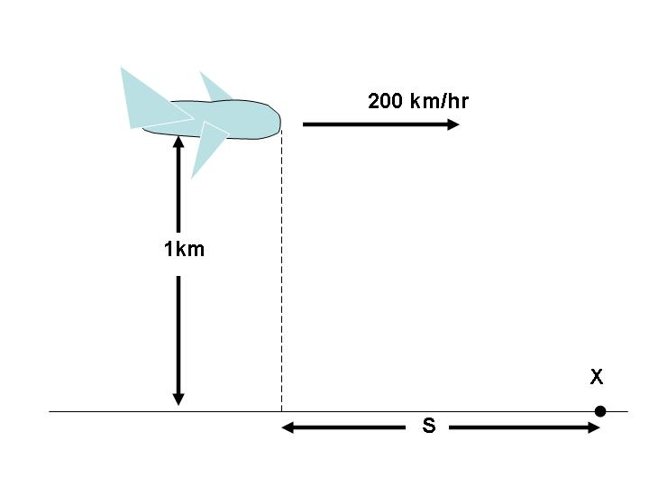
Q.29. i) What is a heat engine? ( 1 mark)
ii) Briefly describe four steps of a Carnot’s cycle. ( 2 marks)
iii) Derive an expression for the efficiency of Carnot’s heat engine, in terms
of temperatures of source and sink. ( 2 marks )
OR
i) When a gas expands adiabatically, it does work on its surroundings. But if
there is no heat input to the gas, where does the energy come from?
( 2 marks)

ii) An ideal gas undergoes an isothermal expansion at 0⁰C from 0.050m³ to 0.600 m³. For 10 mole of gas ,compute

a) the work done b) the heat added and c) the change in internal energy.
{Given that Log₁₀ 20= 1.3010} (1 + 1+ 1 mark)

Q.30. The equation of a transverse travelling wave on a string is
Where x and y are in cm. and t is in seconds. Find
i) amplitude ii) wavelength iii) frequency iv) time period v) wave velocity
( 1+1+1+1+1 mark)
OR
Discuss analytically (ie. prove the equation of a standing wave) formation of
standing waves on stretched string.
( 5 marks )

For Solutions contact : dear.physics@rediffmail.com

