Mathematics
CLASS X

TNo: Nq: 12 MM: 39 Ta: 70 Minutes Dt. 10.01.05
Tc: Algebra-1
Section A: 3 marks each
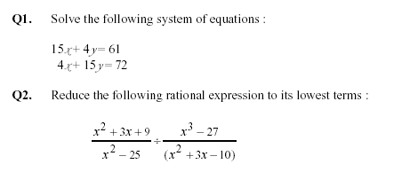
Q3 If $A=\frac{x−1}{x}$ and $B=\frac{A−1}{A}$ and A+B =2 then find nature of x.

Q4 If pth, qth, rth term of an A.P. be x, y, z respectively. Show that
$x(q−r)+y(r−p)+z(p−q)=0$

Q5 Jan Shatabdi Express starts from Jabalpur station and it covers its one third destination in three hours and another express traintakes 1 hour more for cover the total destination. If the speed differs by 16 Km/h one train by another. Find the speeds of the both trains.
OR

The sum of numerator and denominator of a fraction is 8. If 3 is added to both the numerator and denominator the fraction becomes ¾. Find the friction.

Q6 Solve the equation $\text{ax}+\text{by}=a−b$
$\text{bx}−\text{ay}=a+b$
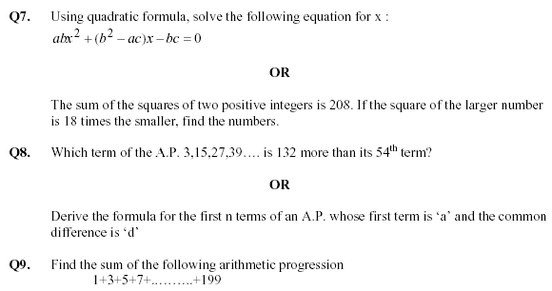

Section B: 4 marks each

Q 10 If the pth term of an A.P. of 1/q and the qth term is 1/p, prove that the sum of pq terms is ½(pq+1).

